Table of Contents

WHAT IS DEVOPS? 2

BENEFITS OF DEVOPS 3

WHAT IS JENKINS? 4

Before and After Jenkins 5

What’s the Difference between Continuous Integration, Continuous Deployment and Continuous Delivery? 5

The nucleus: continuous integration 6

The leap to continuous delivery and deployment 6

Quick summary and final thoughts 7

SONATYPE NEXUS 7

Web server vs. application server: What is the difference? 7

SONARQUBE 7

Architecture and Integration: 7

JENKINS INSTALLATION 8

CONFIGURE JDK, MAVEN ENV: 9

CREATING FIRST JENKINS JOB 11

USING CUSTOM WORKSPACE (LOCAL STORAGE) NOT SCM 13

CRON JOBS 17

APACHE TOMCAT INSTALLATION 18

INTEGRATION OF TOMCAT WITH JENKINS 19

FILE SYSTEM SCM INTEGRATION WITH JENKINS: 22

GIT INTEGRATION WITH JENKINS 23

SONARQUBE INTEGRATION WITH JENKINS 26

What is SonarQube? 26

Why should Integrating SonarQube and Jenkins Useful: 26

Pipeline Creation (Using Build Triggers with individual Freestyle Projects) 32

PIPELINE CREATION USING SCRIPT 35

Generate script for email 37

INTEGRATION OF JUNIT WITH JENKINS: 46

INTEGRATION OF JACOCO WITH JENKINS 48

ARCHIVE THE ARTIFACTS IN JENKINS 50

INTEGRATION OF EMAIL WITH JENKINS 50

FIXING PLUGINS NOT INSTALLING IN JENKINS 55

# WHAT IS DEVOPS?

DevOps is the combination of cultural philosophies, practices, and tools that increases an organization’s ability to deliver applications and services at high velocity: evolving and improving products at a faster pace than organizations using traditional software development and infrastructure management processes. This speed enables organizations to better serve their customers and compete more effectively in the market.

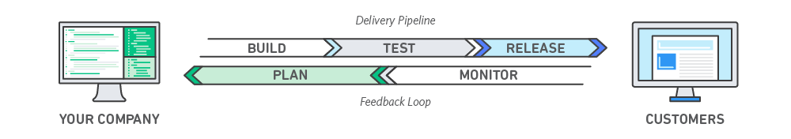

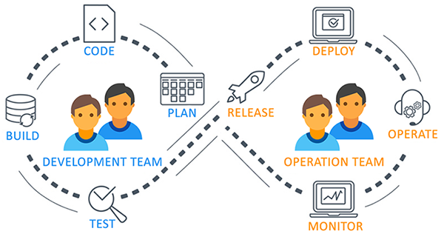

## BENEFITS OF DEVOPS

Speed

Move at high velocity so you can innovate for customers faster, adapt to changing markets better, and grow more efficient at driving business results. The DevOps model enables your developers and operations teams to achieve these results. For example, [microservices](https://aws.amazon.com/devops/what-is-devops/" \l "microservices) and [continuous delivery](https://aws.amazon.com/devops/continuous-delivery/) let teams take ownership of services and then release updates to them quicker.

Rapid Delivery

Increase the frequency and pace of releases so you can innovate and improve your product faster. The quicker you can release new features and fix bugs, the faster you can respond to your customers’ needs and build competitive advantage. [Continuous integration](https://aws.amazon.com/devops/continuous-integration/) and [continuous delivery](https://aws.amazon.com/devops/continuous-delivery/) are practices that automate the software release process, from build to deploy.

Reliability

Ensure the quality of application updates and infrastructure changes so you can reliably deliver at a more rapid pace while maintaining a positive experience for end users. Use practices like [continuous integration](https://aws.amazon.com/devops/continuous-integration/) and [continuous delivery](https://aws.amazon.com/devops/continuous-delivery/) to test that each change is functional and safe. [Monitoring and logging](https://aws.amazon.com/devops/what-is-devops/#monitoring) practices help you stay informed of performance in real-time.

Scale

Operate and manage your infrastructure and development processes at scale. Automation and consistency help you manage complex or changing systems efficiently and with reduced risk. For example, [infrastructure as code](https://aws.amazon.com/devops/what-is-devops/#iac) helps you manage your development, testing, and production environments in a repeatable and more efficient manner.

Improved Collaboration

Build more effective teams under a DevOps cultural model, which emphasizes values such as ownership and accountability. Developers and operations teams [collaborate](https://aws.amazon.com/devops/what-is-devops/#communication) closely, share many responsibilities, and combine their workflows. This reduces inefficiencies and saves time (e.g. reduced handover periods between developers and operations, writing code that takes into account the environment in which it is run).

Security

Move quickly while retaining control and preserving compliance. You can adopt a DevOps model without sacrificing security by using automated compliance policies, fine-grained controls, and configuration management techniques. For example, using infrastructure as code and [policy as code](https://aws.amazon.com/devops/what-is-devops/#policyascode), you can define and then track compliance at scale.

## WHAT IS JENKINS?

**Jenkins** is an open-source automation tool written in Java with plugins built for Continuous Integration purposes. **Jenkins** is **used** to build and test your software projects continuously making it easier for developers to integrate changes to the project, and making it easier for users to obtain a fresh build.

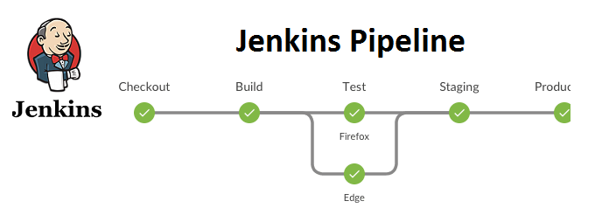

**Jenkins Alternatives**

* GitLab
* Atlassian Bamboo
* TeamCity

What are the Jenkins Features?

* Easy Installation. Jenkins is a **platform**-agnostic, **self**-contained **Java**-based program, ready to run with packages for Windows, Mac OS, and Unix-like operating systems.
* Easy Configuration. ...
* Thousands of available Plugins. ...
* Extensible. ...
* Easy **Distribution**. ...
* Free Open Source.

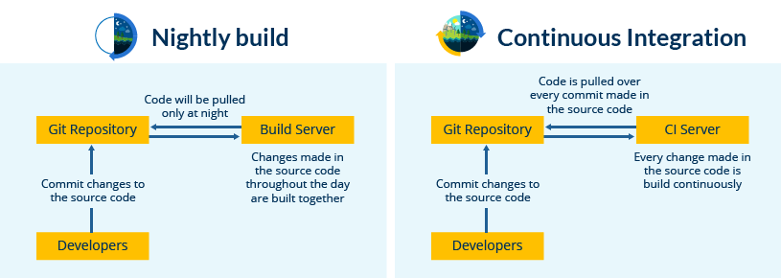

How Jenkins Works……

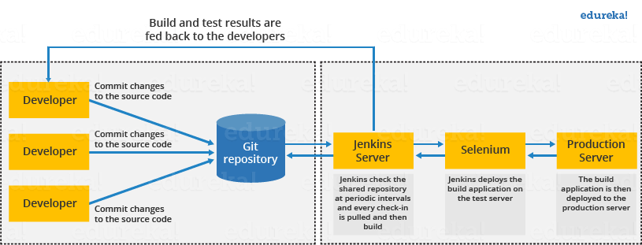

The above diagram is depicting the following functions:

* First, a developer commits the code to the source code repository. Meanwhile, the Jenkins server checks the repository at regular intervals for changes.
* Soon after a commit occurs, the Jenkins server detects the changes that have occurred in the source code repository. Jenkins will pull those changes and will start preparing a new build.
* If the build fails, then the concerned team will be notified.
* If built is successful, then Jenkins deploys the built in the test server.
* After testing, Jenkins generates a feedback and then notifies the developers about the build and test results.
* It will continue to check the source code repository for changes made in the source code and the whole process keeps on repeating.

You now know how Jenkins overcomes the traditional SDLC shortcomings. The table below shows the comparison between “Before and After Jenkins”.

## Before and After Jenkins

|  |  |
| --- | --- |
| **Before Jenkins** | **After Jenkins** |
| The entire source code was built and then tested. Locating and fixing bugs in the event of build and test failure was difficult and time-consuming, which in turn slows the software delivery process. | Every commit made in the source code is built and tested. So, instead of checking the entire source code developers only need to focus on a particular commit. This leads to frequent new software releases. |
| Developers have to wait for test results | Developers know the test result of every commit made in the source code on the run. |
| The whole process is manual | You only need to commit changes to the source code and Jenkins will automate the rest of the process for you. |

## What’s the Difference between Continuous Integration, Continuous Deployment and Continuous Delivery?

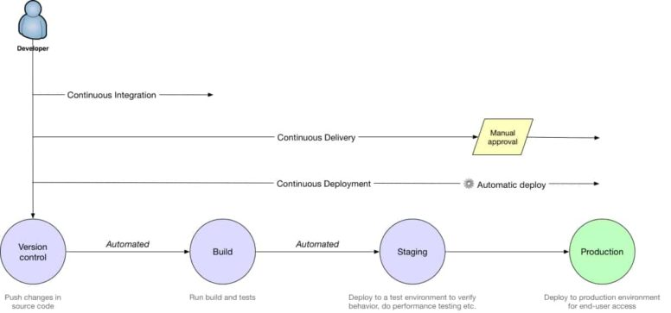

The nucleus: continuous integration

Most developers [start with Continuous Integration (CI)](https://semaphoreci.com/continuous-integration), which is about everyone merging code changes to a central repository multiple times a day. Each merge triggers an automated build and testing sequence for the given project.

Depending on the programming language, the program may first need to be compiled. Today there is also an increasing need to package the code in a Docker container. Automated tests then verify specific units of code, UI behavior, application performance, API reliability, and more. Together, all these steps are commonly referred to as the “Build” stage.

CI acts as a safety net that lets developers prevent many issues before they reach users. As a result, developers ship code with more confidence, but not necessarily faster — the deployment process may still be manual, long, and error-prone.

The best initial investment developers can make is to ensure that their automated test suite is comprehensive and stable enough that they feel safe to deploy every passed CI build to a staging, and later production environment, without a long manual QA (quality assurance) process.

The second thing to pay attention to is CI speed: at [Semaphore](https://semaphoreci.com/), we strongly believe that [developers must get CI results within 10 minutes](https://semaphoreci.com/blog/2017/03/02/what-is-proper-continuous-integration.html), otherwise their productivity shrinks due to lack of focus and frequent context switching. We build our product to support that. An easy way to optimize CI time is to [run tests in parallel on a powerful platform](https://semaphoreci.com/blog/2017/05/23/introducing-semaphore-boosters-one-click-parallel-ci.html).

The leap to continuous delivery and deployment

[Continuous Delivery (CD)](https://semaphoreci.com/cicd) is a practice of automating the entire software release process. The idea is to do CI, **plus** automatically prepare and track a release to production. The desired outcome is that anyone with sufficient privileges to deploy a new release can do so at any time in one or a few clicks. By eliminating nearly all manual tasks, developers become more productive.

The continuous delivery process typically includes at least one manual step of approving and initiating a deploy to production. In complex systems with multiple dependencies, the [continuous delivery pipeline](https://semaphoreci.com/blog/cicd-pipeline) may include additional steps, which are either manual or automatic.

[Continuous Deployment](https://semaphoreci.com/community/tutorials/elements-of-a-continuous-deployment-workflow) is a step up from Continuous Delivery in which every change in the source code is deployed to production automatically, without explicit approval from a developer. A developer’s job typically ends at reviewing a pull request from a teammate and merging it to the master branch. A CI/CD service takes over from there by running all tests and deploying the code to production, while keeping the team informed about outcome of every important event.

Continuous deployment requires a highly developed culture of monitoring, being on call, and having the capacity to recover quickly.

Quick summary and final thoughts

To sum up:

* Continuous Integration (CI): short-lived feature branches, team is merging to master branch multiple times per day, fully automated build and test process which gives feedback within 10 minutes; deployment is manual.
* Continuous Delivery (CD): CI + the entire software release process is automated, it may be composed of multiple stages, and deployment to production is manual.
* Continuous Deployment: CI + CD + fully automated deployment to production.

## SONATYPE NEXUS

**Nexus** by Sonatype is a repository manager that organizes, stores and distributes artifacts needed for development. With **Nexus**, developers can completely control access to, and deployment of, every artifacts in an organization from a single location, making it easier to distribute software.

Web server vs. application server: What is the difference?

A ***web server*** delivers static web content - e.g., HTML pages, files, images, video—primarily in response to hypertext transfer protocol (HTTP) requests from a web browser.

An ***application server*** typically can deliver web content too, but its primary job is to enable interaction between end-user clients and server-side application code—the code representing what is often called business logic-to generate and deliver dynamic content, such as transaction results, decision support, or real-time analytics. The client for an application server can be the application’s own end-user UI, a web browser, or a mobile app, and the client-server interaction can occur via any number of communication protocols.

In practice, however, the line between web servers and application servers has become fuzzier, particularly as the web browser has emerged as the application client of choice and as user expectations of web applications and web application performance have grown.

## SONARQUBE

# Architecture and Integration:

The SonarQube Platform is made of 4 components:  
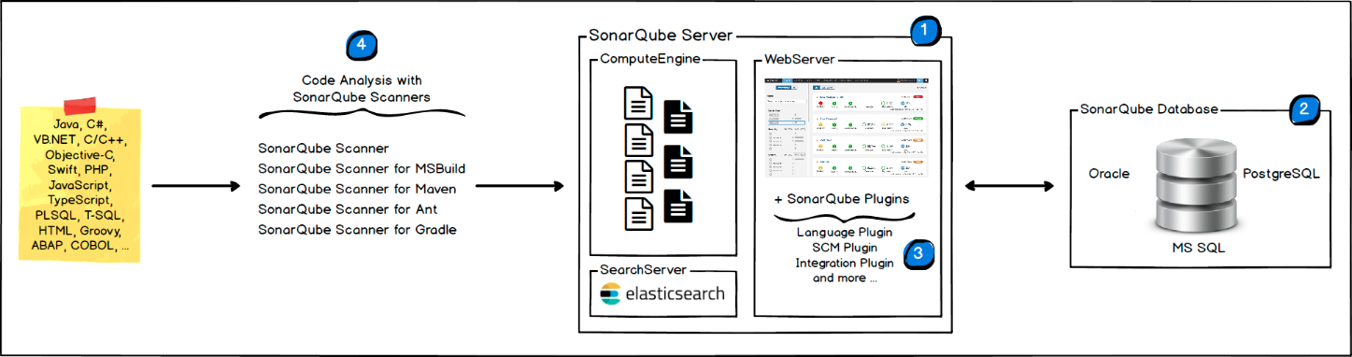

1. One SonarQube Server starting 3 main processes:
   * Web Server for developers, managers to browse quality snapshots and configure the SonarQube instance
   * Search Server based on ElasticSearch to back searches from the UI
   * Compute Engine Server in charge of processing code analysis reports and saving them in the SonarQube Database
2. One SonarQube Database to store:
   * the configuration of the SonarQube instance (security, plugins settings, etc.)
   * the quality snapshots of projects, views, etc.
3. Multiple SonarQube Plugins installed on the server, possibly including language, SCM, integration, authentication, and governance plugins
4. One or more SonarScanners running on your Build / Continuous Integration Servers to analyze projects

# JENKINS INSTALLATION

Run Jenkins via command line: java -jar jenkins.war

Download jenkins in your PC. You can download jenkins from below mentioned link.

<https://www.jenkins.io/download/>

After opening above mentioned link click on download jenkins for Windows and download will start automatically.

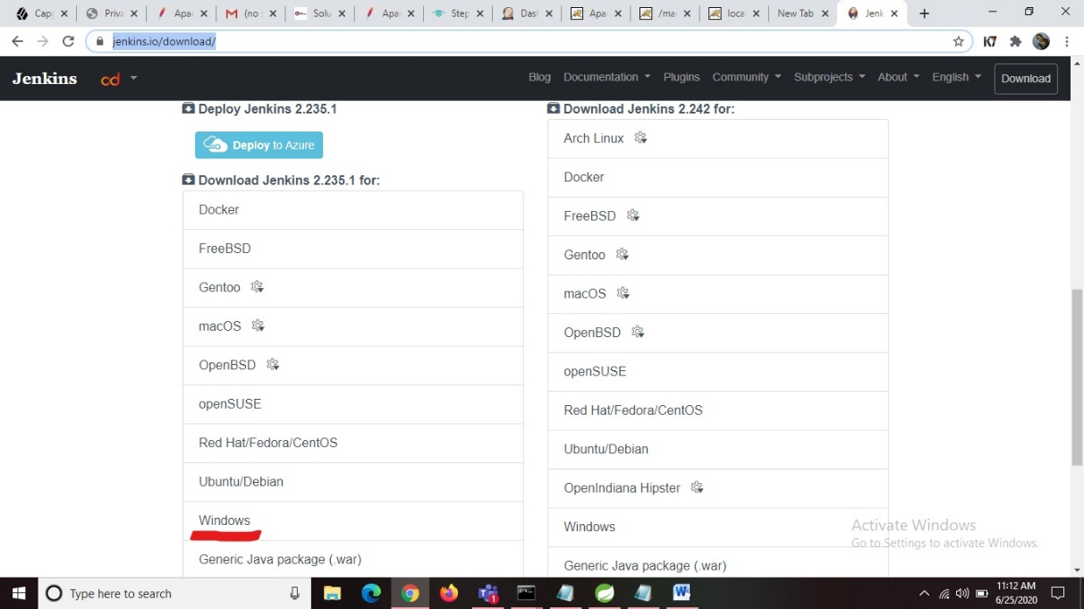

Open the downloaded zip file and extract it. Later open the extracted file and click on jenkins installer file and install the jenkins.

By default jenkins run on port number 8080. So after successful installation you can check port number 8080.

**Creation of .war file in STS or Eclipse using maven-war-plugin:**

**Step -1** Open your pom.xml file and add below lines of code and save changes.

<packaging>war</packaging>

<dependency

<groupId>org.apache.maven.plugins</groupId>

<artifactId>maven-war-plugin</artifactId>

<version>3.3.0</version>

</dependency>

# CONFIGURE JDK, MAVEN ENV:

**Step-1**

Open <http://localhost:8080/> where jenkins is running.

Click on **Manage Jenkins** link located within the left menu bar. And in the **System Configuration** click on **Global Tool Configuration.**

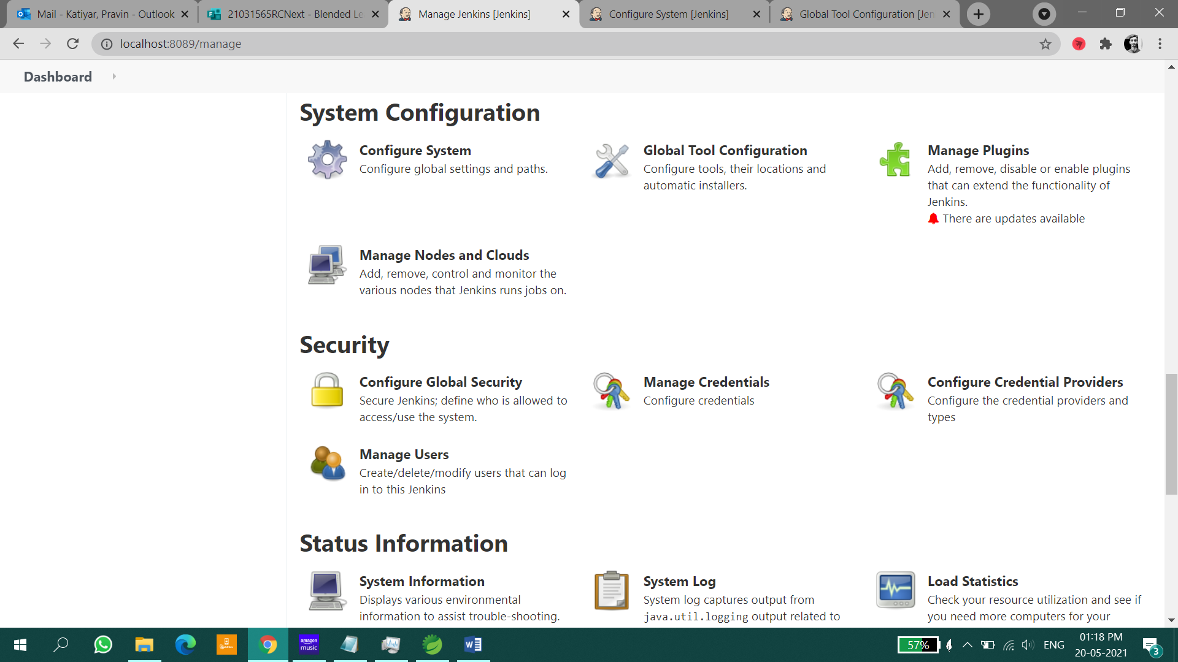

Later click on **JDK installations** and in the **JAVA_HOME** field provide your JDK local path (C:\Program Files\Java\jdk1.8.0_181) and the **name** can be anything.

Can refer through below image:

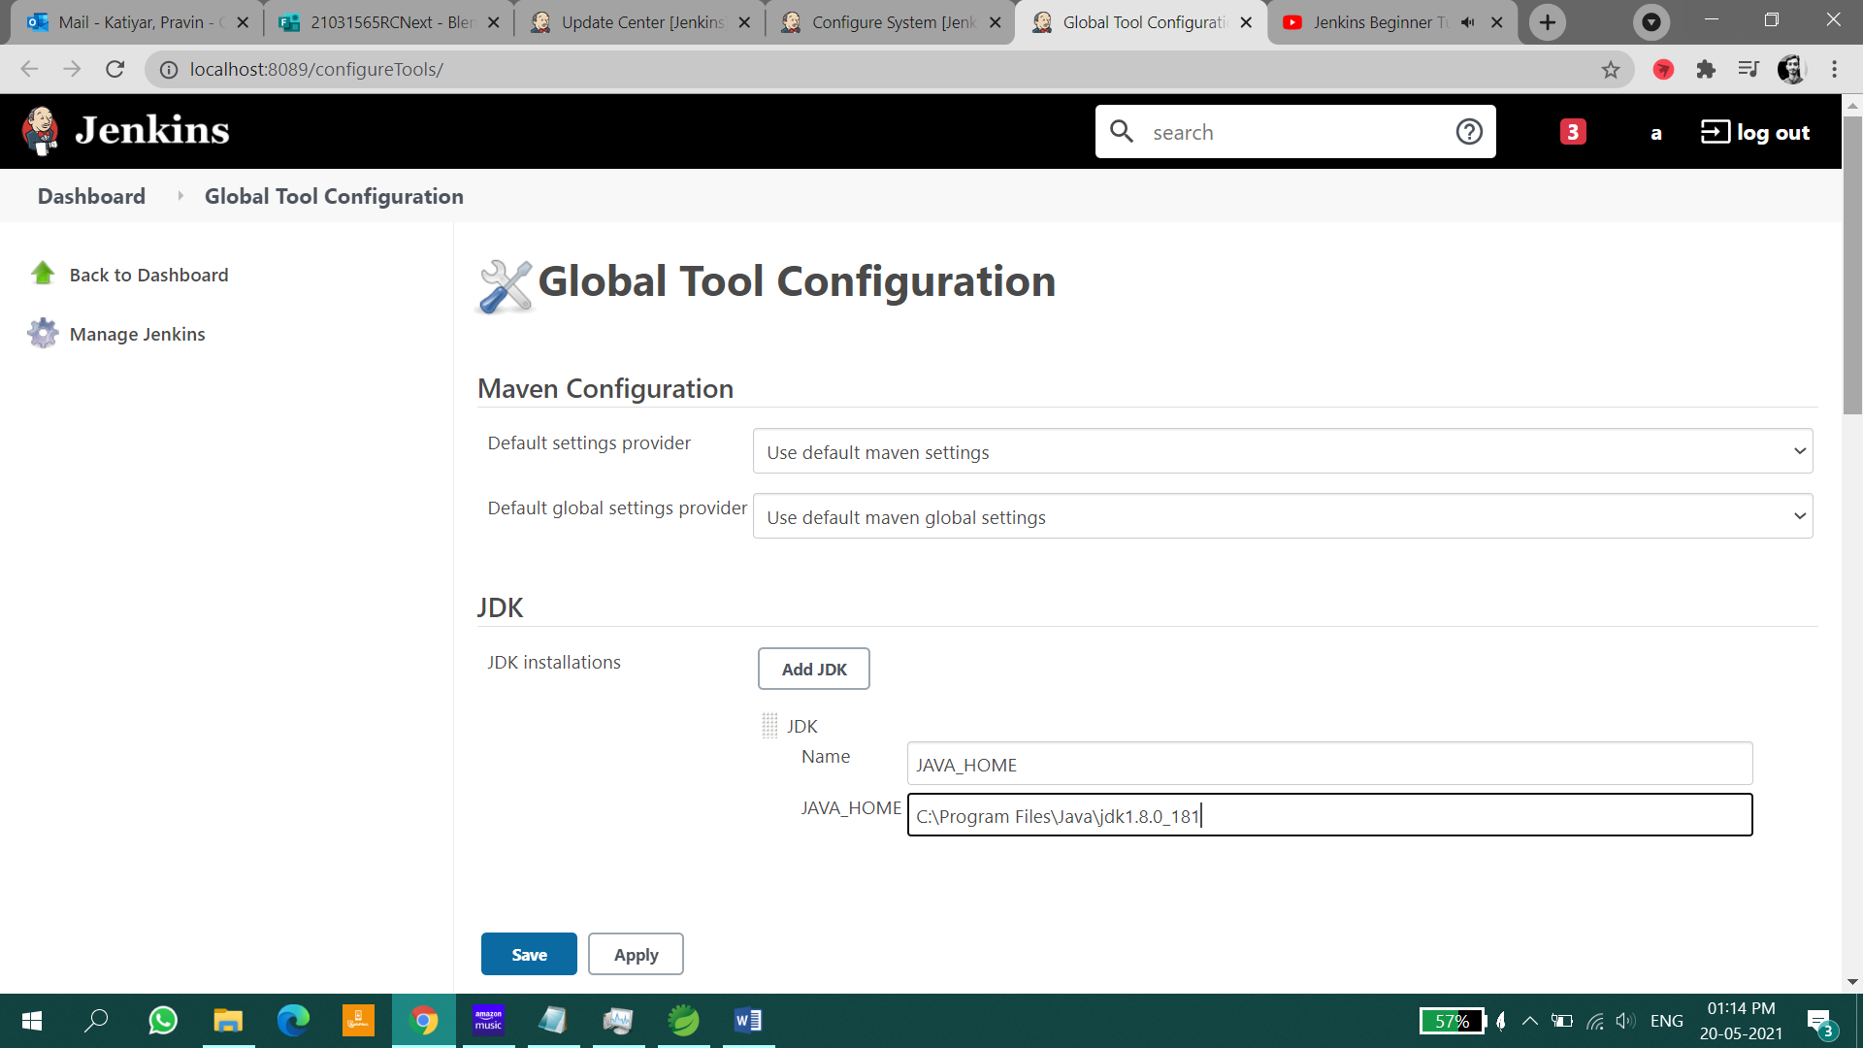

Later in **Maven** click on **Maven** **installations** and in the **MAVEN_HOME** field provide your maven path (C:\Program Files\apache-maven-3.6.3) and the **name** can be anything. Can see in the below image.

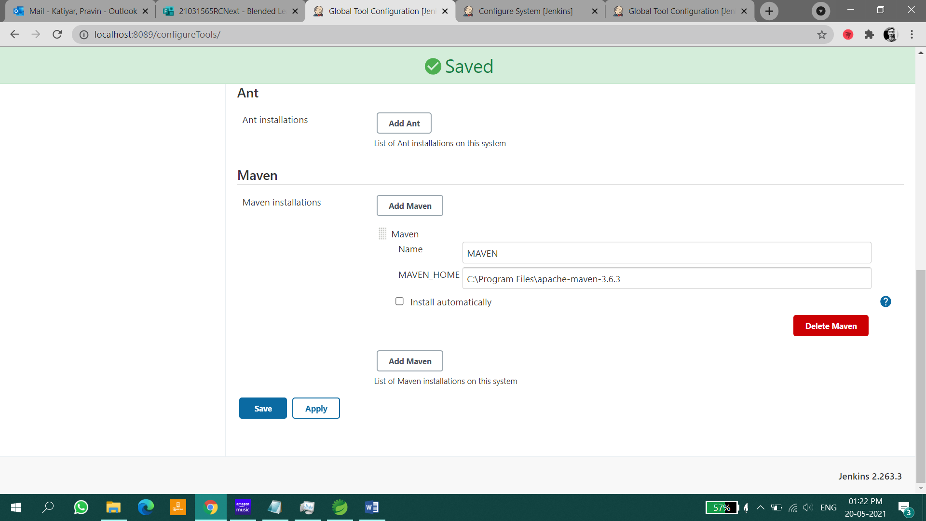

Click **Apply** button and click on **save**.

Go back to Jenkins home page.

# CREATING FIRST JENKINS JOB

Select a new Item on dashboard

Enter the Item name

Select Freestyle projects

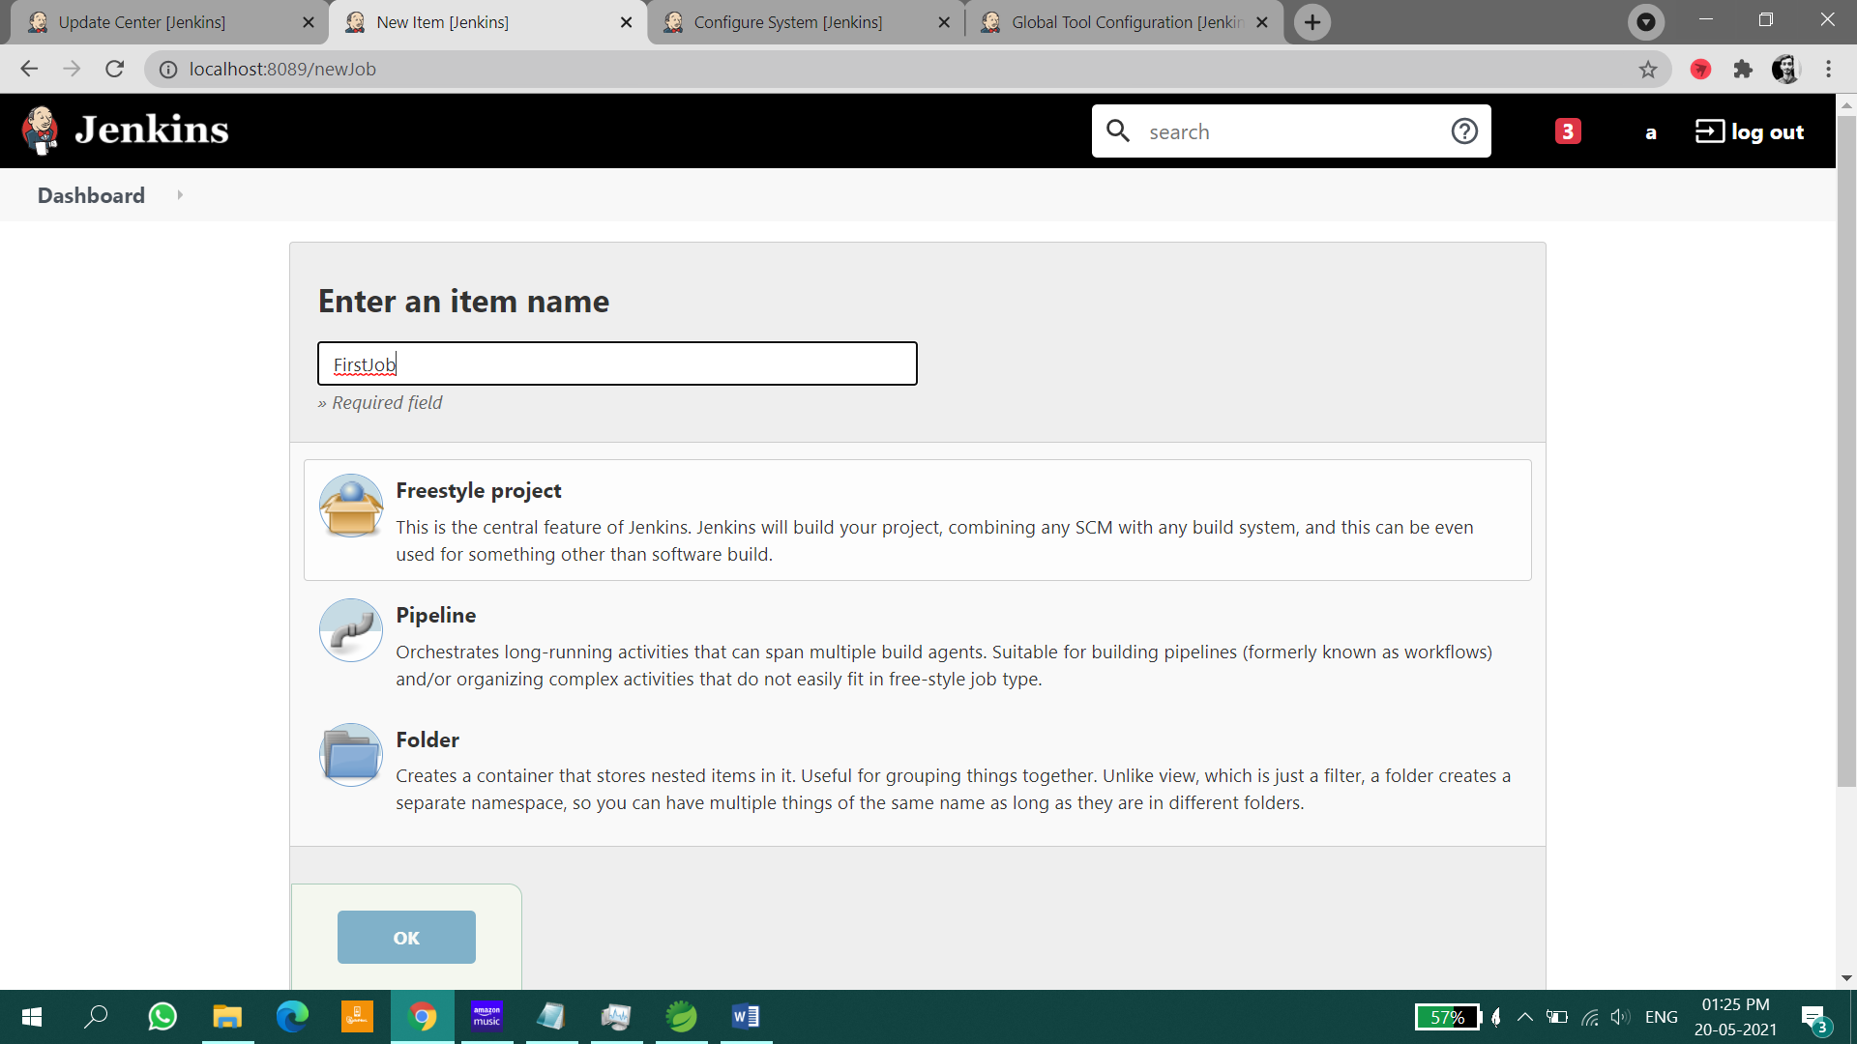

Scroll down to build section

Click “Add Build Step”, select execute windows batch command

Write echo "This is first Job!!"

Click apply and save

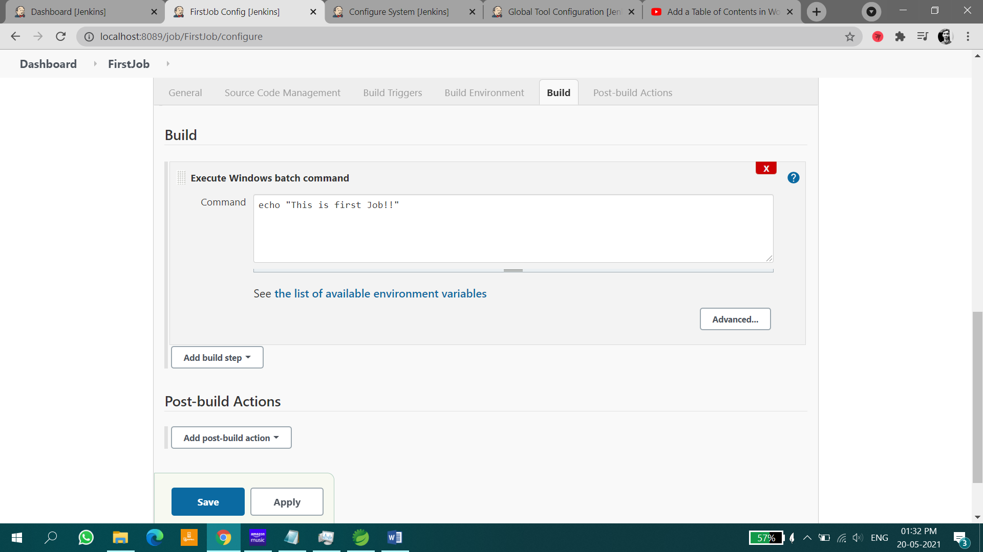

Click on “Build Now”

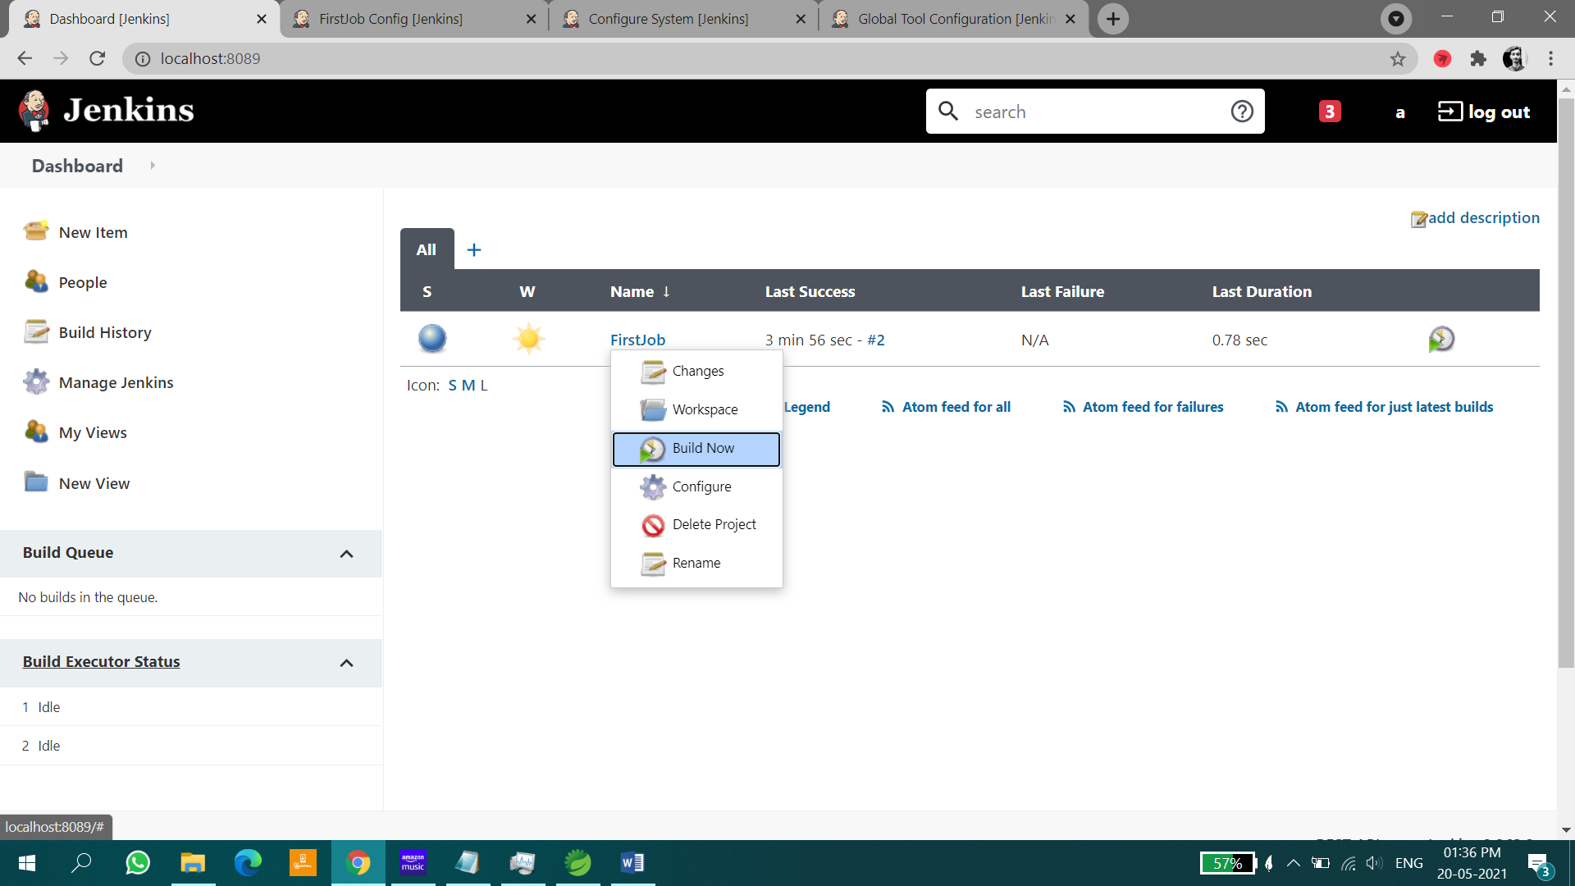

Click on “Console output” to see output by build.

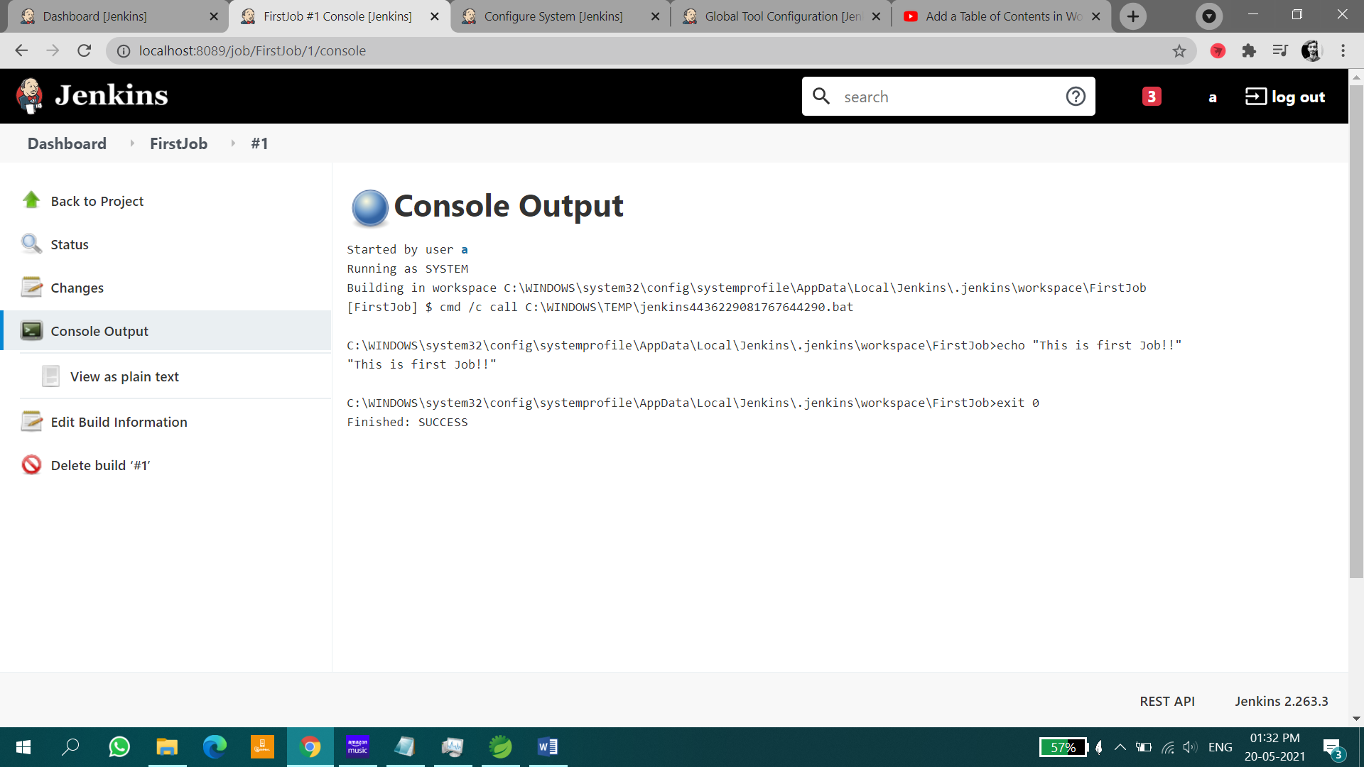

# USING CUSTOM WORKSPACE (LOCAL STORAGE) NOT SCM

Step 1:

Click on New Item link located within the left menu bar.

Enter an item name that you want to give for your project. Click on Freestyle project and then click on OK button.

**Step-2**

Go back to jenkins home page there you can see your project. Open your project and click on configure link located within the left menu bar.

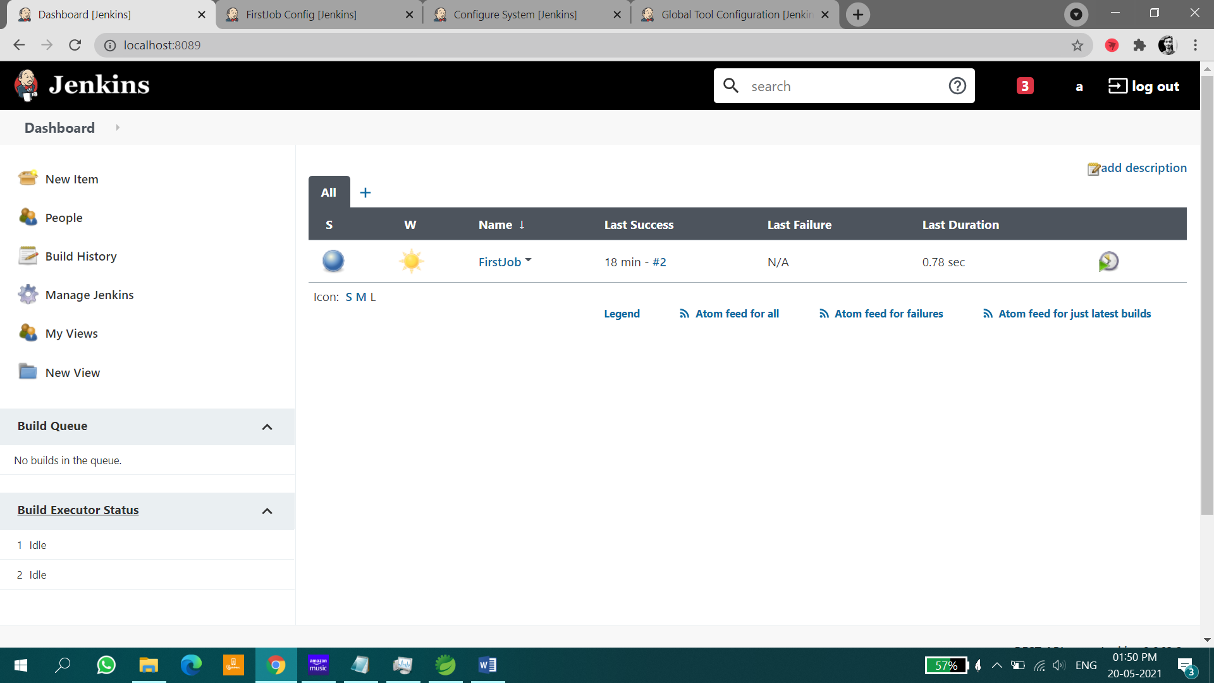

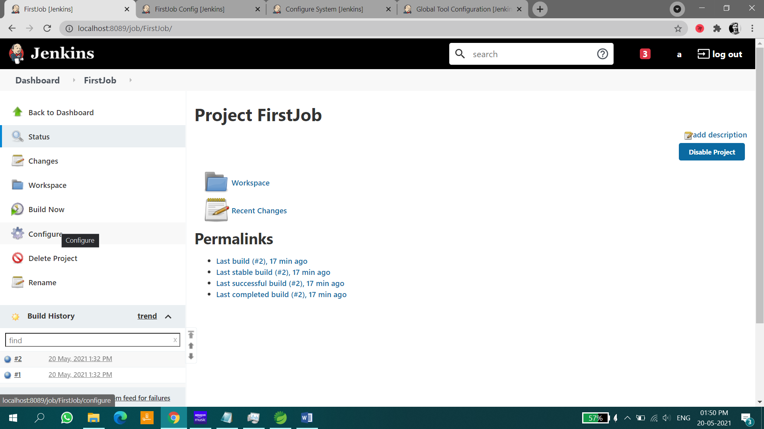

Then you will be redirected to a page where you need do some configurations. In the **General** section you can see a **description** text box enter description about your project.

Later if you scroll down you can locate a **advanced** button click on the button and later select Use **custom workspace** as shown in the below figure and provide your project location in the **Directory** field and the **Display name** can be anything.

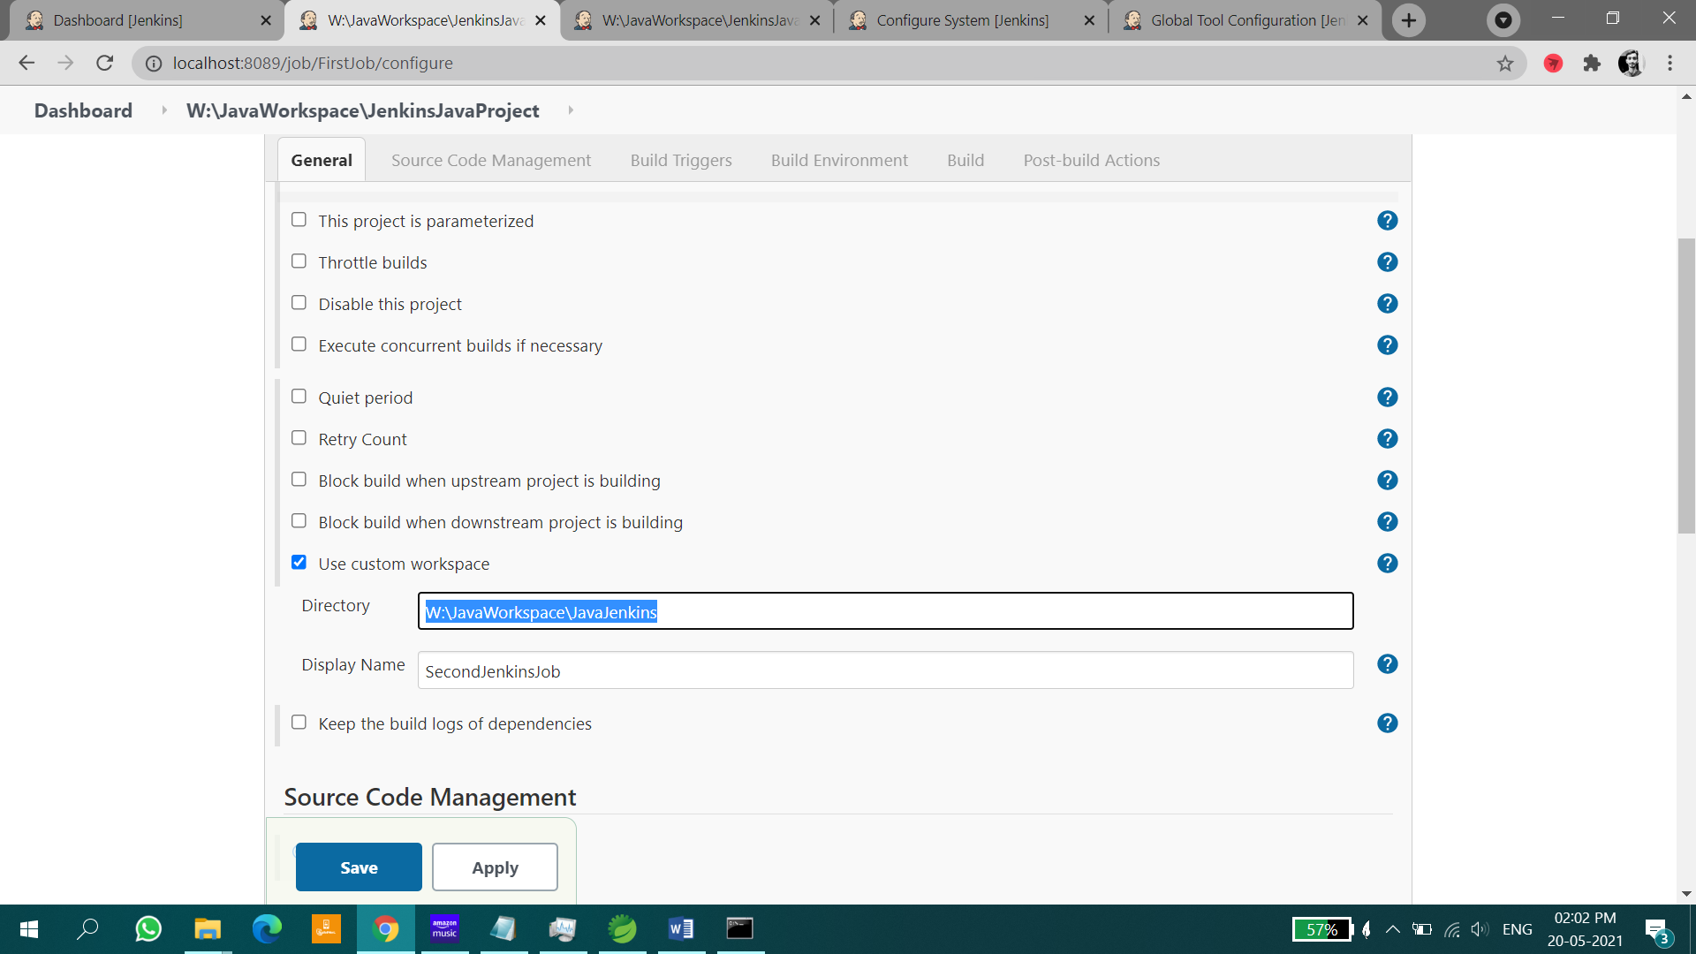

Down to that you can locate **Source Code Management** in that select **None.** As shown in the below image.

Later if you scroll down you can locate **Build** in that click on **Add build setup** button and select the **Maven Version** from the drop down and in the **Goals** field enter package. As shown in the below image.

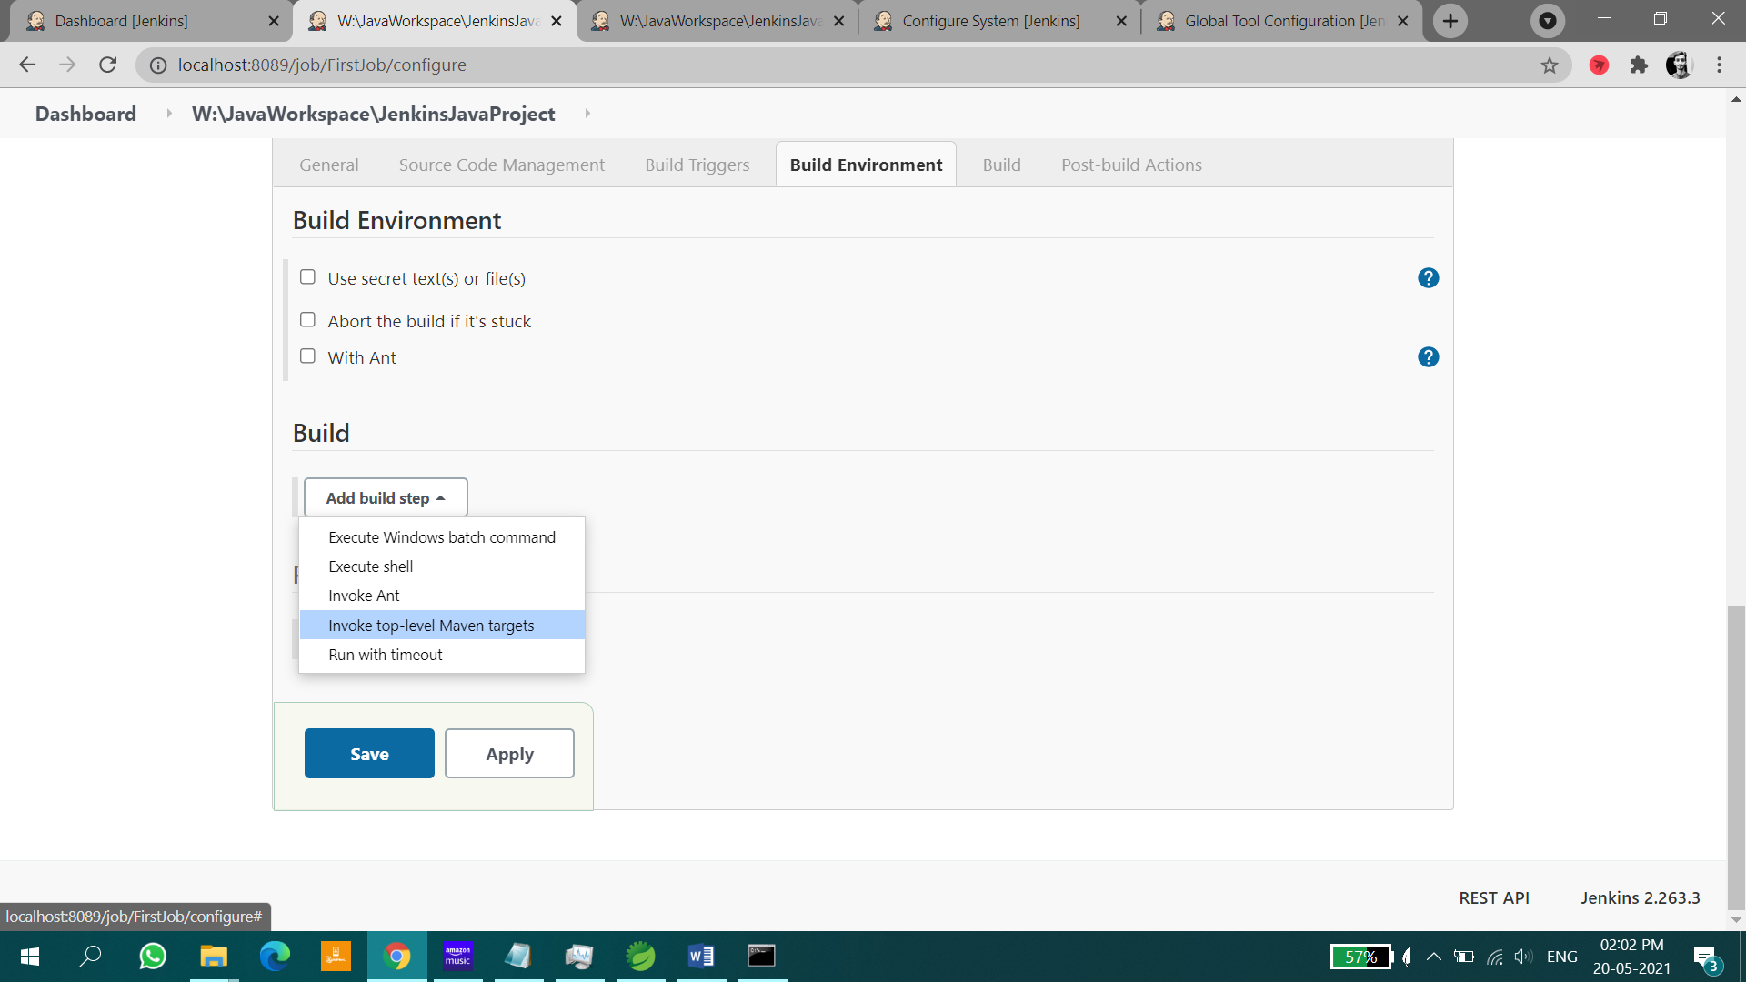

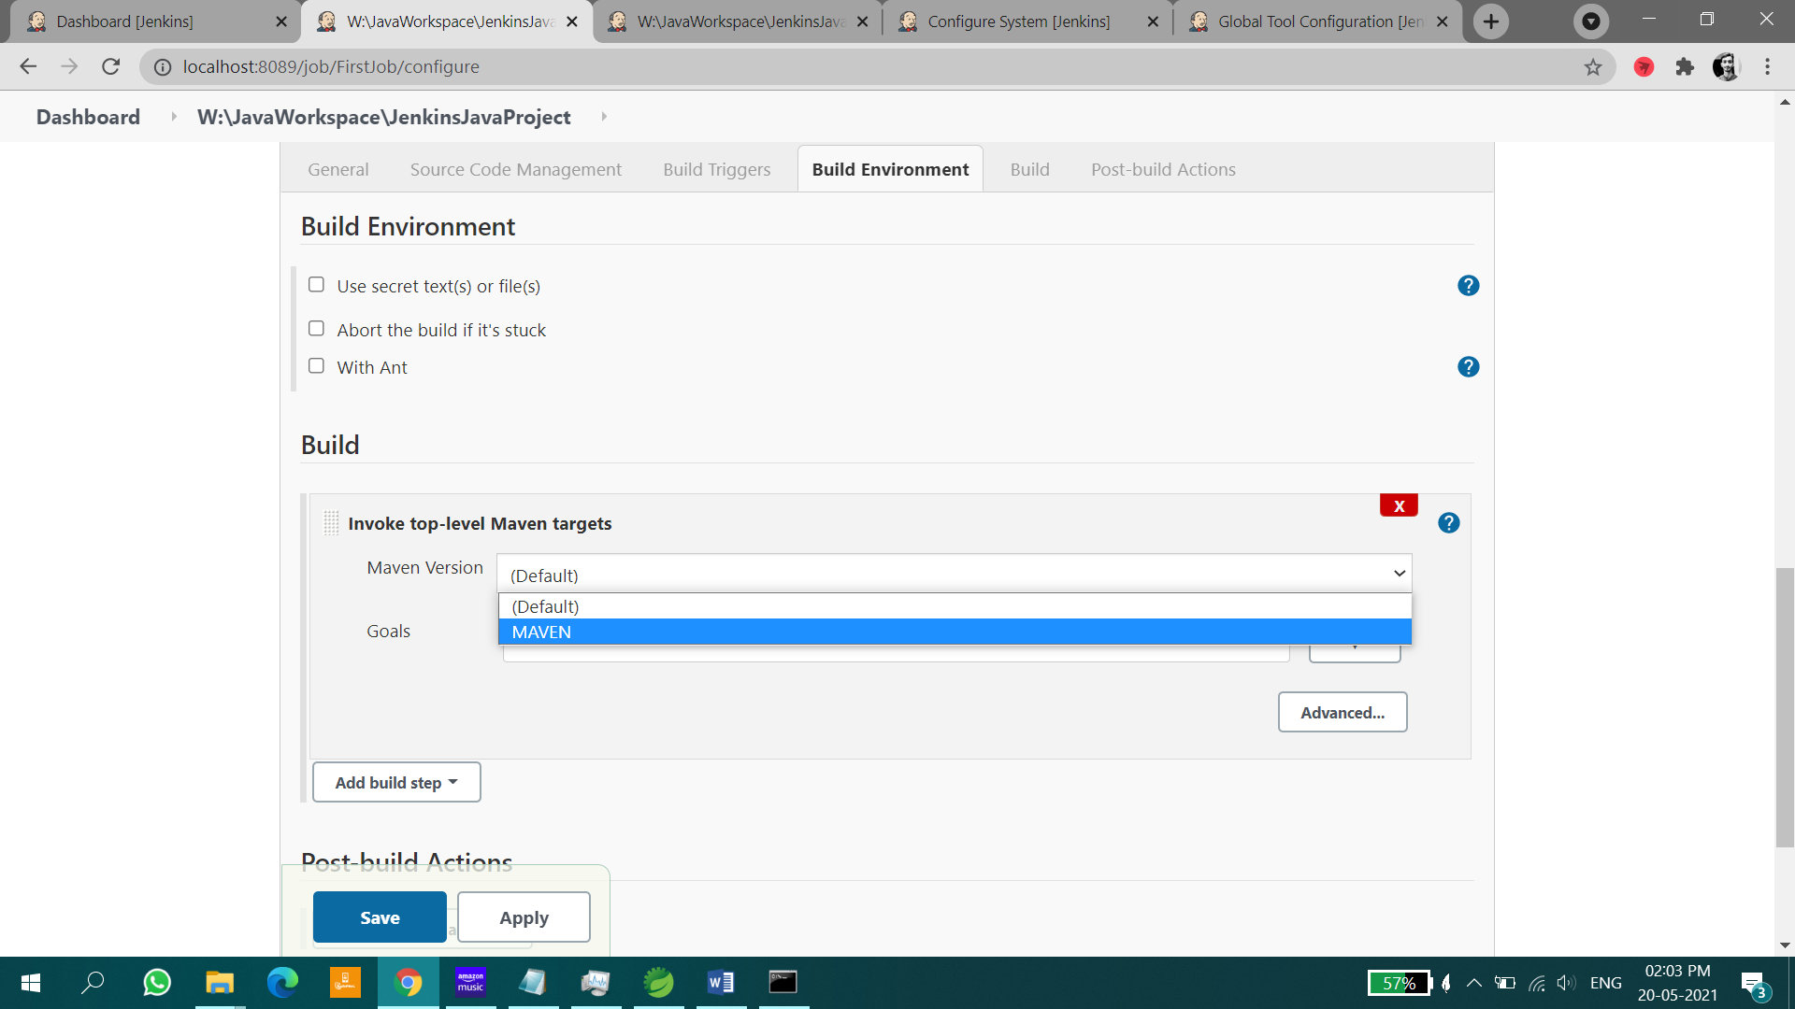

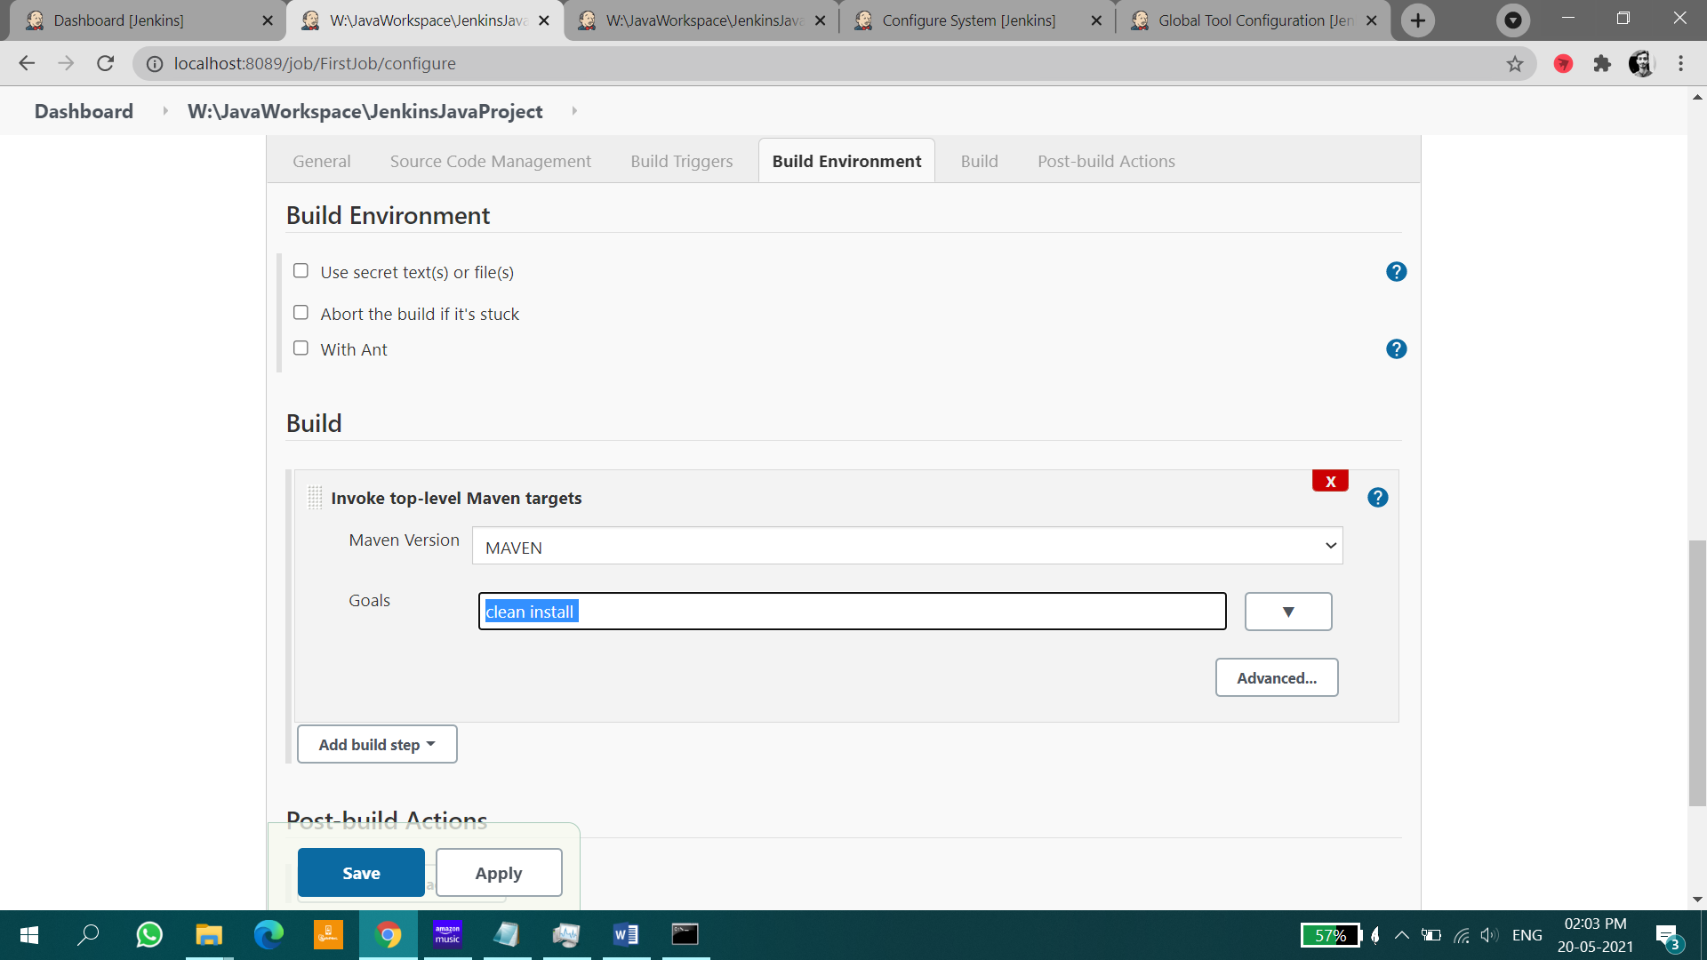

Click on **Apply** button and later click on **Save.**

Go back to jenkins home page.

**Step-4**

Open your project by clicking on your project name displayed in jenkins home page.

Click on **Build Now** link located within the left menu bar. Then project build will be started you can see it in **Build History** located below the left menu bar. As shown in the below image.

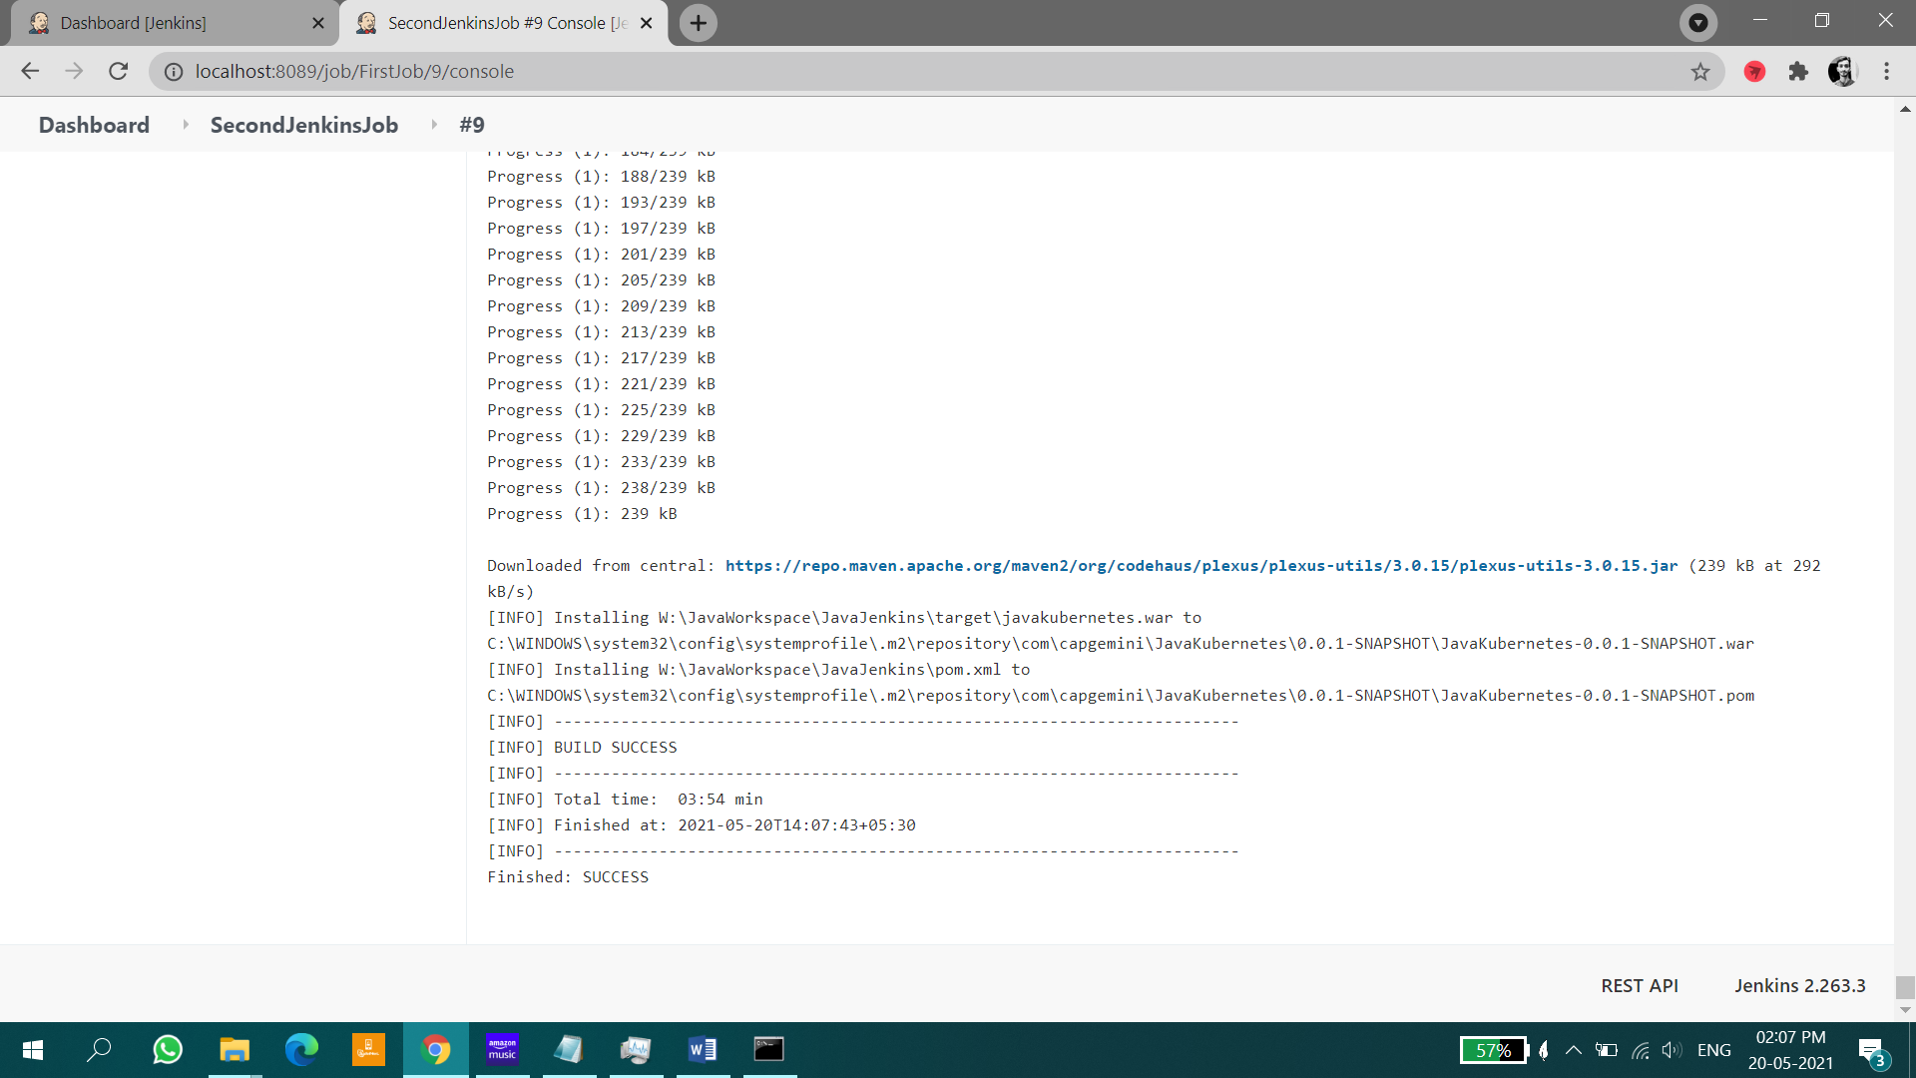

Later click on specific build and click on Console Output there you can see your build output as show in the below image.

After successful build you can see a war file generated in target folder of your work space. As shown in below image.

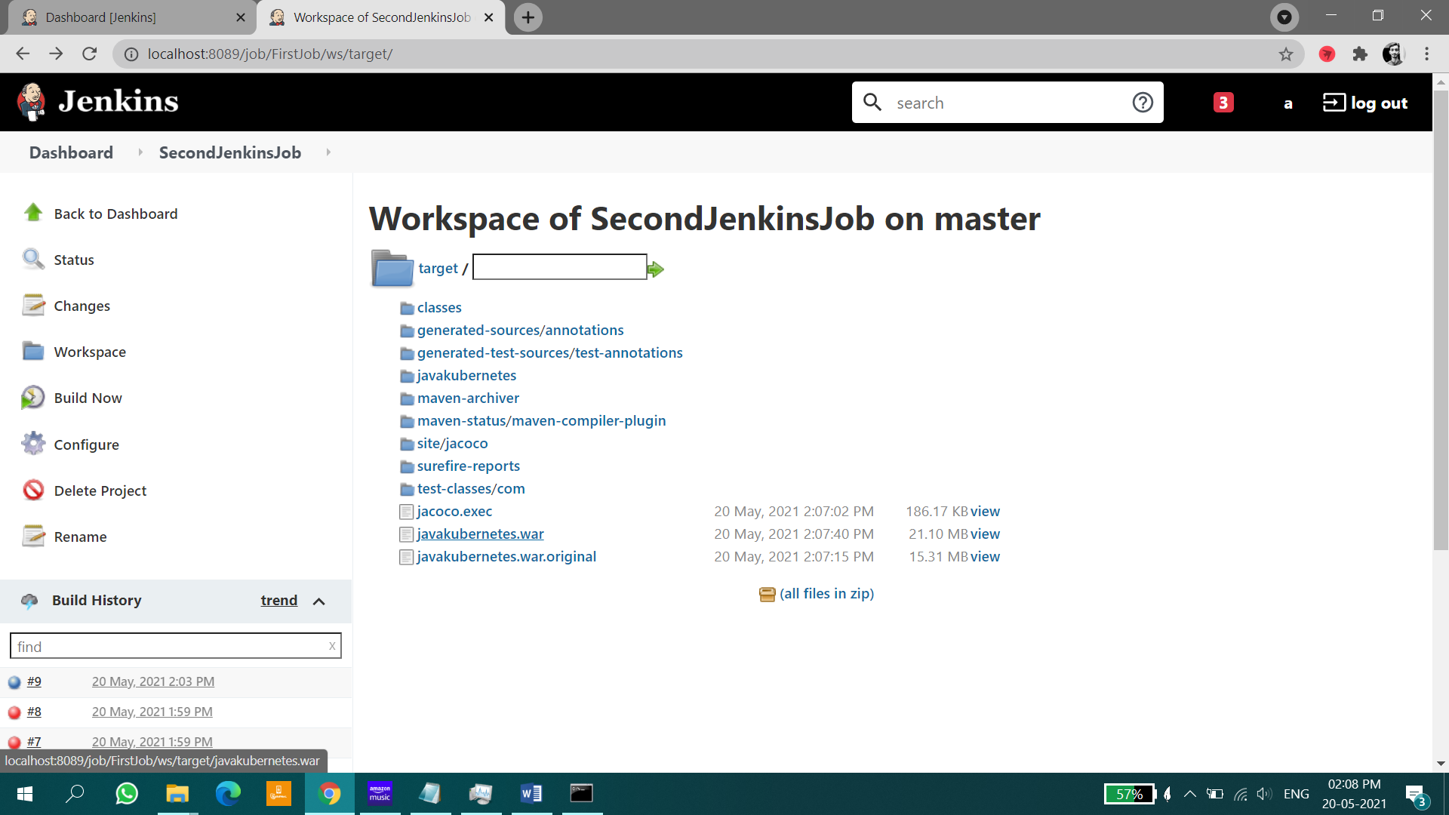

# CRON JOBS

Down to that you can locate **Build Triggers** in that select **poll SCM** and in the **Schedule** text box enter 5 stars with space (* * * * * ) as shown in the below image.

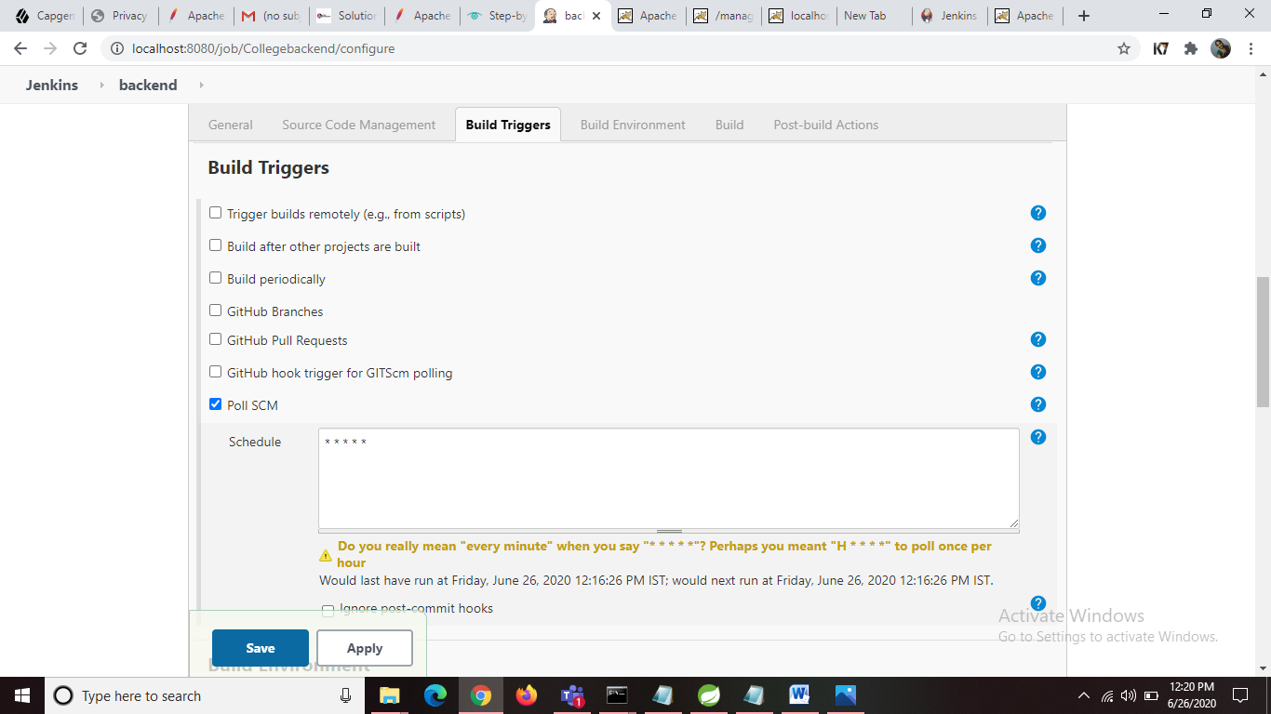

# APACHE TOMCAT INSTALLATION

Click on the below link

<https://tomcat.apache.org/>

Scroll down a little to locate and click on the [Tomcat 9 link](https://tomcat.apache.org/download-90.cgi) located within the left menu bar.

Next, locate the [32-bit/64-bit Windows Service Installer](https://www-eu.apache.org/dist/tomcat/tomcat-9/) link and click on it.

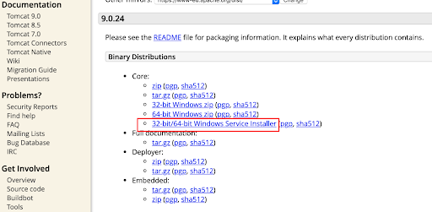

By clicking on it download will be automatically started. Open the downloaded installer and start installing tomcat in your pc.

Please change the port at configuration step of installation because tomcat default port number is also 8080 as jenkins is already running in 8080 change the port number and set username and password.

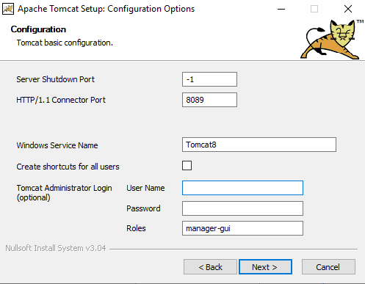

Continue installing tomcat after successful installation you can see tomcat running in port number that you have specified.

Now you have to deploy war file on Tomcat using jenkins for that you need to add below line in

Tomcat server folder🡪 conf 🡪 tomcat-users.xml and change username and password.

<user username="admin1" password="admin" roles="manager-script" />

# INTEGRATION OF TOMCAT WITH JENKINS

Now open jenkins home page and click on Manage Jenkins link located within the left menu bar. And Select Manage Plugins and in the Available section search for deploy and select Deploy to container Plugin and click on Install without restart.

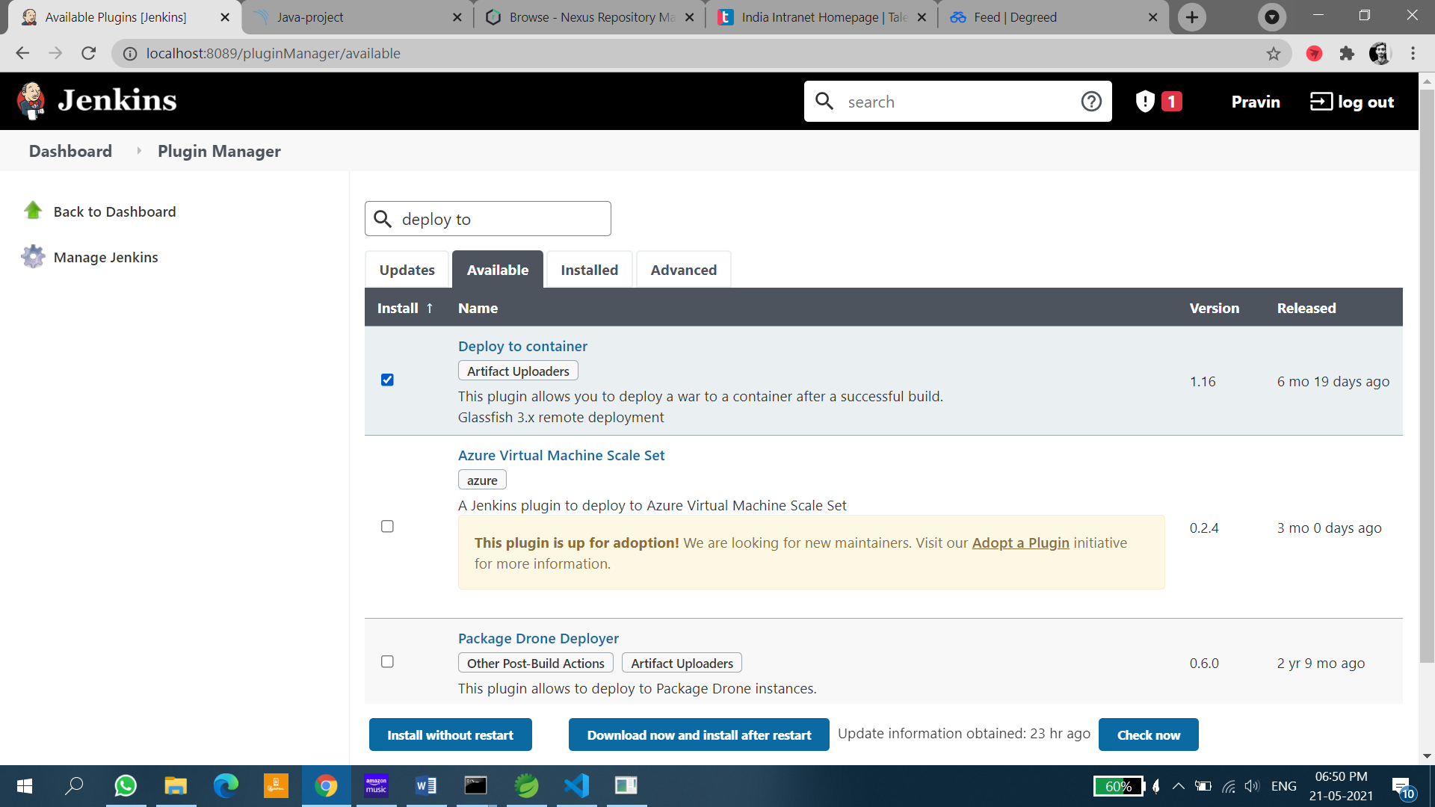

Later open project configure and scroll down at last you can see Post-build Actions in that click on Add post-build action and in WAR/EAR files field give your war file name in the context path field give any name. In containers add Tomcat URL where your tomcat is running and Add credentials that you have added in the file in previous step. As shown in the below image.

*GLOB ANT FORMAT: **\*.war*

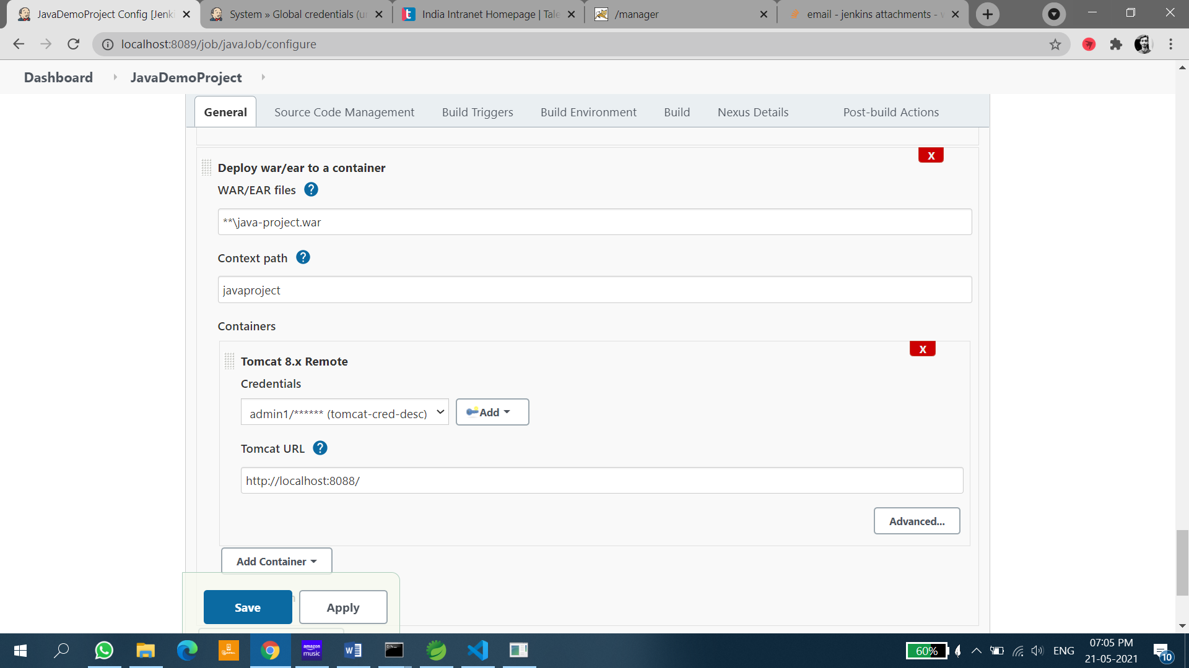

Click on **Apply** and click on **Save**.

**Step-6**

Go back and Click on **Build Now**.

If the Console Output you can see the result as shown in the below image.

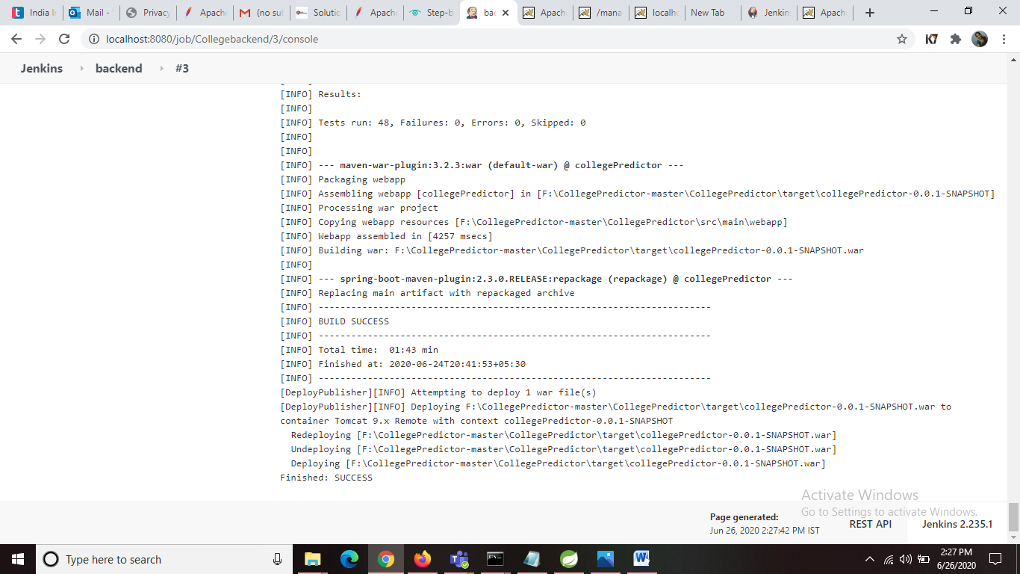

If the Build is success open localhost where your tomcat is running and click on **Manager App** button located in the right side as shown in the below image.

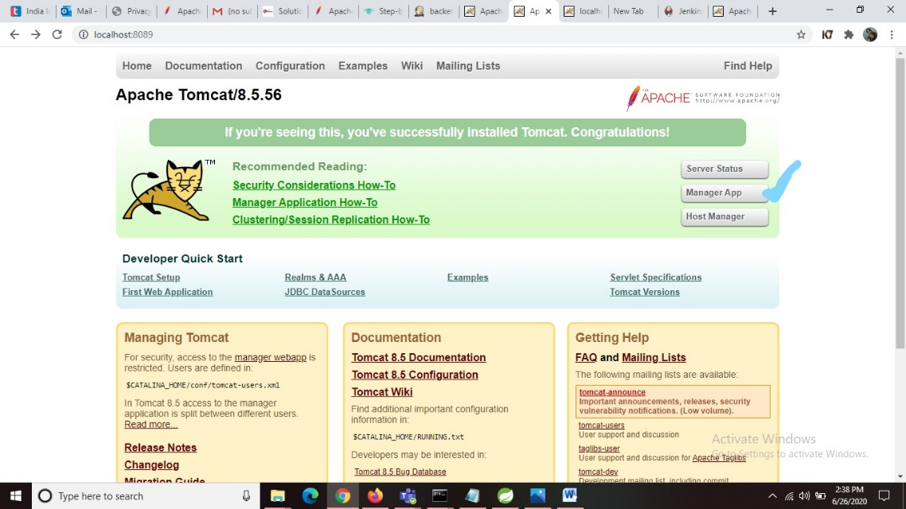

Then Tomcat Web Application Manager page will be opened. There in the Applications path you can see your project war file name that is deployed. As shown in the below image.

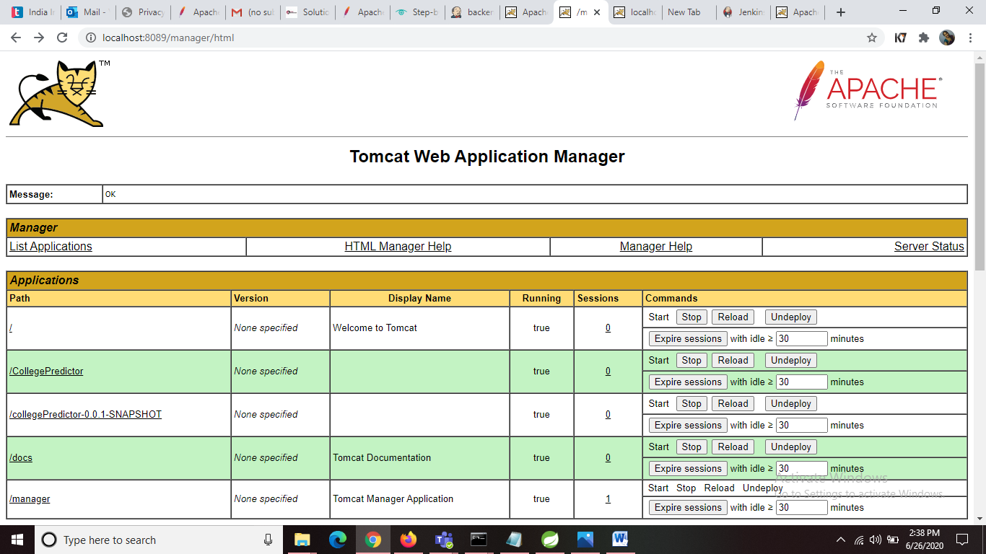

You can check its working by opening the link like below mentioned link for your project. Then you can view the result of your functionality.

# FILE SYSTEM SCM INTEGRATION WITH JENKINS:

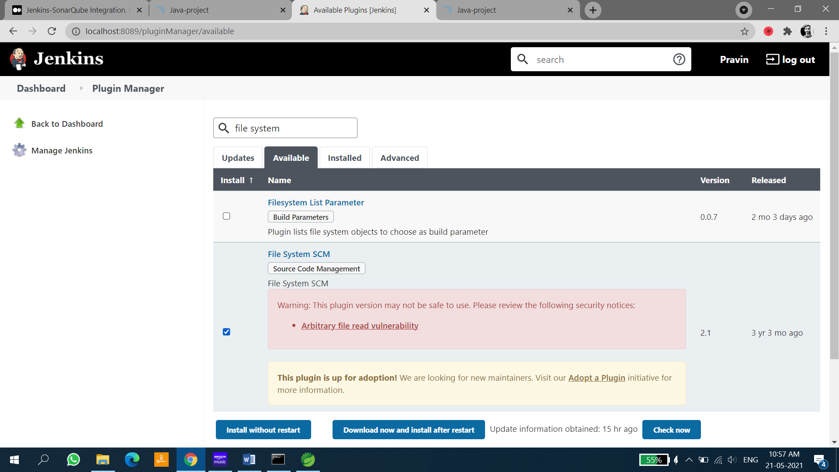

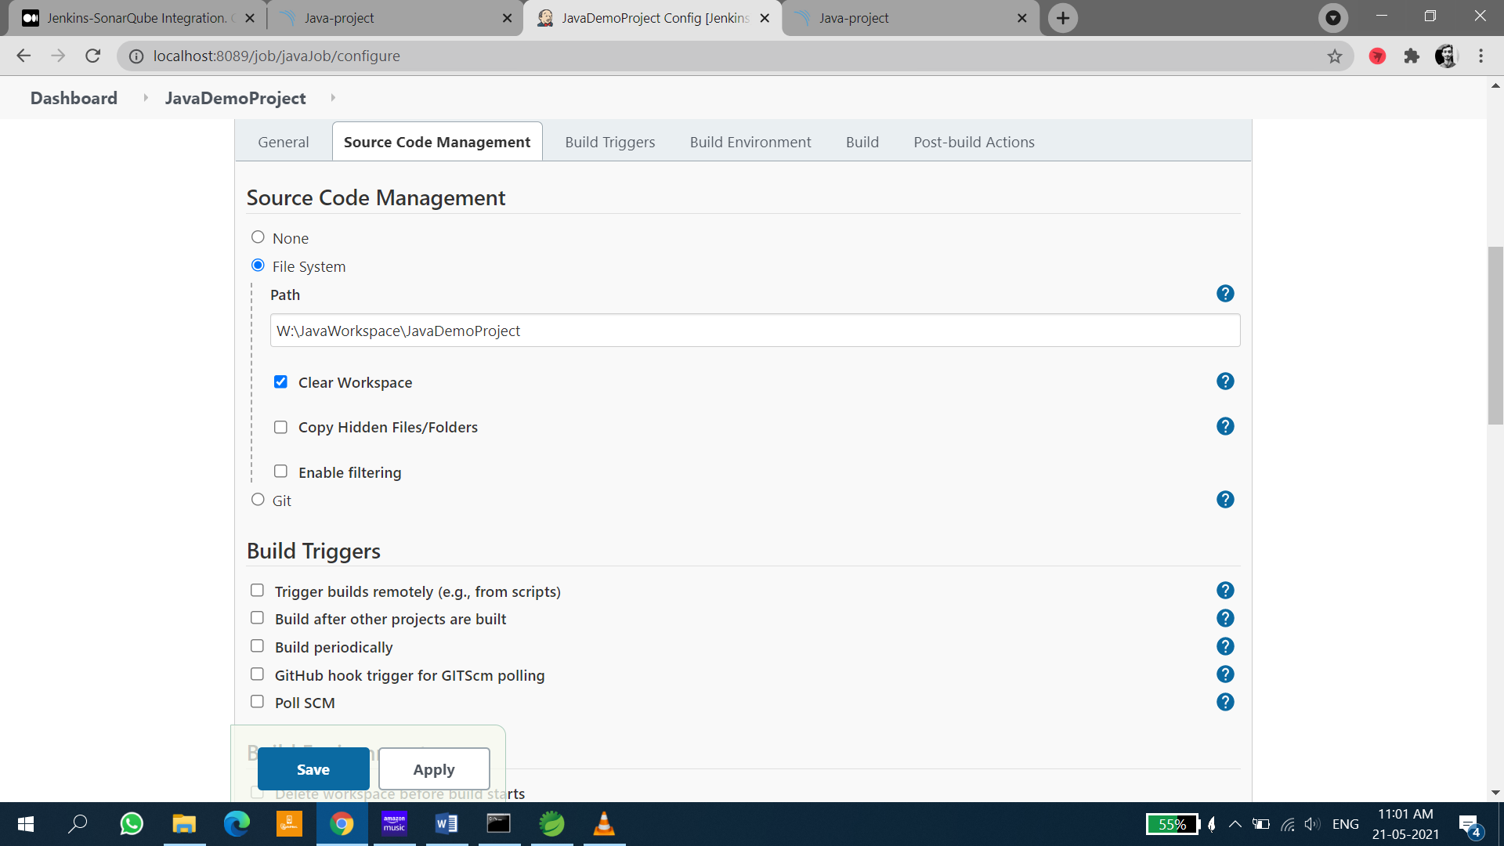

# GIT INTEGRATION WITH JENKINS

Install git on your pc

Install GitHub desktop on your PC

Create Git Repository

Push the code to the repository

I have used GitHub Desktop

Step 1: Go to manage =>Plugin Manager=>Search for “Git Plugin”.

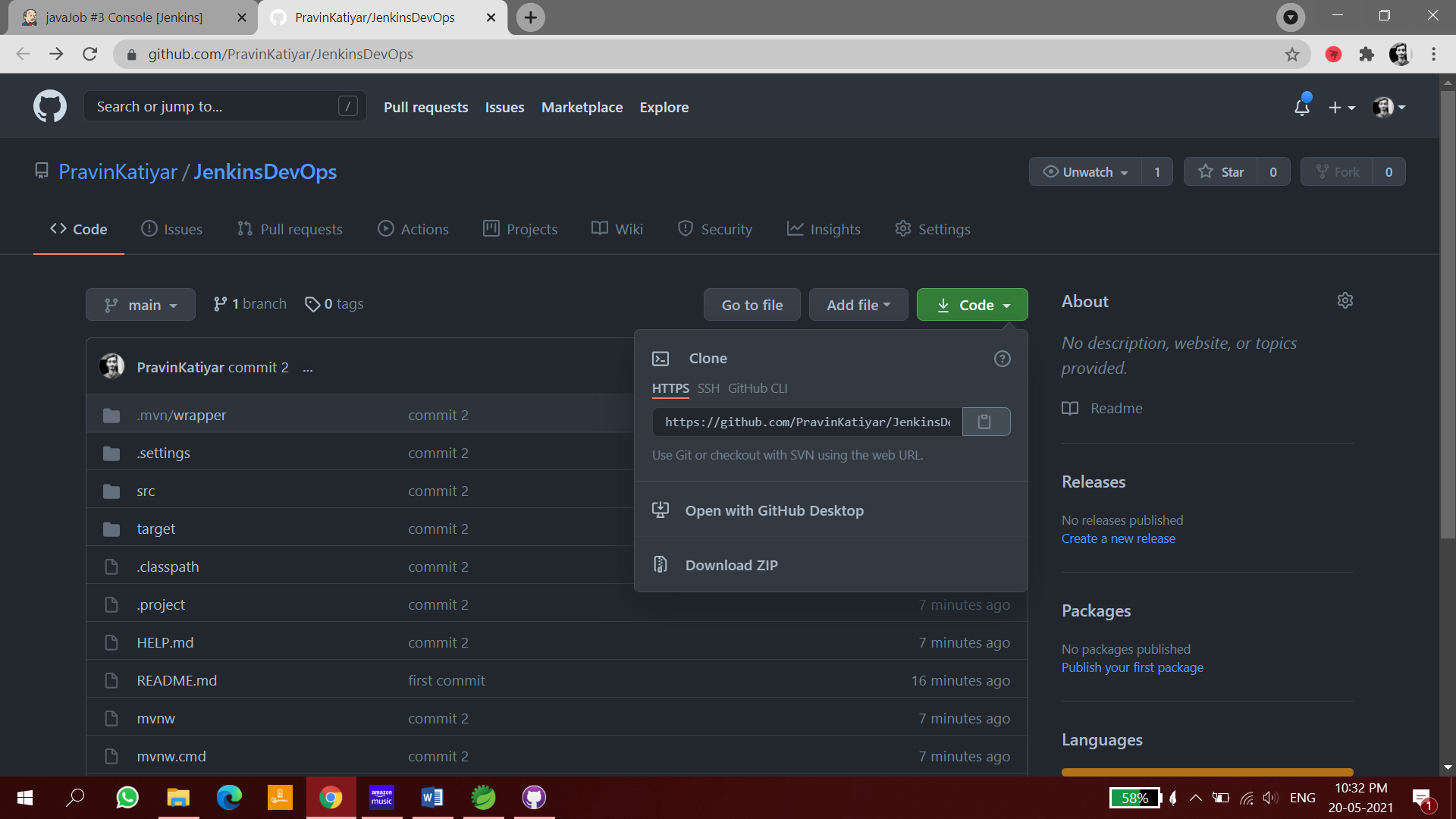

Install git Plugin

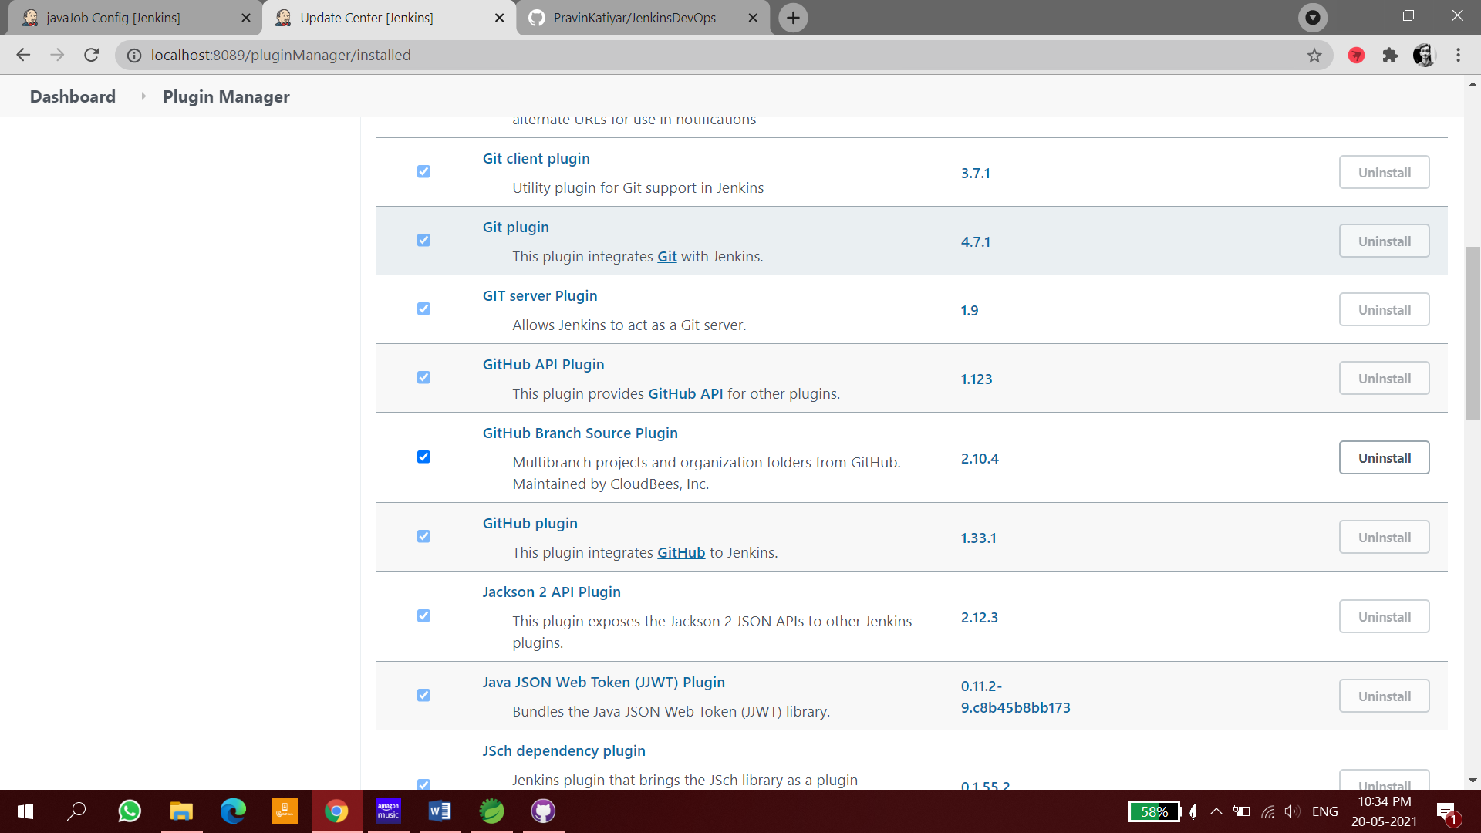

Configure git in Global tool configuration

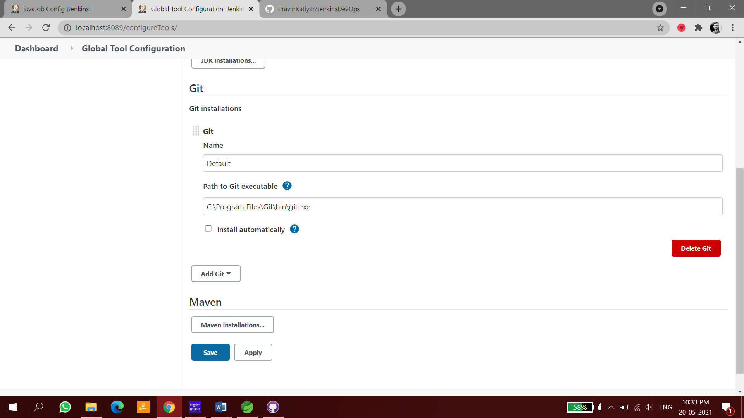

Open job and configure as given below

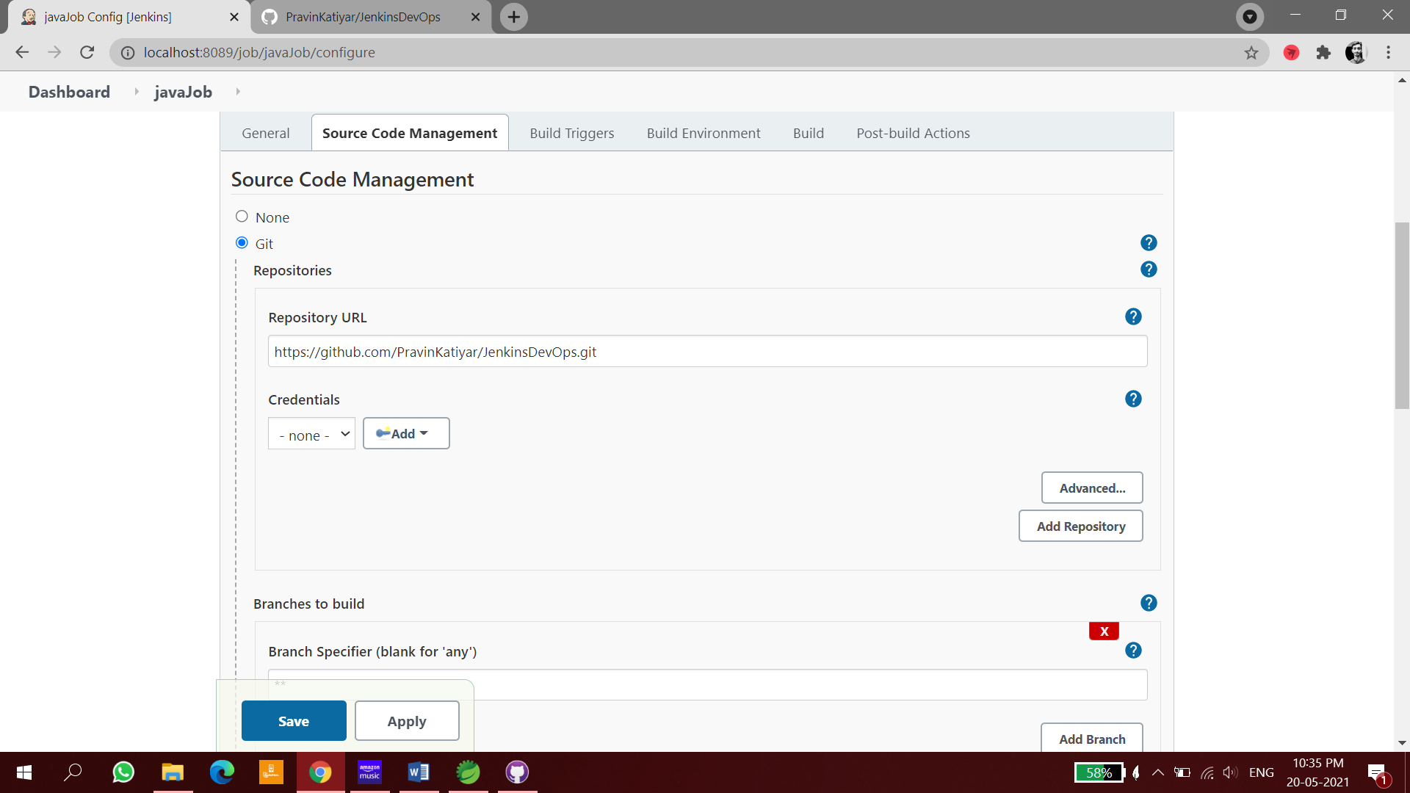

Invoke top level maven targets to just check is ( git + jenkins ) is working or not

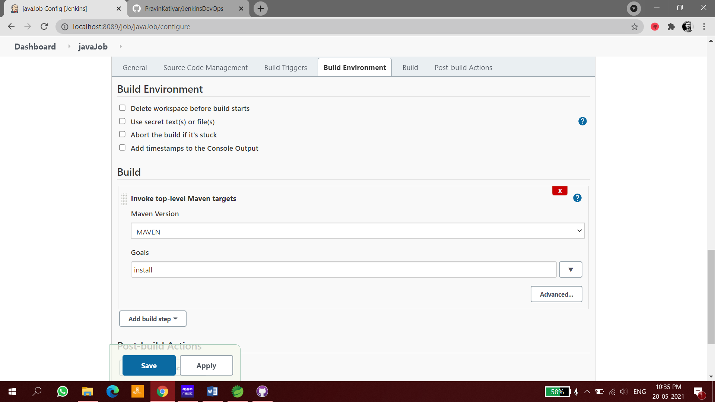

Save and run build

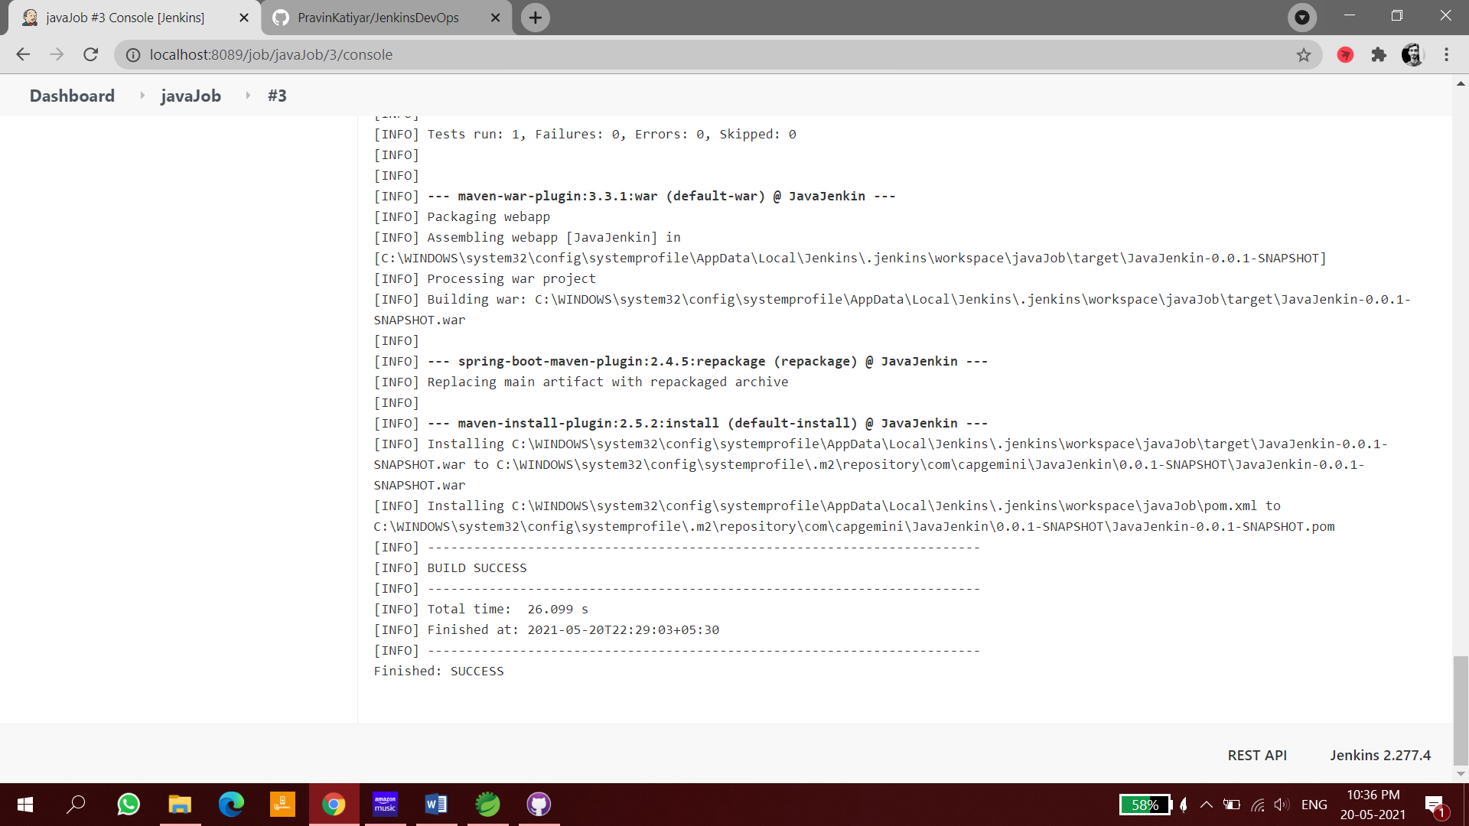

Its Successful.

# SONARQUBE INTEGRATION WITH JENKINS

Jenkins

Jenkins is an open source Continuous Integration system. It is a process in which developers puts their code in a shared repository and every time the automated cycle is performed from Build, Test and Deploy, etc.

## What is SonarQube?

SonarQube Integration is an open source static code analysis tool that is gaining tremendous popularity among software developers. It enables software professionals to measure code quality, identify non-compliant code, and fix code quality issues.

SonarQube enables developers to track code quality, which helps them to ascertain if a project is ready to be deployed in production. Further, it allows developers to continuously inspect the code, perform automatic reviews and run analysis to find code quality issues.

## Why should Integrating SonarQube and Jenkins Useful:

When you are working on a project and if are doing SonarQube analysis sometimes then you can do that easily but if the scenario changes to that SonarQube analysis will be performed after completion of each and every task or say deployment then the manual action would become hard to rely on. So, to overcome the problem of manual analysis with it,

SonarQube is integrated with Jenkins which performs automated tasks. Now, you have to only add your sonar script for analysis in Jenkins job to perform SonarQube analysis and you can perform this action as your requirements and also get a quality report of your code in SonarQube.

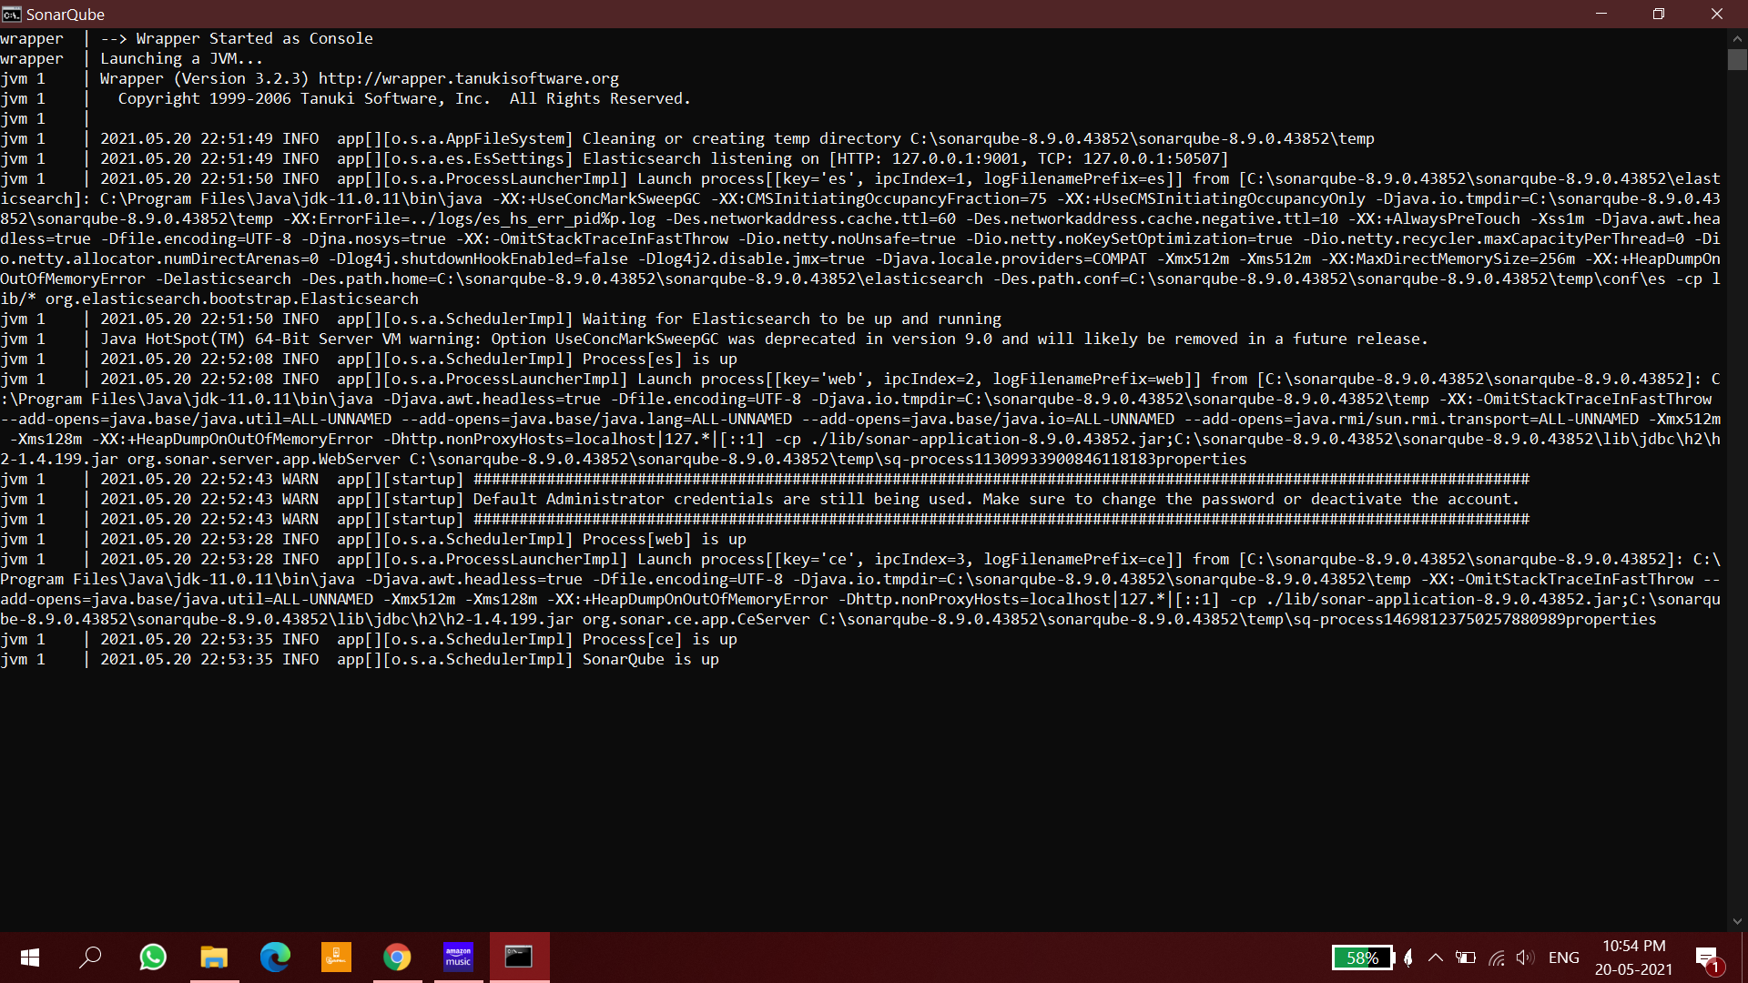

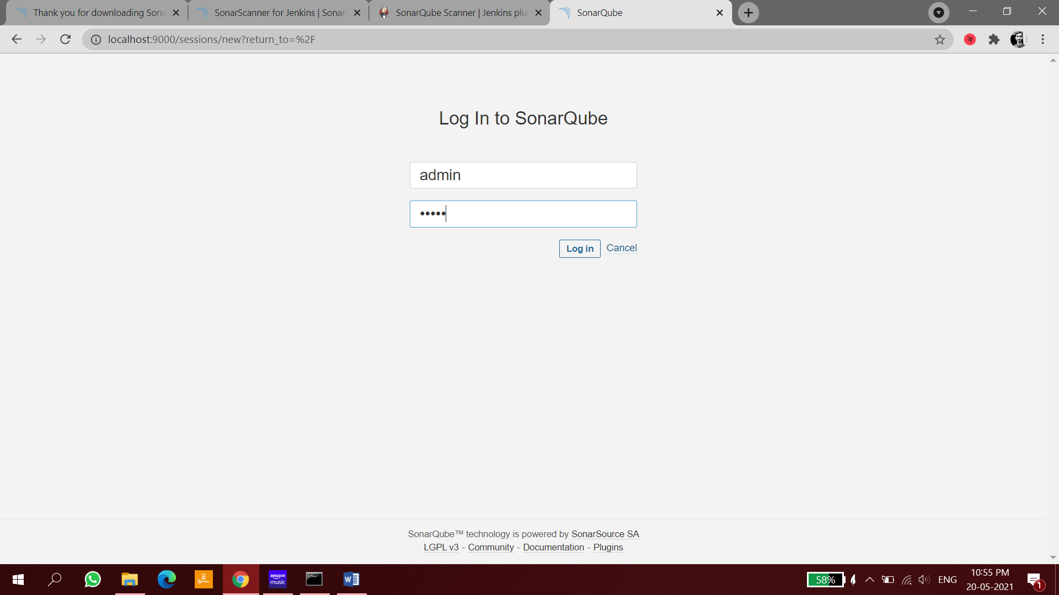

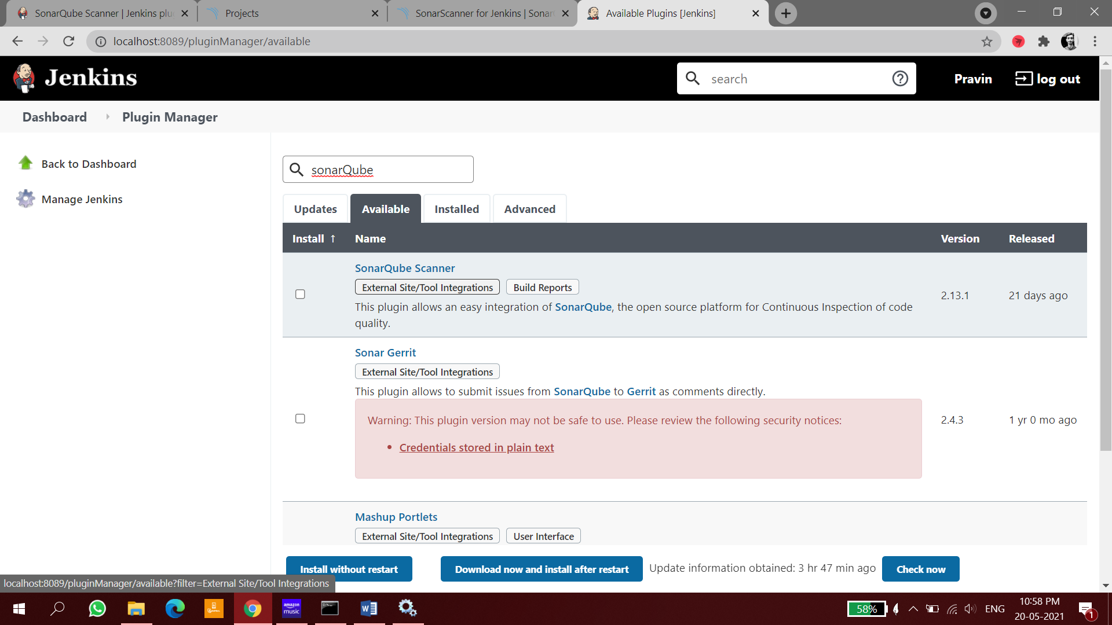

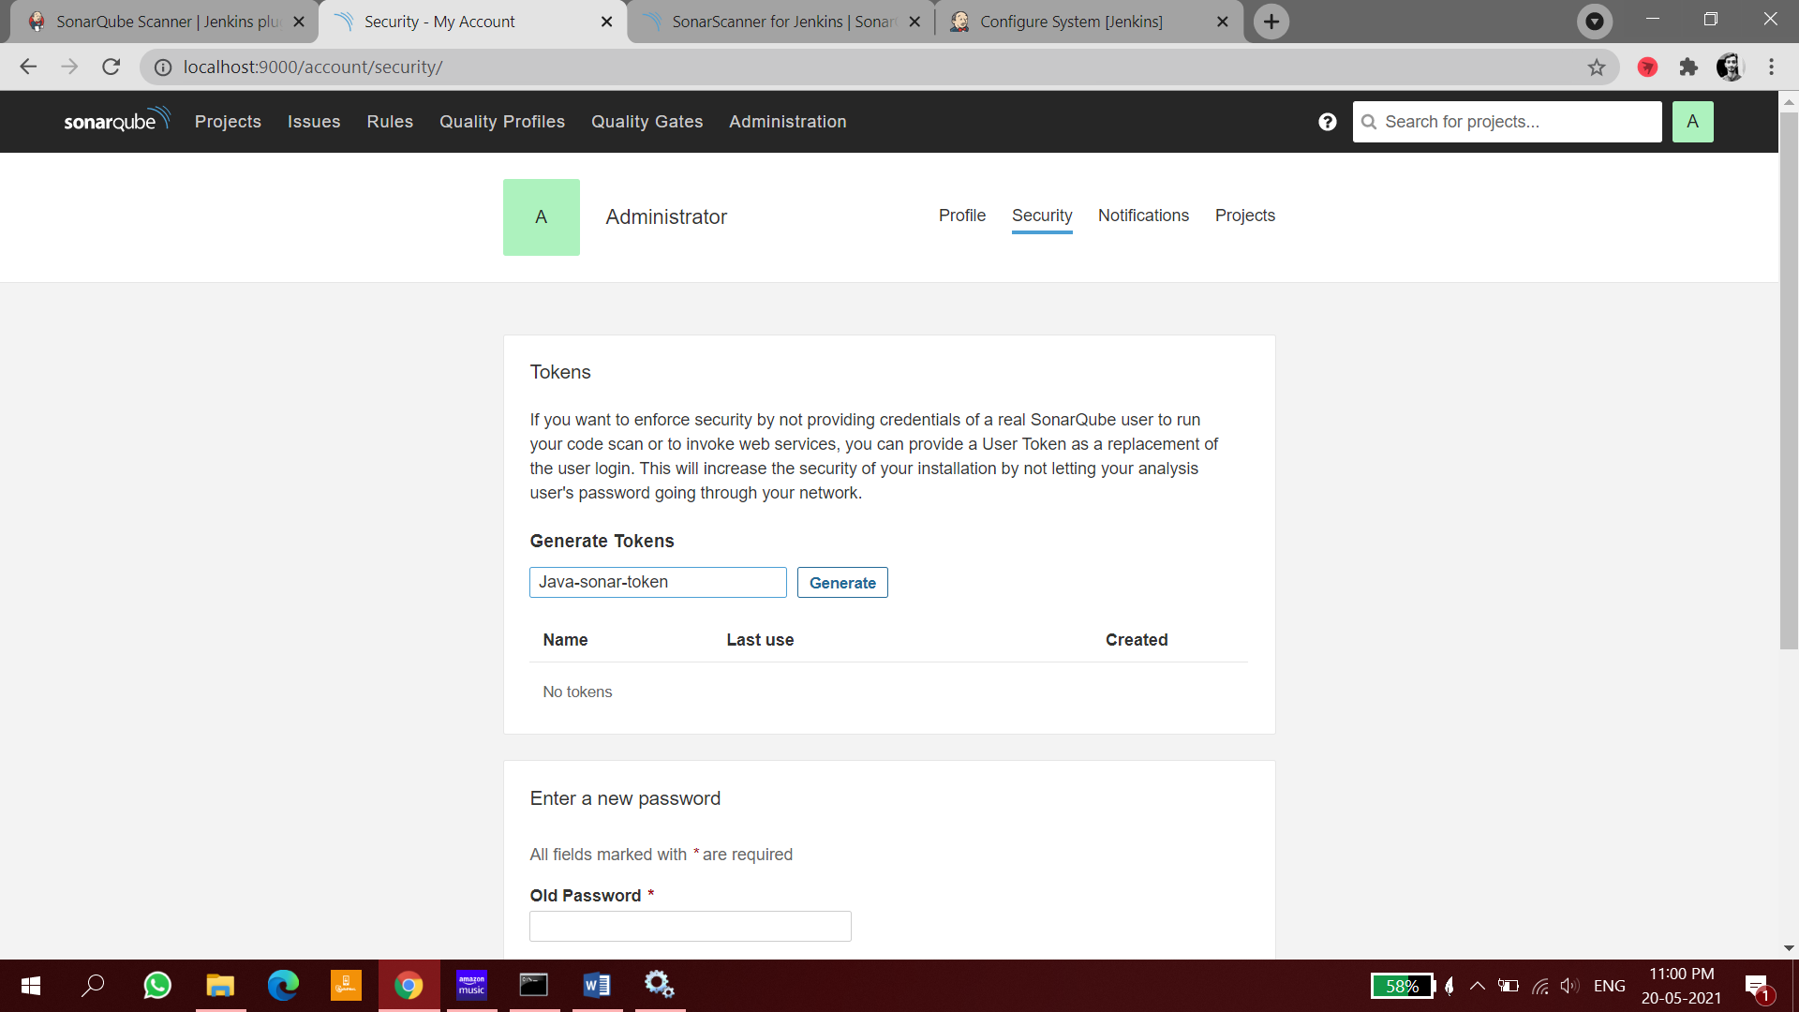

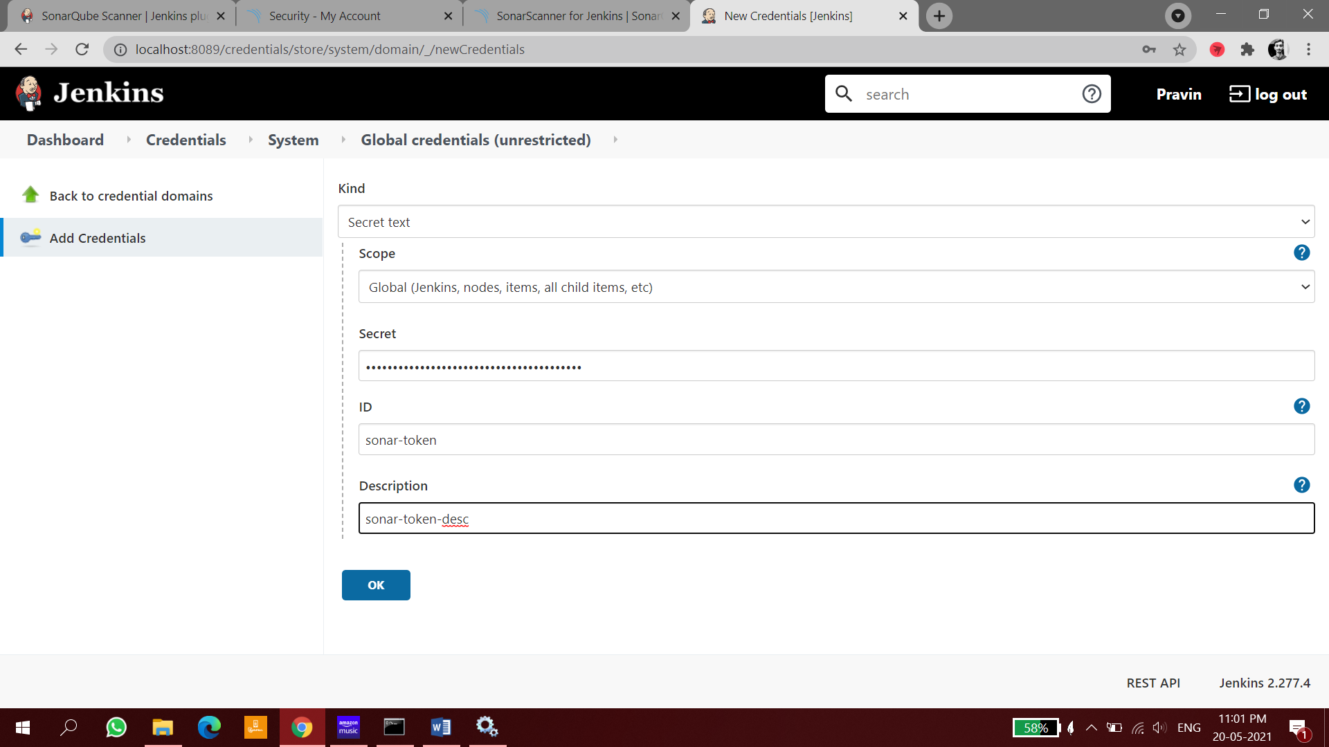

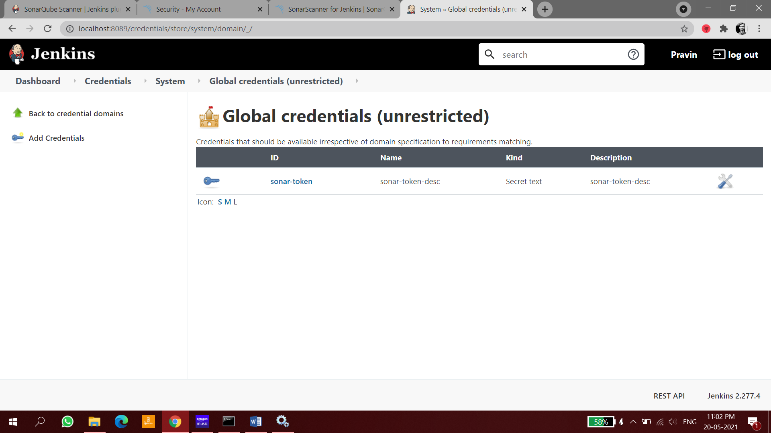

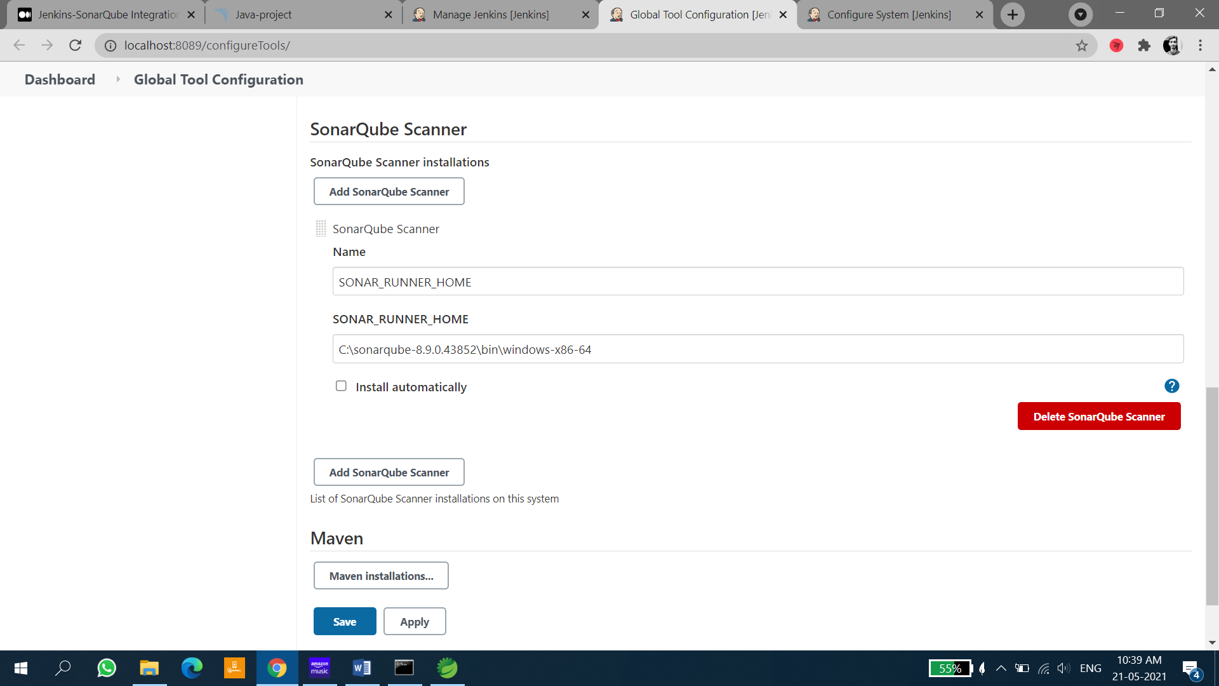

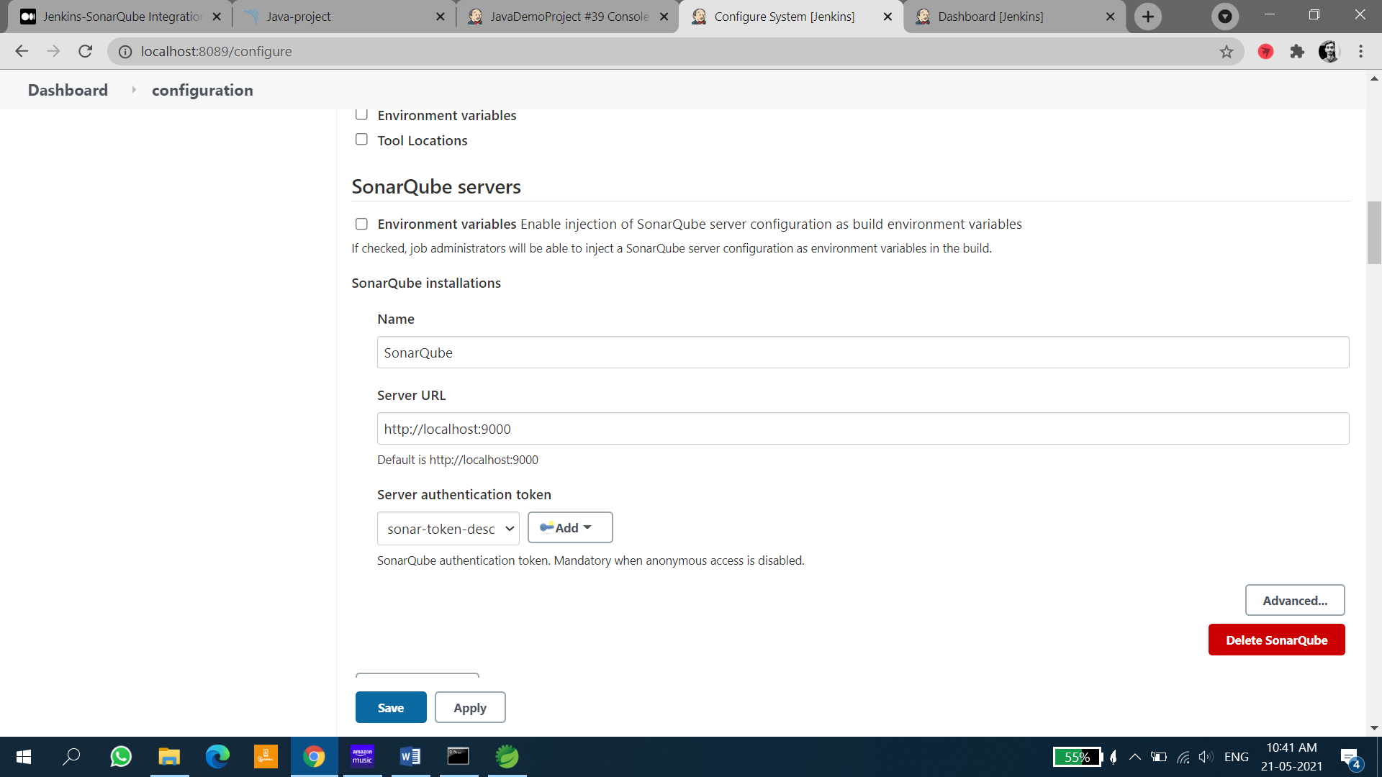

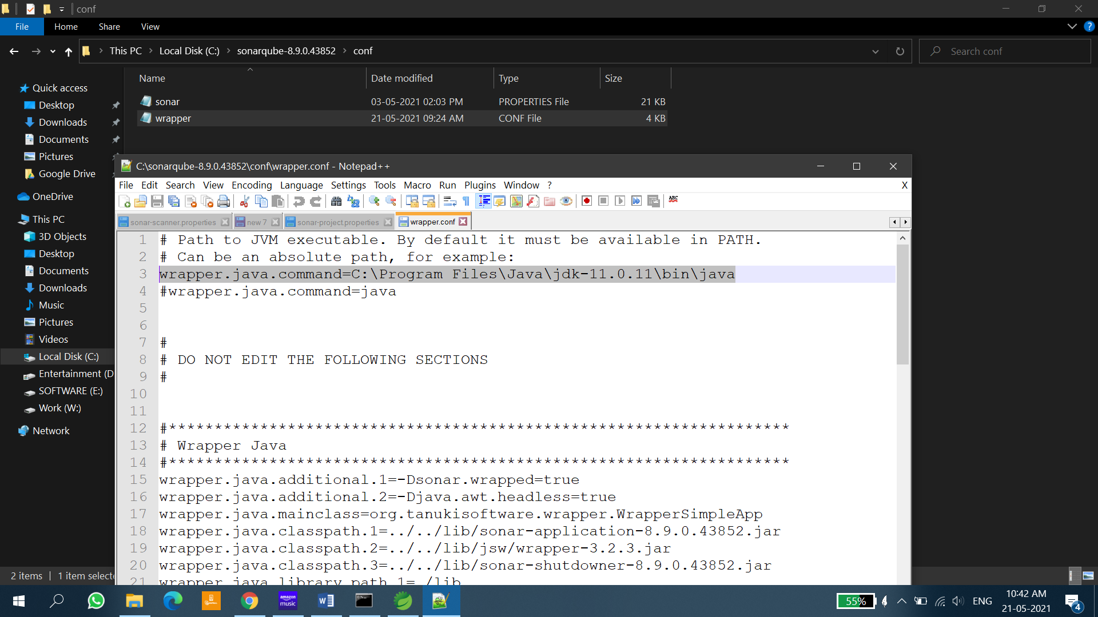

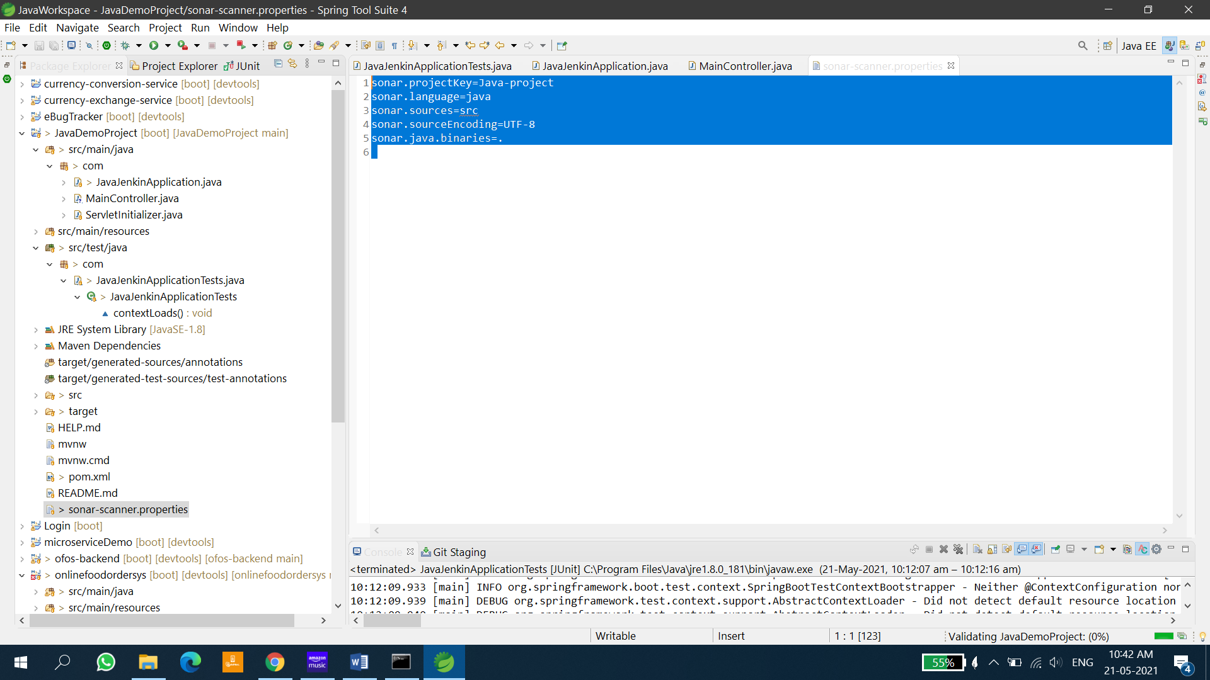

sonar.projectKey=Java-project

sonar.language=java

sonar.sources=src

sonar.sourceEncoding=UTF-8

sonar.java.binaries=.

Paste dependency in POM.XML in java project

<dependency>

<groupId>org.sonarsource.scanner.maven</groupId>

<artifactId>sonar-maven-plugin</artifactId>

<version>3.9.0.2155</version>

</dependency>

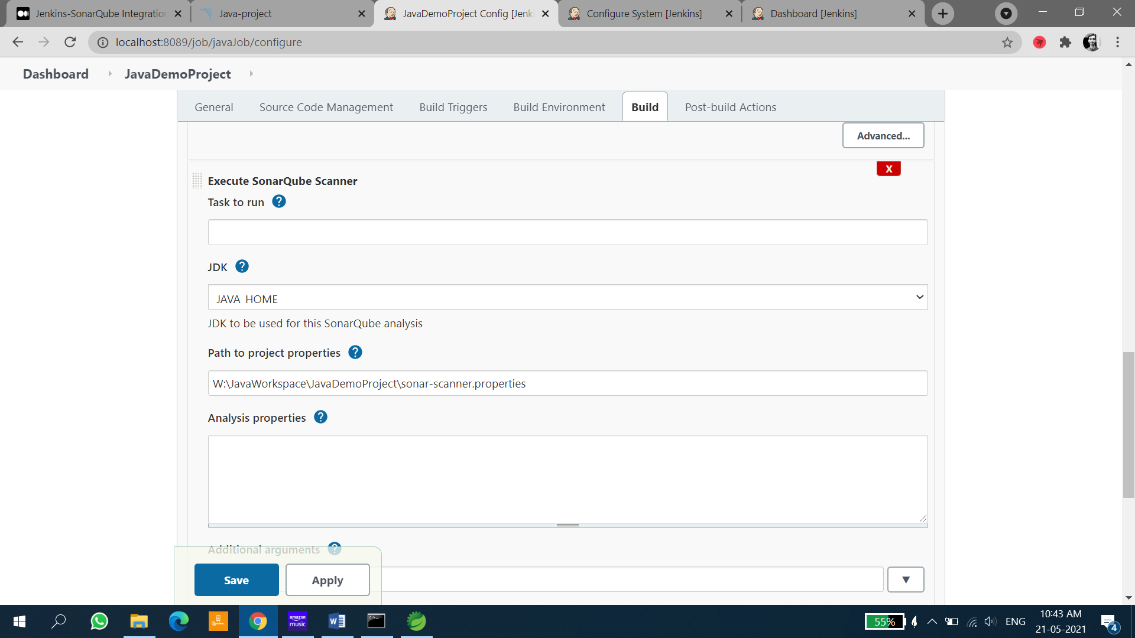

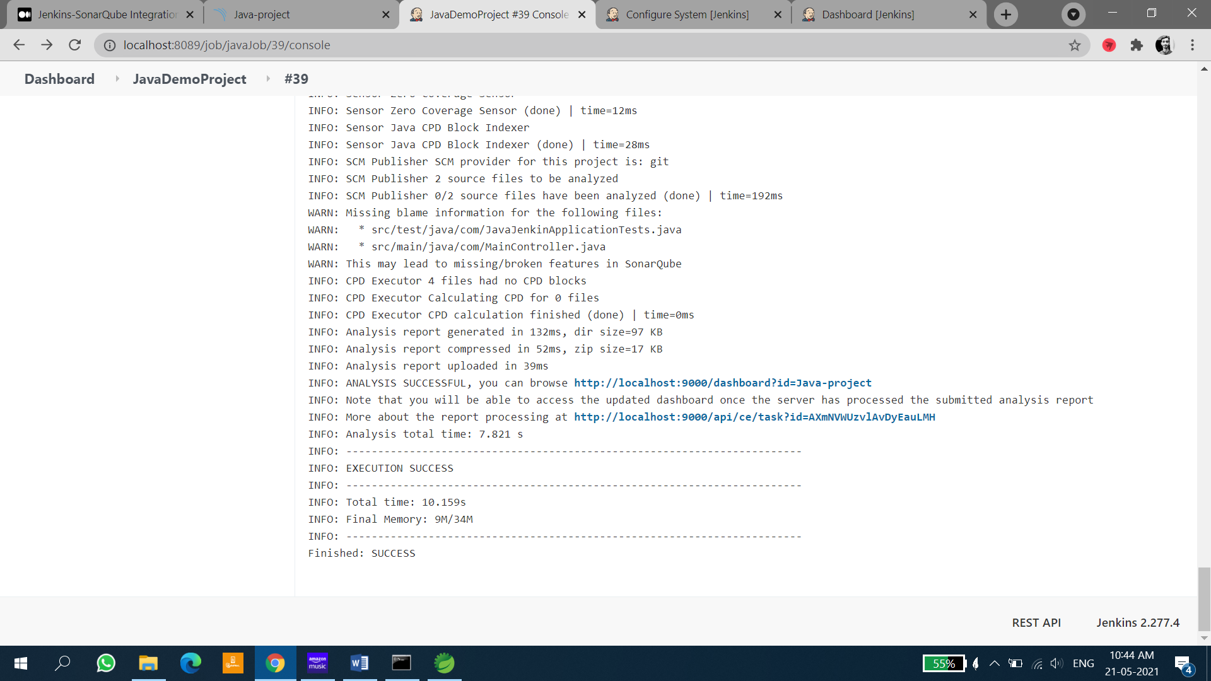

# Pipeline Creation (Using Build Triggers with individual Freestyle Projects)

Firstly start with linking all the different jobs in the specific order that has to be triggered. To do that first identify the initial job and update the configurations.

In the **Post Build Action** select **Build Other Projects** and give the name of the job that has to be triggered after the completion of the present job and save the configurations.

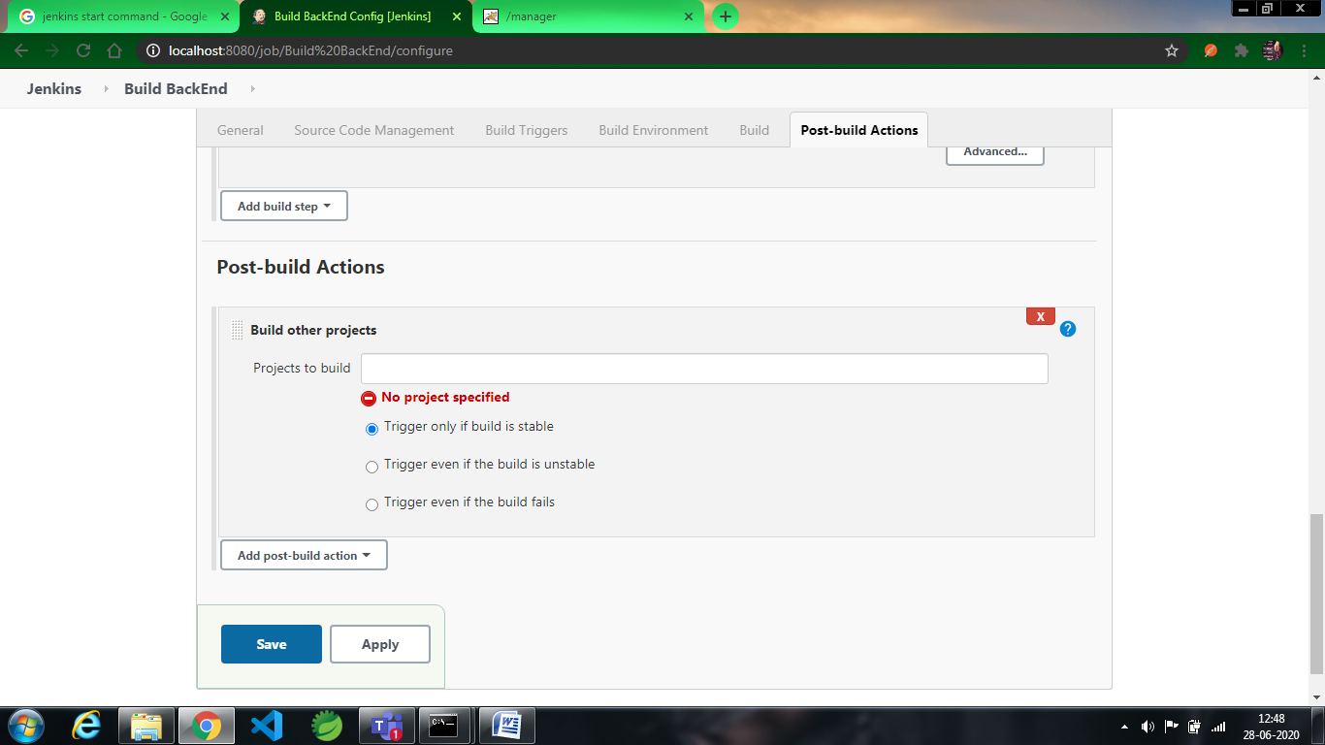

Continue updating all the configurations until the chain of triggers has been completed.

Then add the plugin **Build Pipeline** from the Manage plugins available section and allow it to successfully added.

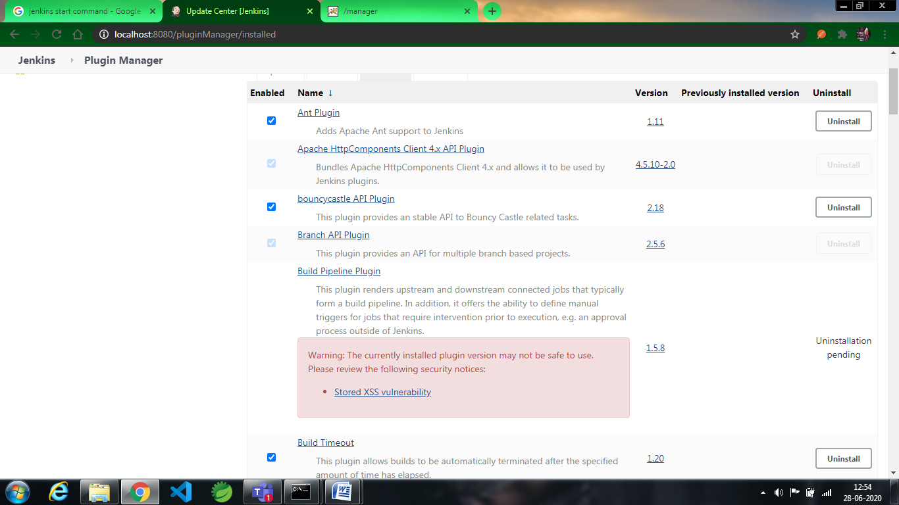

After adding the pipeline create the new pipeline and add the name of the pipeline in the **View name** section and select the option **Build Pipeline view and** select ok.

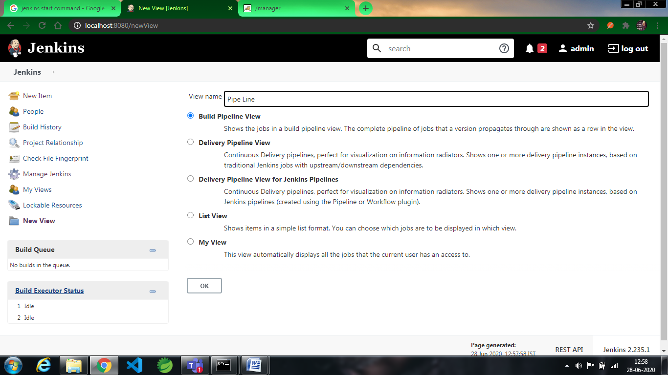

And later Add the description(optional) and in the bottom section you can find **Pipeline**  **Flow** Section and in that **Select Initial Job** give the first job where the process has to start and press ok so that the changes are saved.

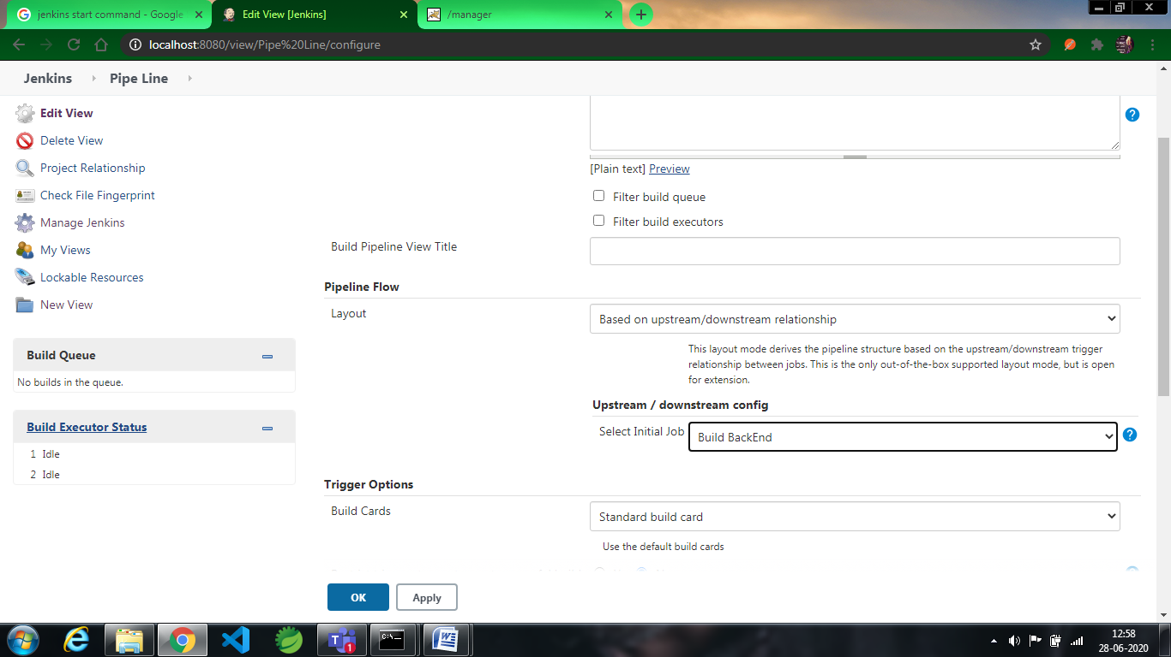

Now start the first job and open the pipleline you have created to find the status. You can find the below image where **Yellow** statesthat the process is going on while the rest of the jobs are held in the queue

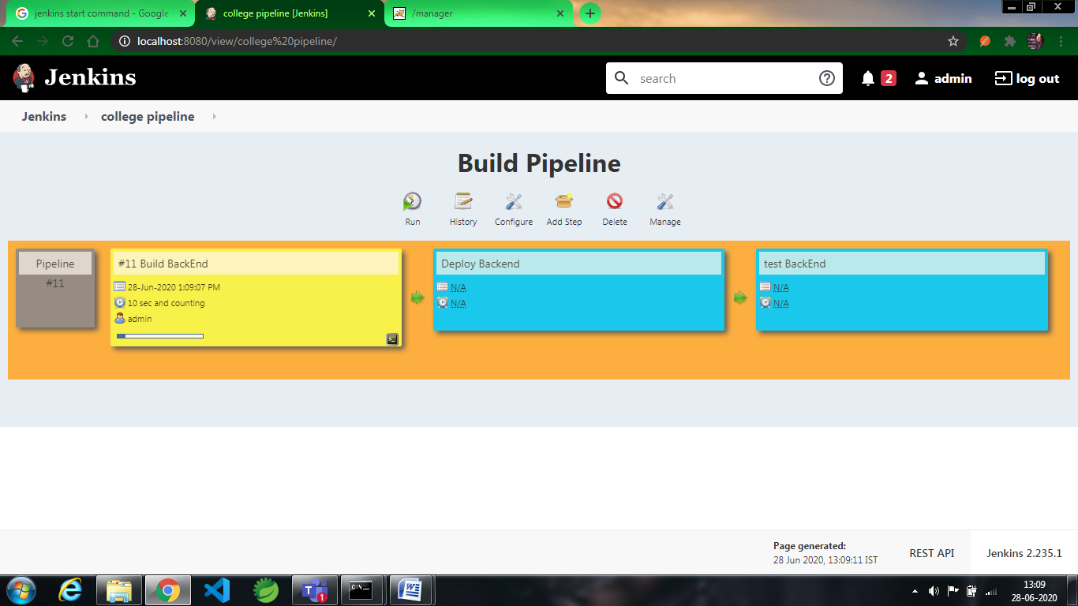The next job starts after completion of the ruuning job. **Green** colour states that the job is completed while **Blue** is for the jobs in the queue

You can find which job has been triggered in the process even in the console as below picture.

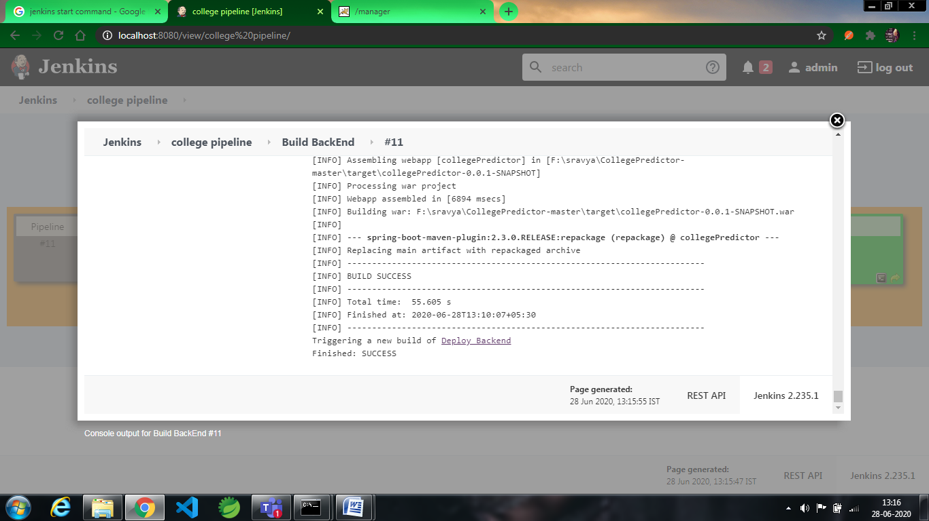

The process continues until all the jobs have been completed successfully. If there is any error/failure in any job then the flow of the pipeline breaks and do not process further.

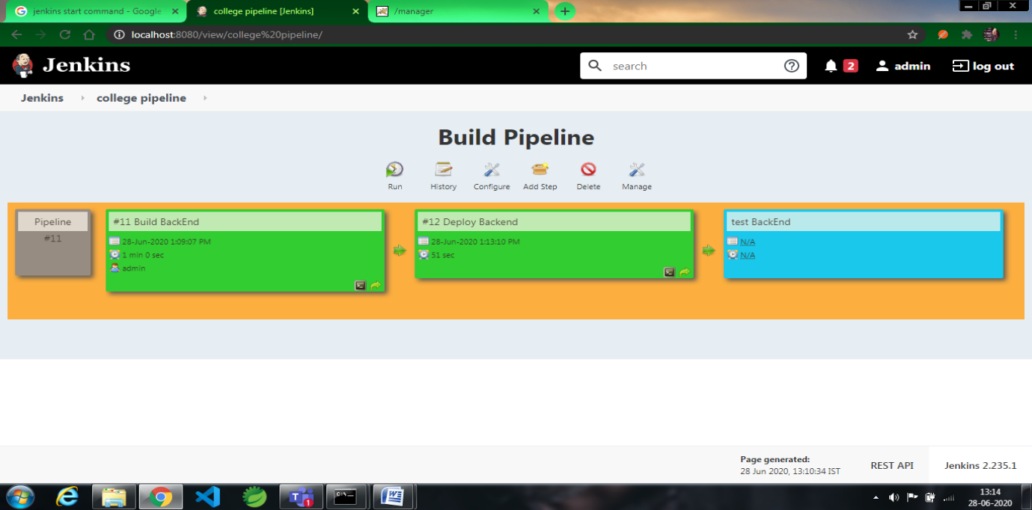

After completion of all the process you can find the below image and thus the flow of pipeline comes to an end.

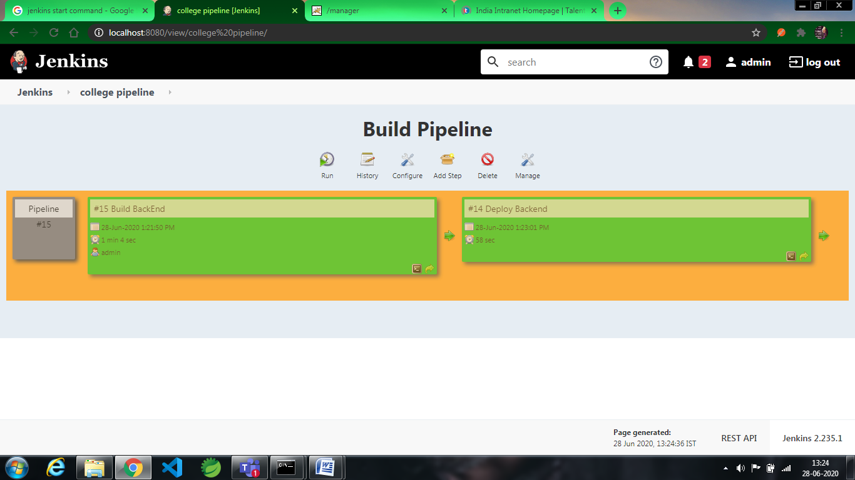

# PIPELINE CREATION USING SCRIPT

1. First, we need to install some plugins mainly two plugins they are:

*Delivery Pipeline Plugin

* Build Pipeline Plugin\

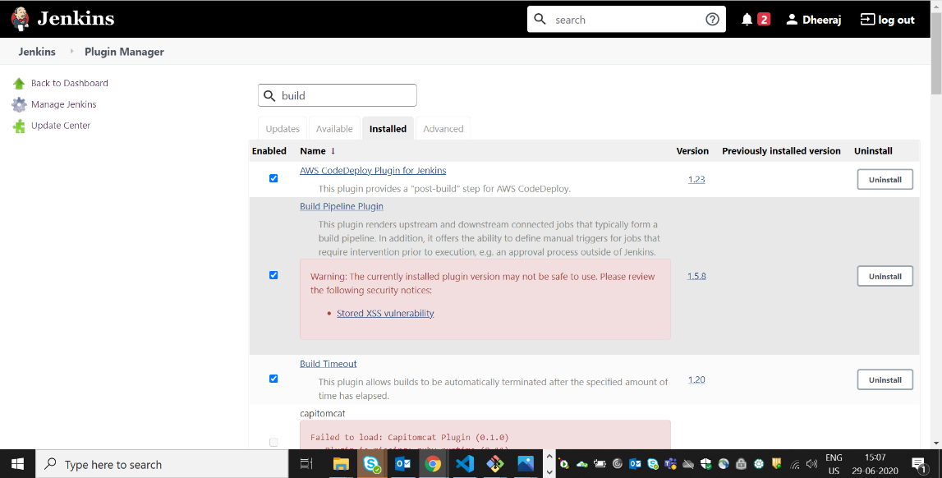

1. We need a create Pipeline Project

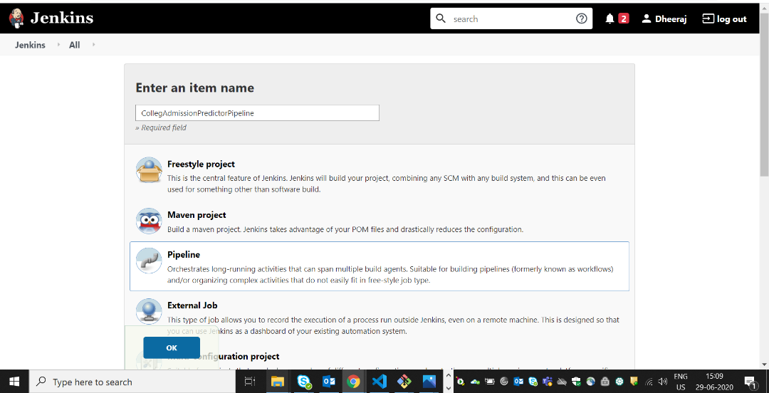

1. We need to configure poll scm(optional) :

Here 5 stars indicating 1 min

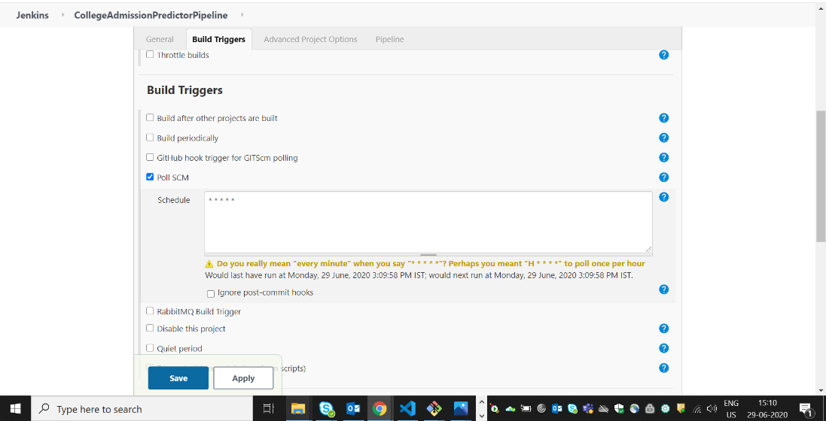

1. We need to write script to enable automatic build for each step we need to write script. In order to write script we can generate script by going in to Snippet Generator:

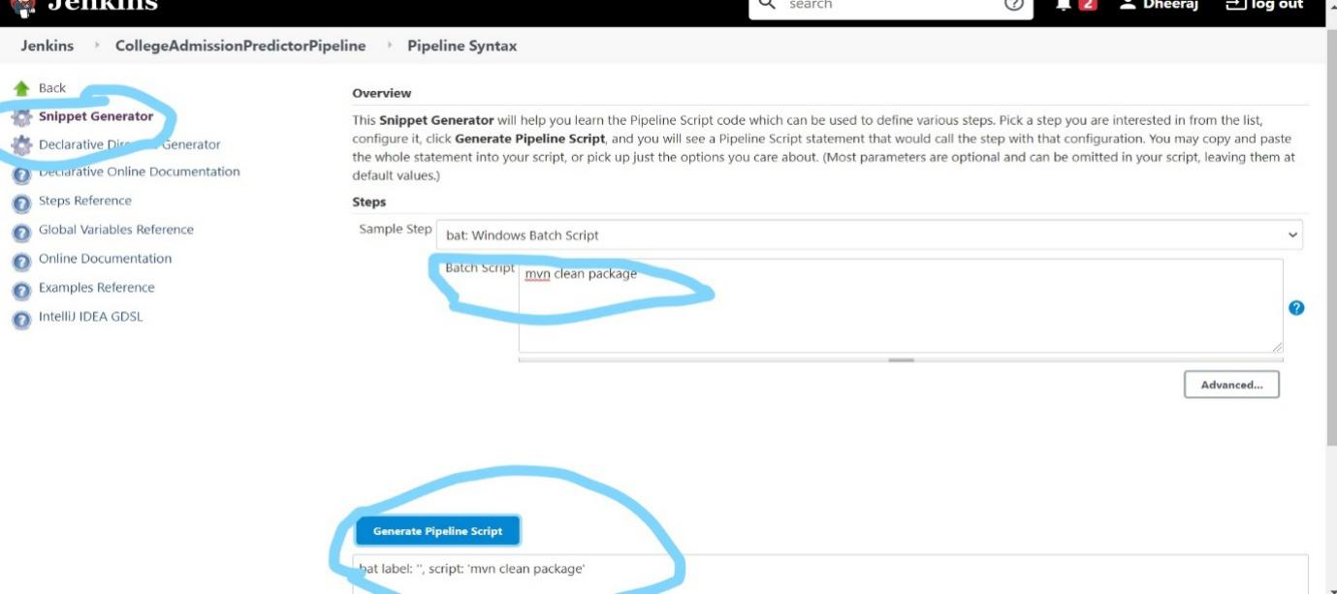

### Generate script for email

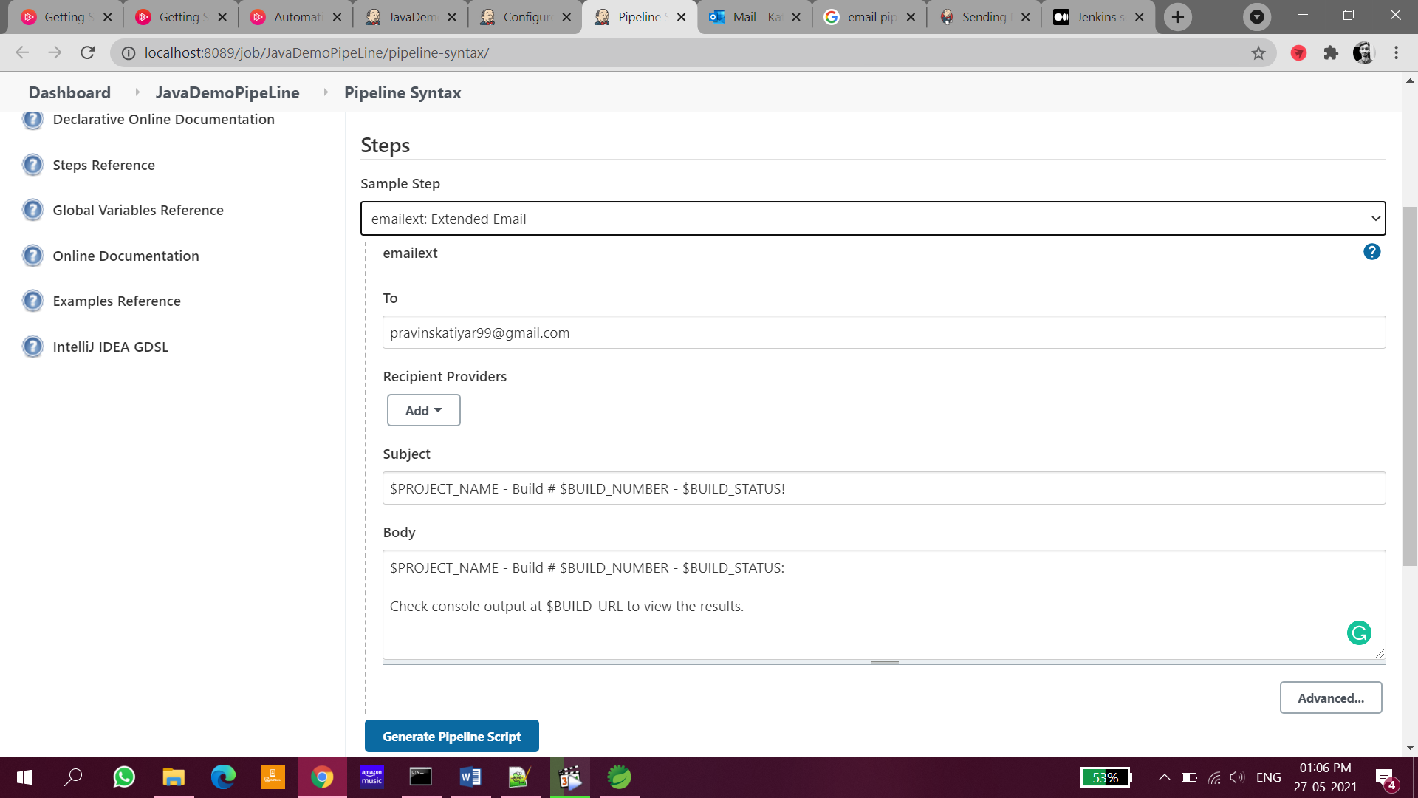

post {

always {

emailext body: '''$PROJECT_NAME - Build # $BUILD_NUMBER - $BUILD_STATUS:

Check console output at $BUILD_URL to view the results.''', subject: '$PROJECT_NAME - Build # $BUILD_NUMBER - $BUILD_STATUS!', to: 'pravinskatiyar99@gmail.com'

}

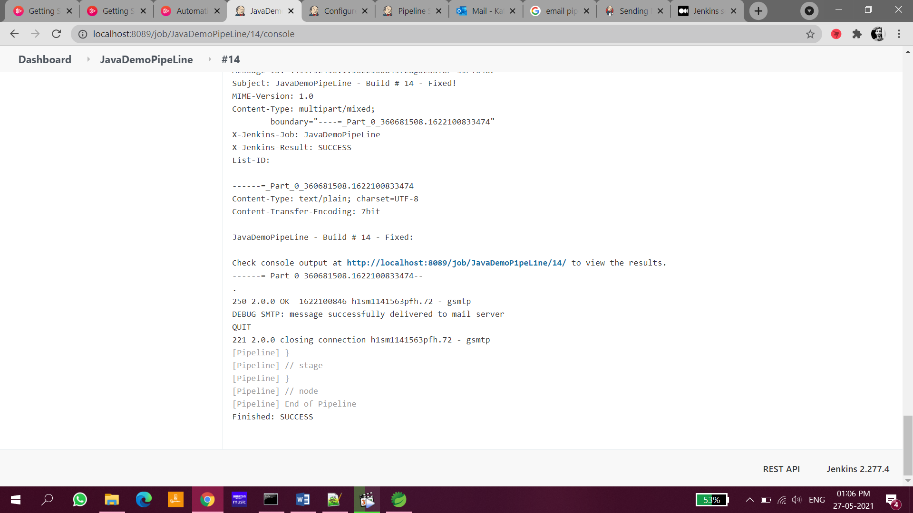

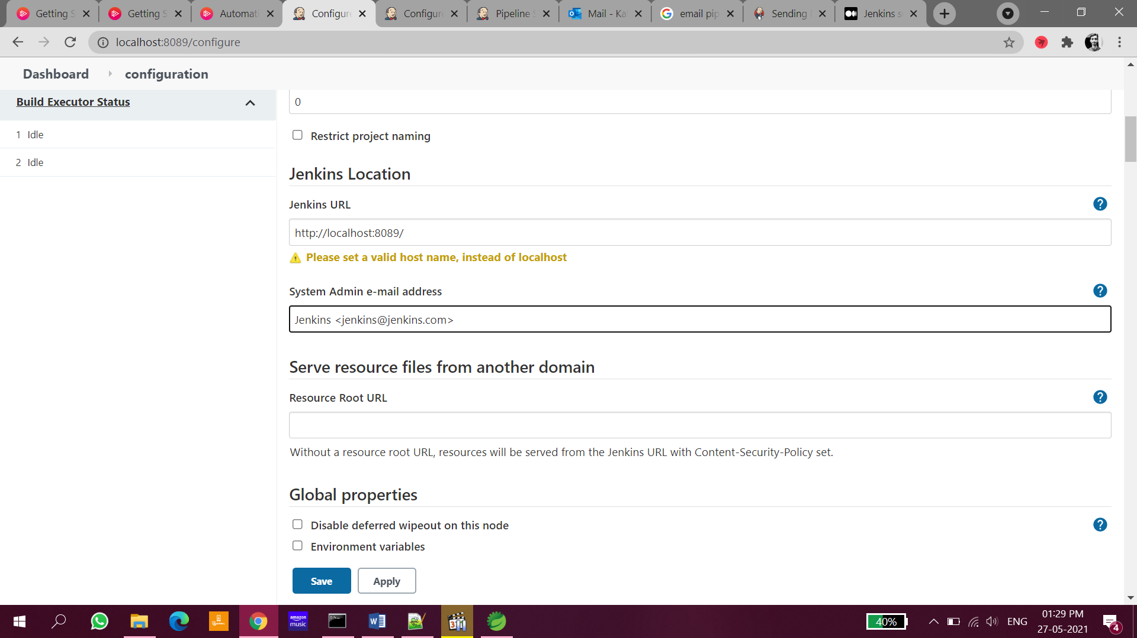

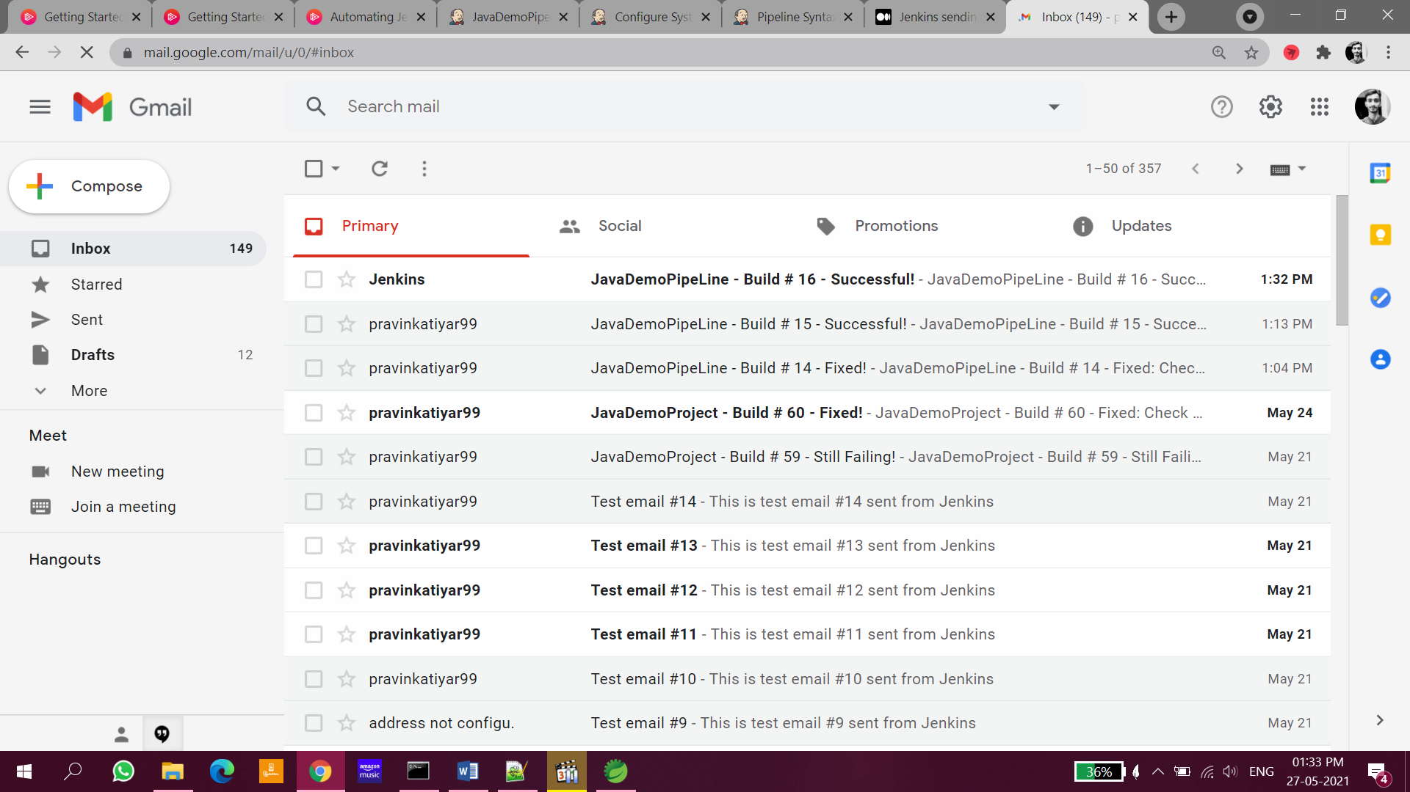

1. We need to write script or we can copy script from snippet generator:

node

{

dir('C:/Users/kommahes/CollegePredictor/CollegePredictor'){

stage('Build'){

bat label: '', script: 'mvn clean package'

}

stage('Testing'){

junit 'target\\surefire-reports/*.xml'

}

stage('SonarQube analysis') {

withSonarQubeEnv(installationName: 'SonarQube') {

bat 'mvn org.sonarsource.scanner.maven:sonar-maven-plugin:3.6.0.1398:sonar'

}

}

stage('Nexus'){

nexusArtifactUploader artifacts: [[artifactId: 'collegePredictor', classifier: '', file: 'target\\CollegePredictor.war', type: 'war']], credentialsId: '89bb6a2b-0409-4829-b1b8-718963dee600', groupId: 'com.caps', nexusUrl: 'localhost:8081', nexusVersion: 'nexus3', protocol: 'http', repository: 'maven-snapshots', version: '0.0.1-SNAPSHOT'

}

stage('Deploy'){

archiveArtifacts artifacts: 'target/*.war', followSymlinks: false

deploy adapters: [tomcat9(credentialsId: 'c1f4ed80-9510-4dc7-93c4-000384fa74d5', path: '', url: 'http://localhost:8009/')], contextPath: 'CollegePredictor', war: 'target\\CollegePredictor.war'

}

}

}

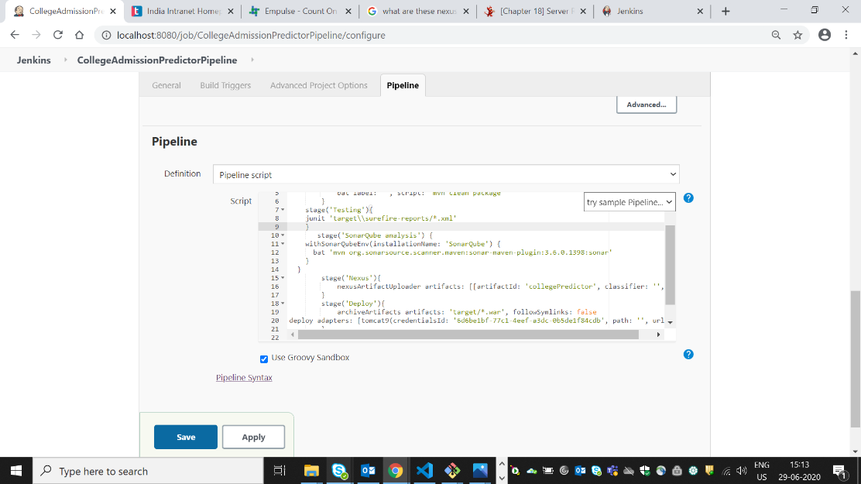

1. After completion it shows the stage view for various steps:

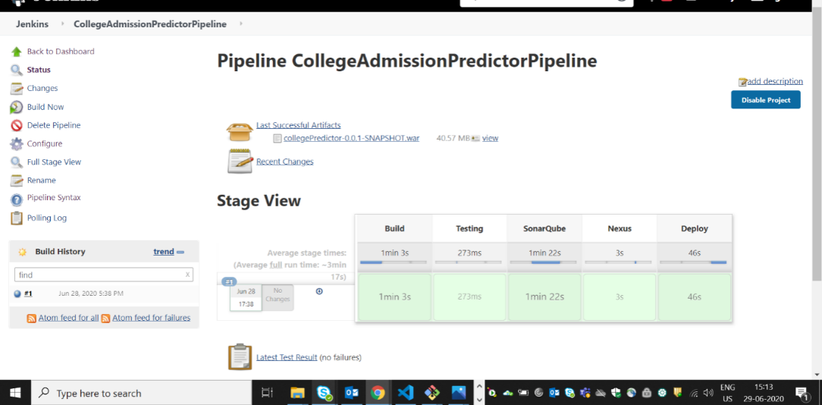

**SONATYPE NEXUS:**

Nexus is a repository manager. It allows you to proxy, collect, and manage your dependencies so that you are not constantly juggling a collection of JARs. It makes it easy to distribute your software. Internally, you configure your build to publish artifacts to Nexus and they then become available to other developers.

1. **Installation:**
   * Go to Nexus from <https://www.sonatype.com/download-oss-sonatype>
   * Select community version and download it
   * Extract .zip file

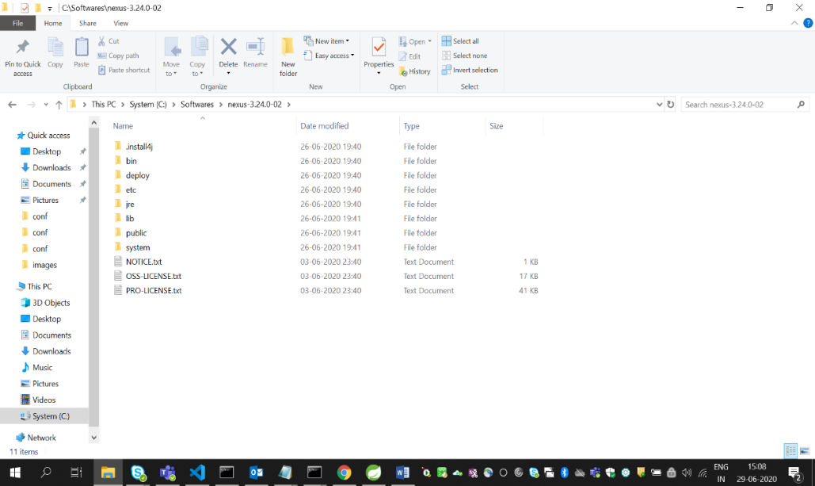

* Open Administrator command prompt
* Navigate to nexus path till bin 🡪 C:\Softwares\nexus-3.24.0-02\bin
* Execute the commands
  + - * nexus /install
      * nexus /start

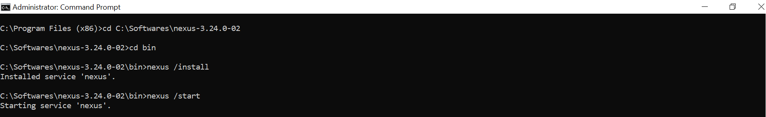

* Open <http://localhost:8081> in the browser
* We can see the below UI

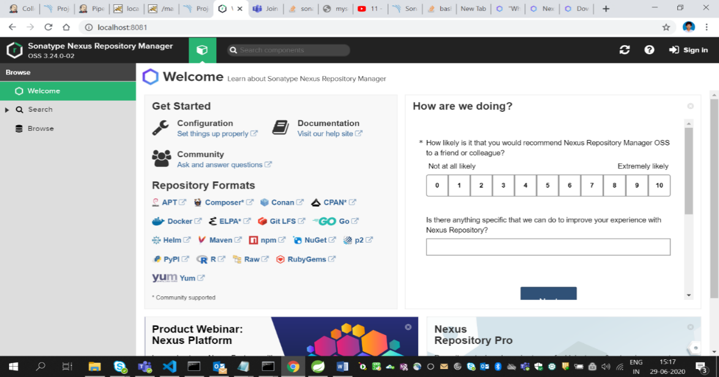

1. **Adding dependencies in pom.xml:**

* Add the below dependency in pom.xml

<distributionManagement>

<repository>

<id>deployment</id>

<name>maven-releases</name>

<url>http://localhost:8081/repository/maven-releases/</url>

</repository>

<snapshotRepository>

<id>deployment</id>

<name>maven-snapshots</name>

<url>http://localhost:8081/repository/maven-snapshots/</url>

</snapshotRepository>

</distributionManagement>

1. **Adding server in maven settings.xml:**

* Go to maven directory and open conf folder then edit settings.xml file and add below code.

**<server>**

**<id>1234</id>**

**<username>admin</username>**

**<password>admin</password>**

**</server>**

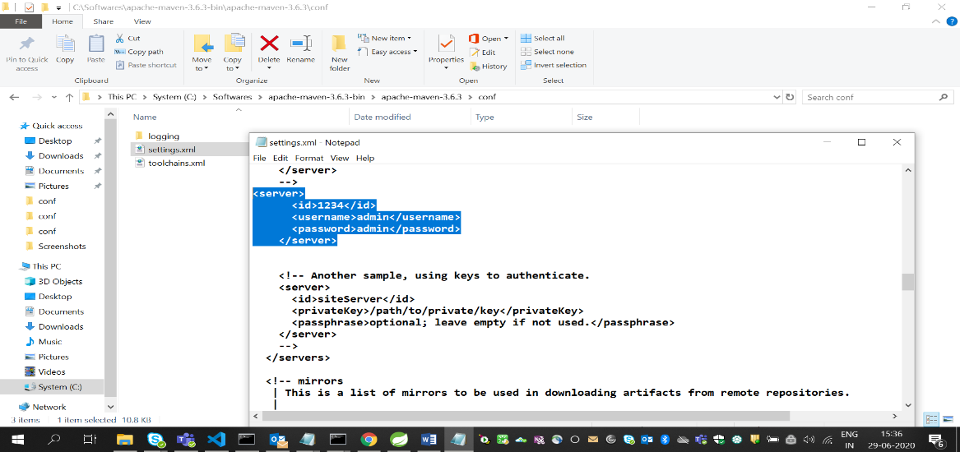

1. **Jenkins Configuration:**

* Open Jenkins : <http://localhost:8080>
* Go to Manage Jenkins🡪Manage Plugins
  + Select available and search for nexus artifact, nexus platform uploader and install it.

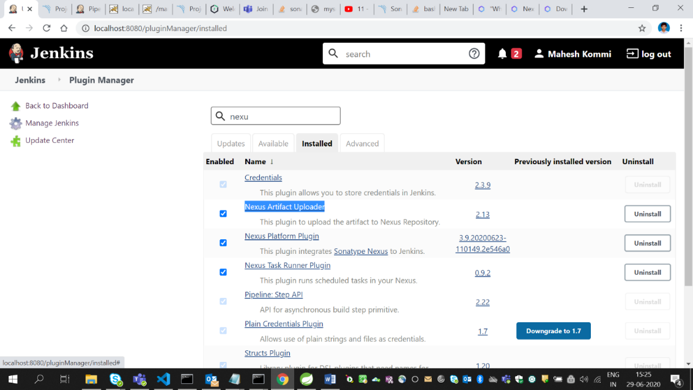

* Again go to Manage Jenkins🡪Configuration
* Look for SonaType Nexus
* Click on Add Nexus Repository Manager Server.
* Add the below configurations

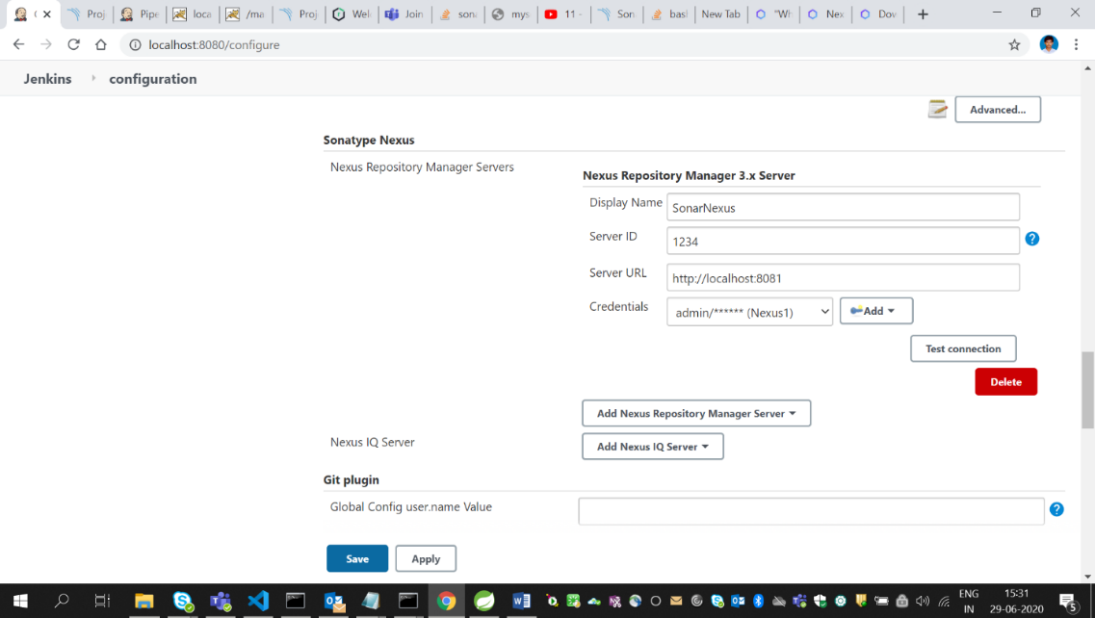

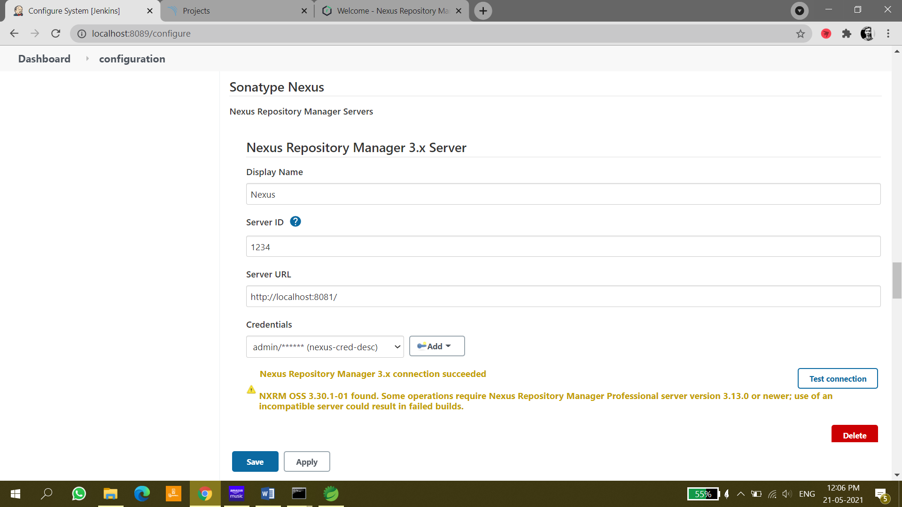

1. **Nexus Configuration in Jenkins Job:**

* Click on job in which we need to configured nexus
* Go to configure
* Go to Build
* Click on Add build Step
* Add the following configurations
* Then click apply 🡪 save

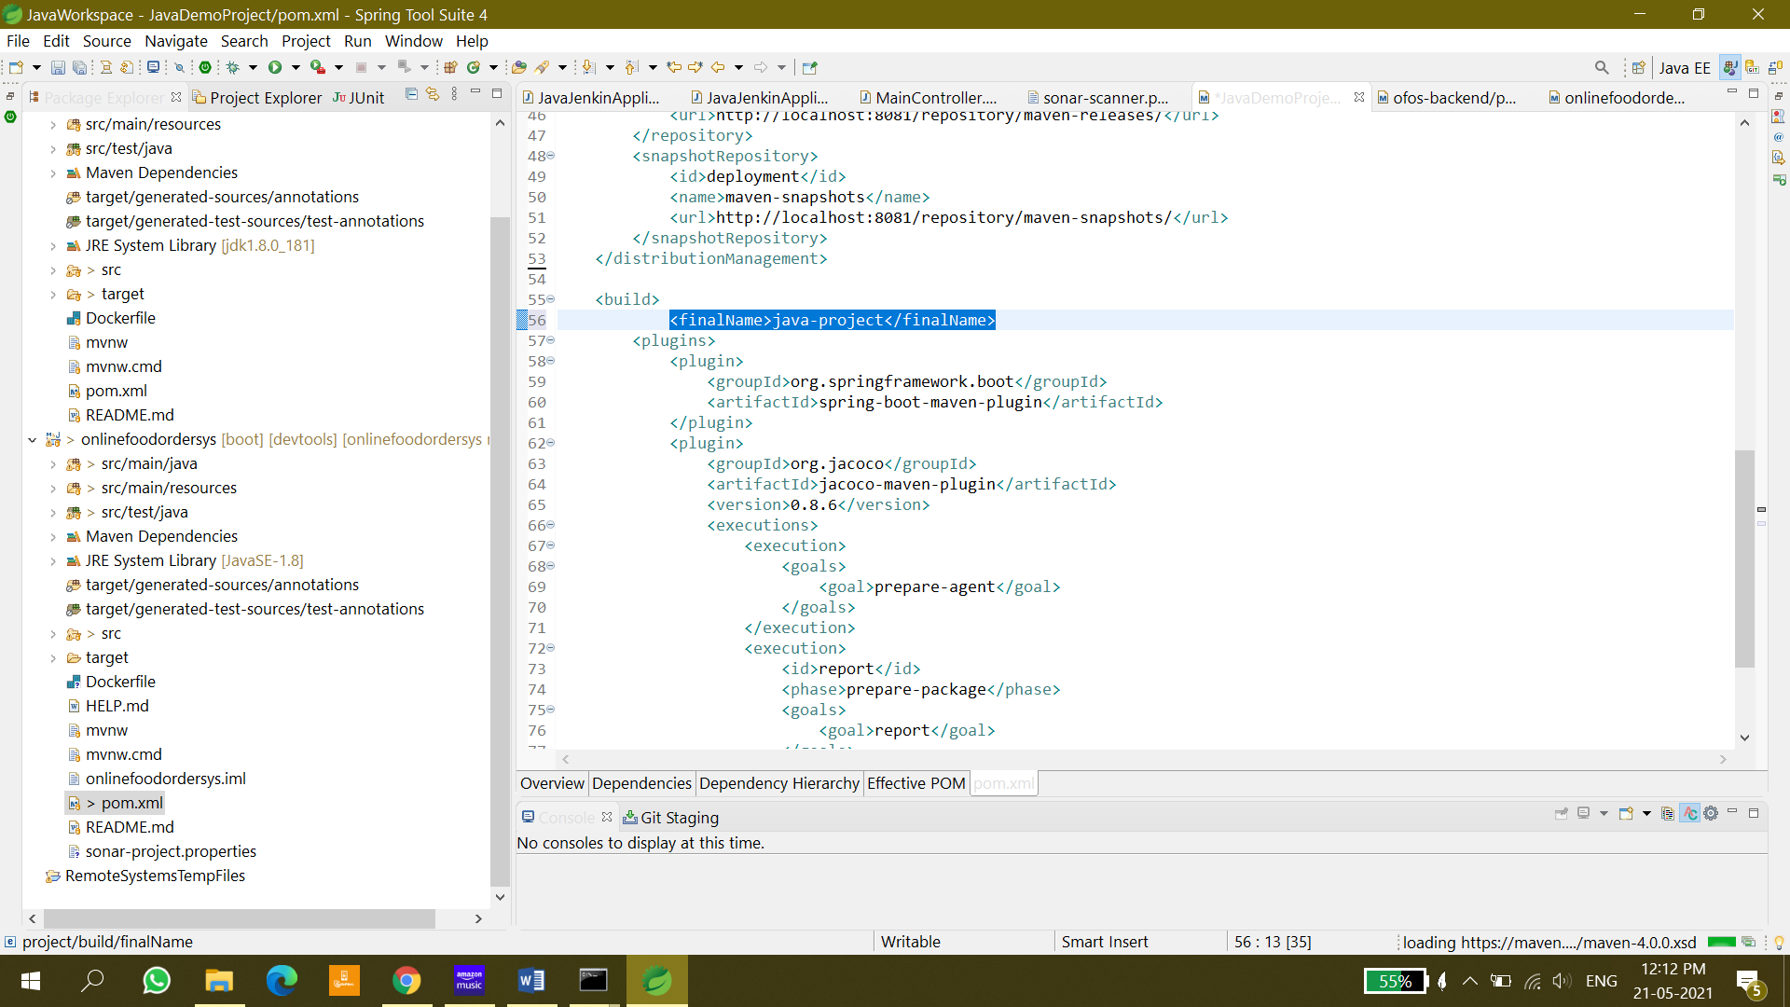

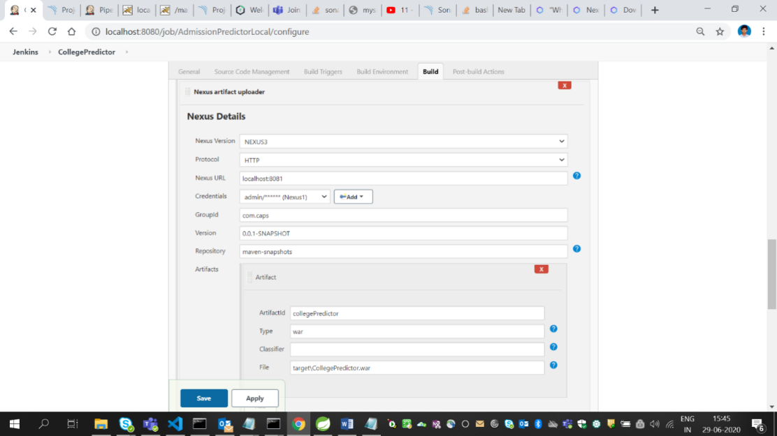

* Click on Build now
* Go to console output
* You can see artefact uploaded successfully in the last

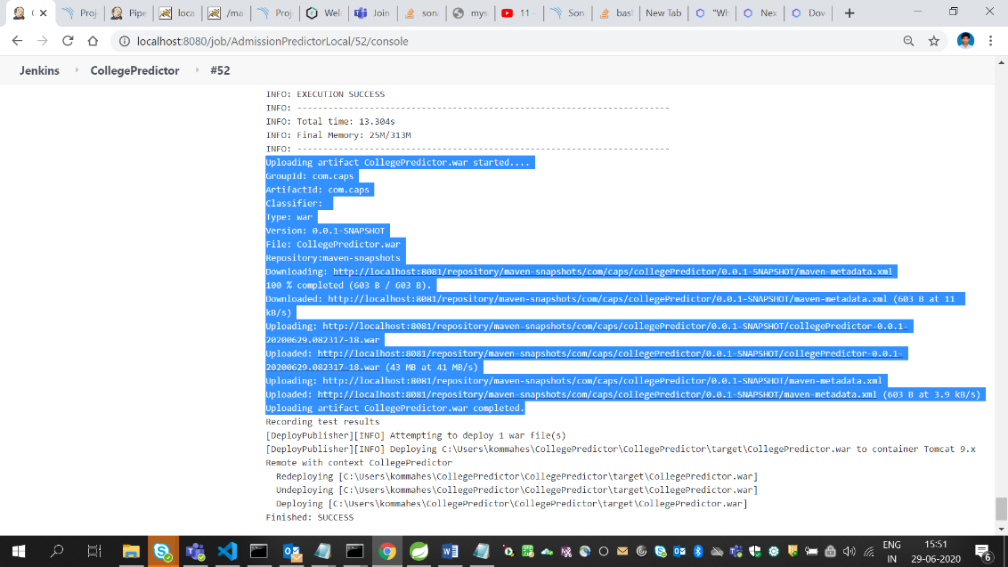

1. **Checking the artifats in Nexus:**

* Go to <http://localhost:8081>
* Go to Browse🡪maven-snapshots
* There we can find the uploaded articats

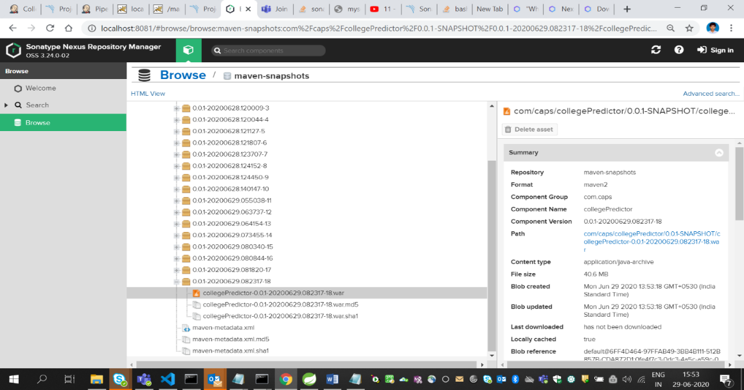

* **Nexus is successfully completed.**

# INTEGRATION OF JUNIT WITH JENKINS:

**Installing plugin**

1. Open Jenkins
2. Go to manage jenkins🡪 manage plugins🡪 available
3. Search for Junit plugin
4. Install it

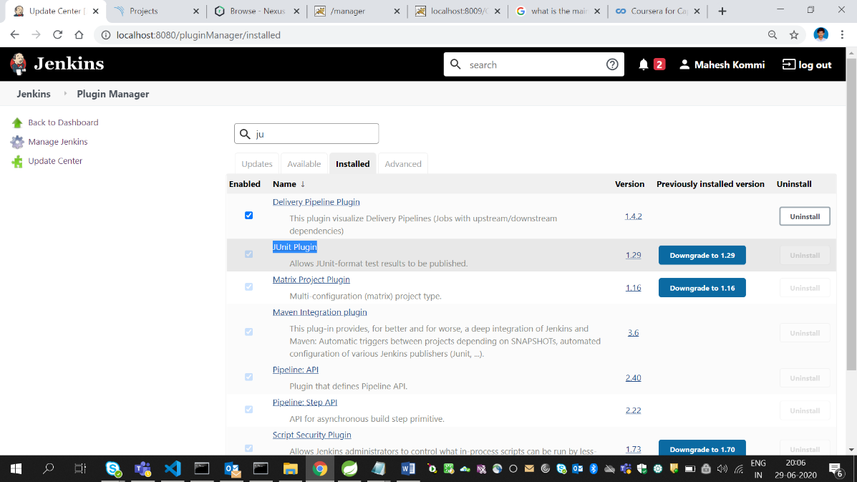

**Configuring Junit tests result report:**

1. Go to the project in which we need to configure Junit test results.
2. Go to configure 🡪 Post-build actions
3. Click on Add post build action button
4. Select publish JUnit Test Result Report.
5. The following configurations need to be done.

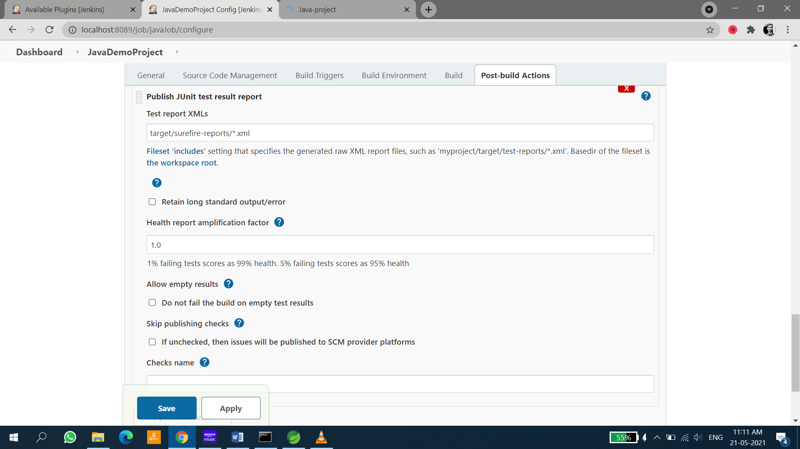

1. Click on apply then save
2. Click on build now
3. We will be able to see the following graph for test results

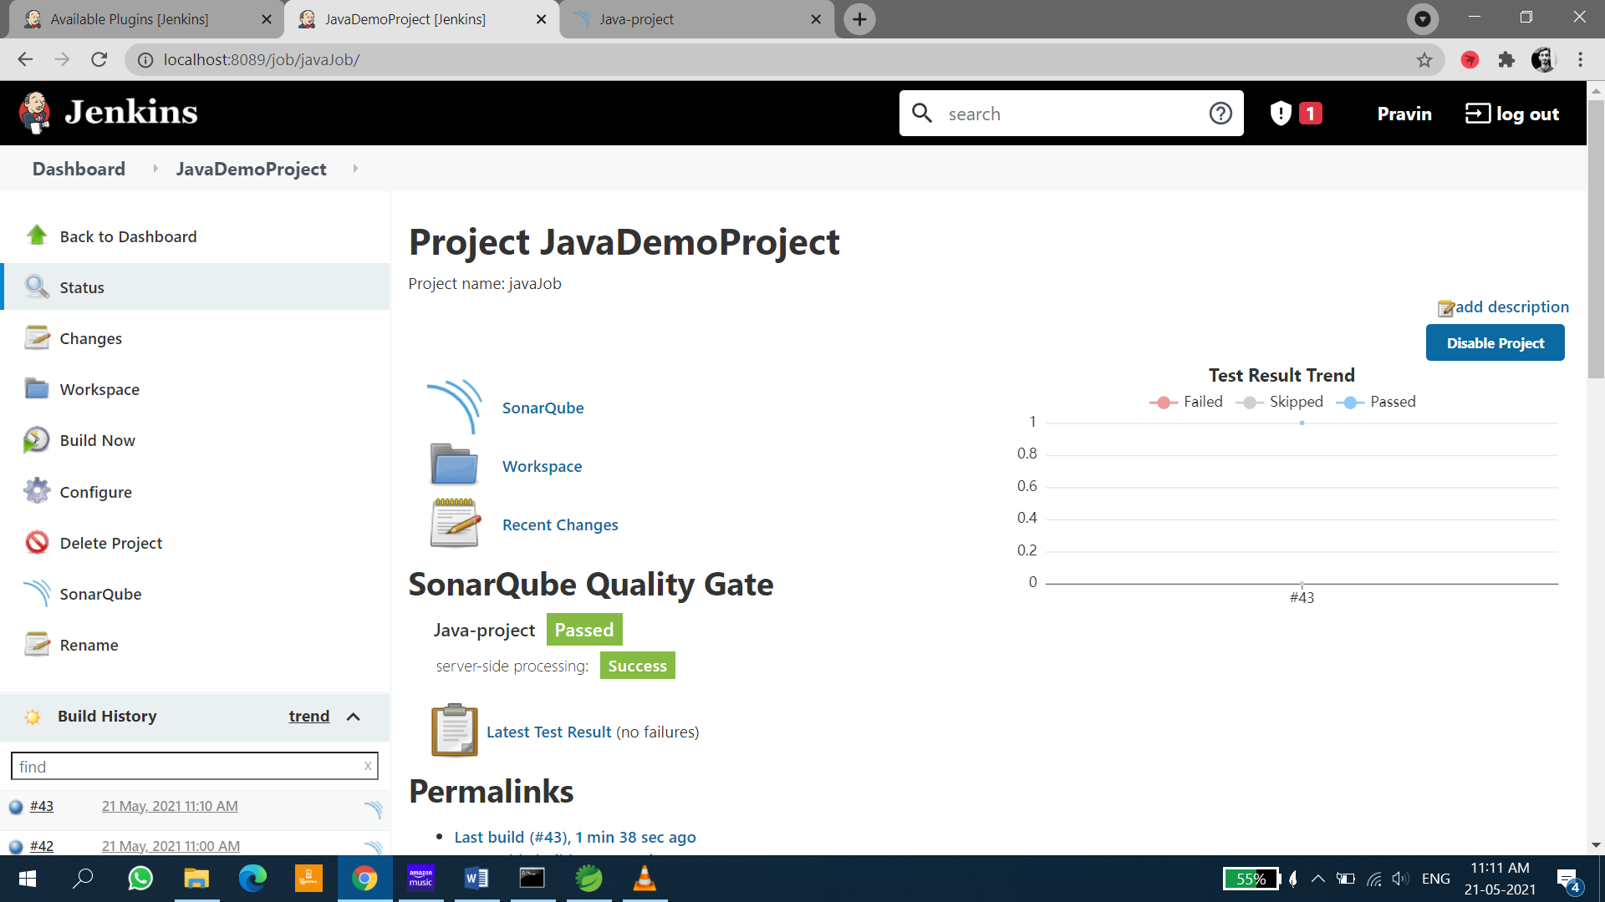

# INTEGRATION OF JACOCO WITH JENKINS

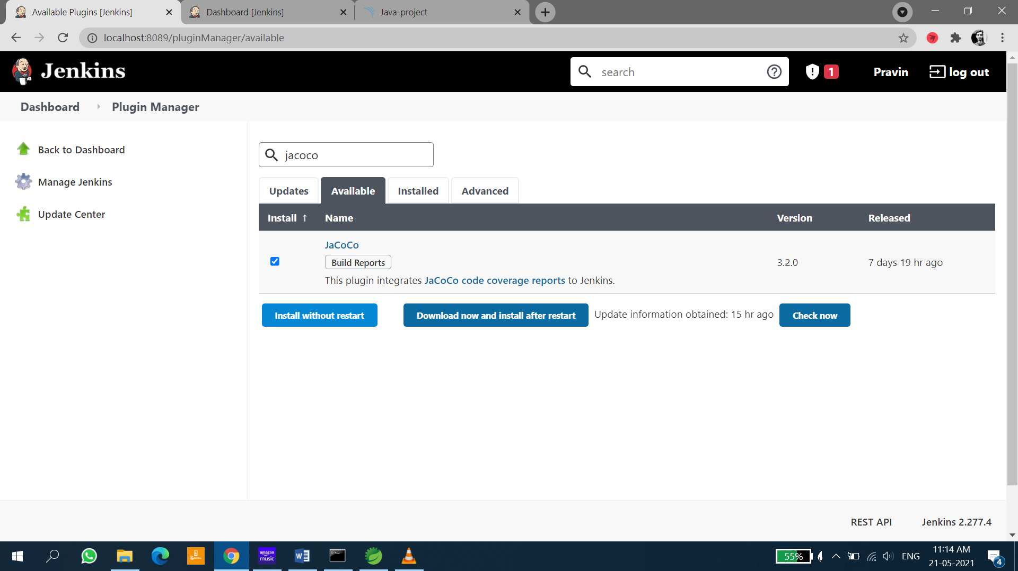

<plugin>

<groupId>org.jacoco</groupId>

<artifactId>jacoco-maven-plugin</artifactId>

<version>0.8.6</version>

<executions>

<execution>

<goals>

<goal>prepare-agent</goal>

</goals>

</execution>

<execution>

<id>report</id>

<phase>prepare-package</phase>

<goals>

<goal>report</goal>

</goals>

</execution>

</executions>

</plugin>

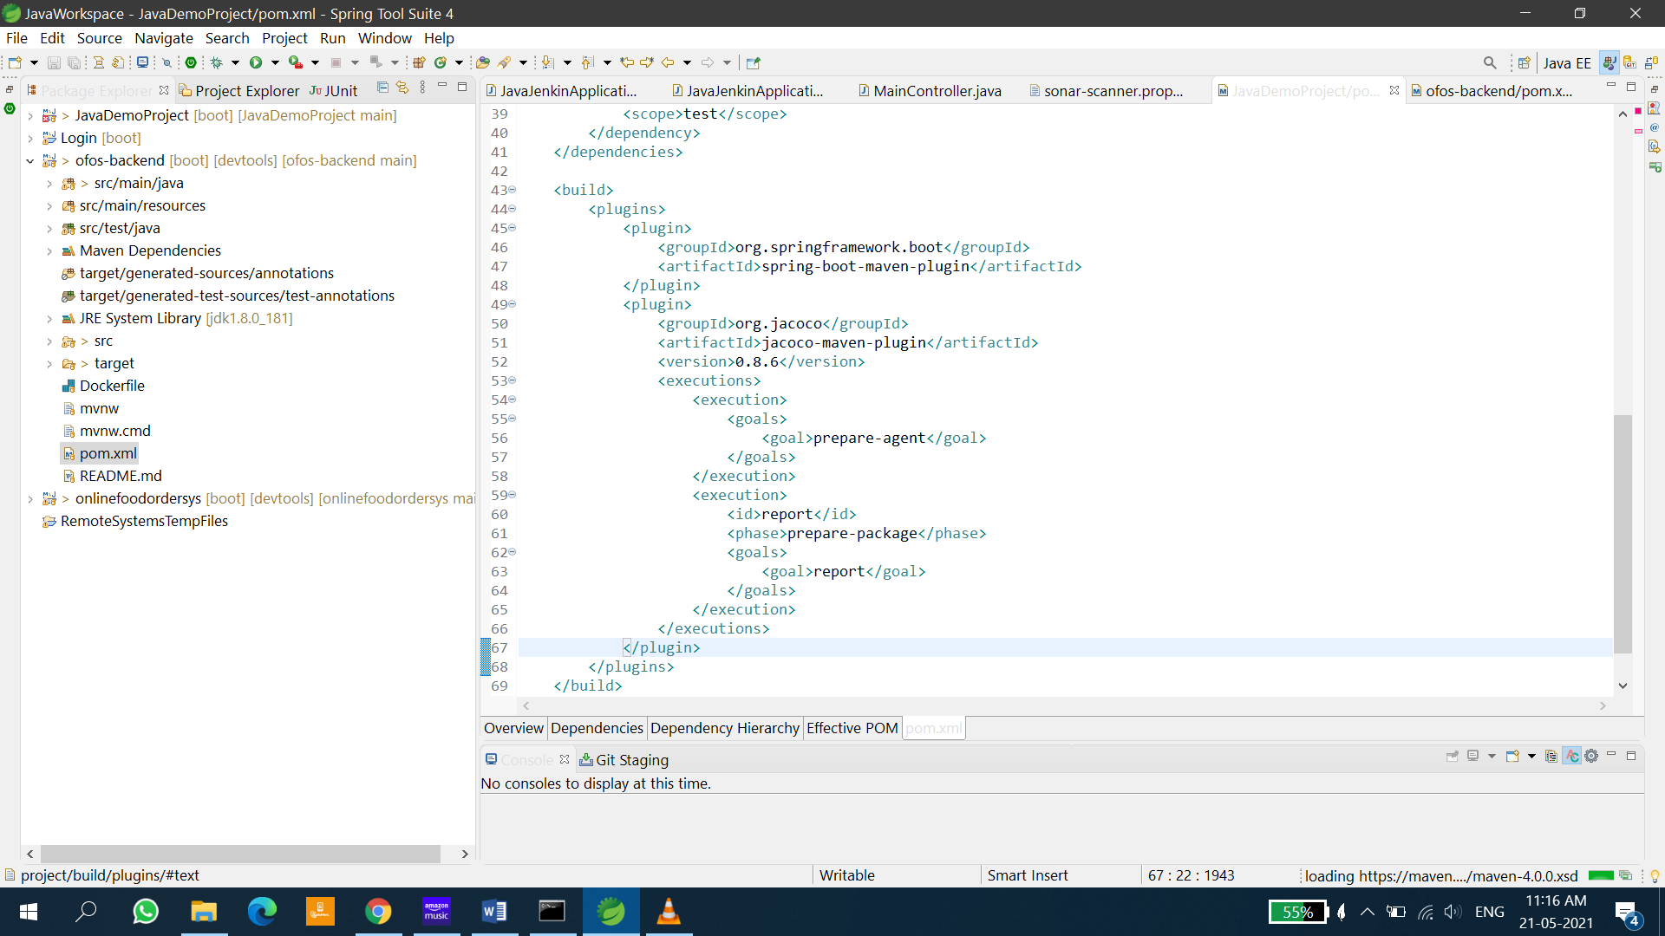

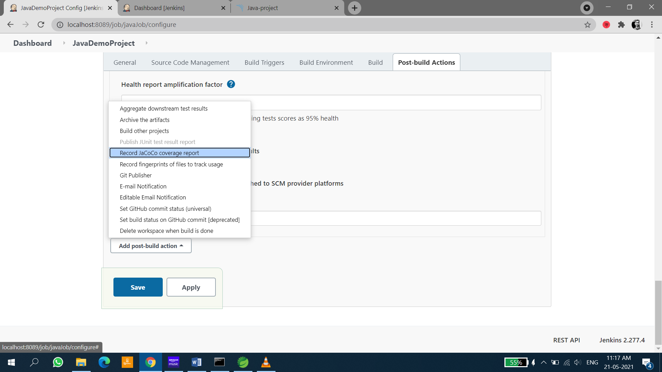

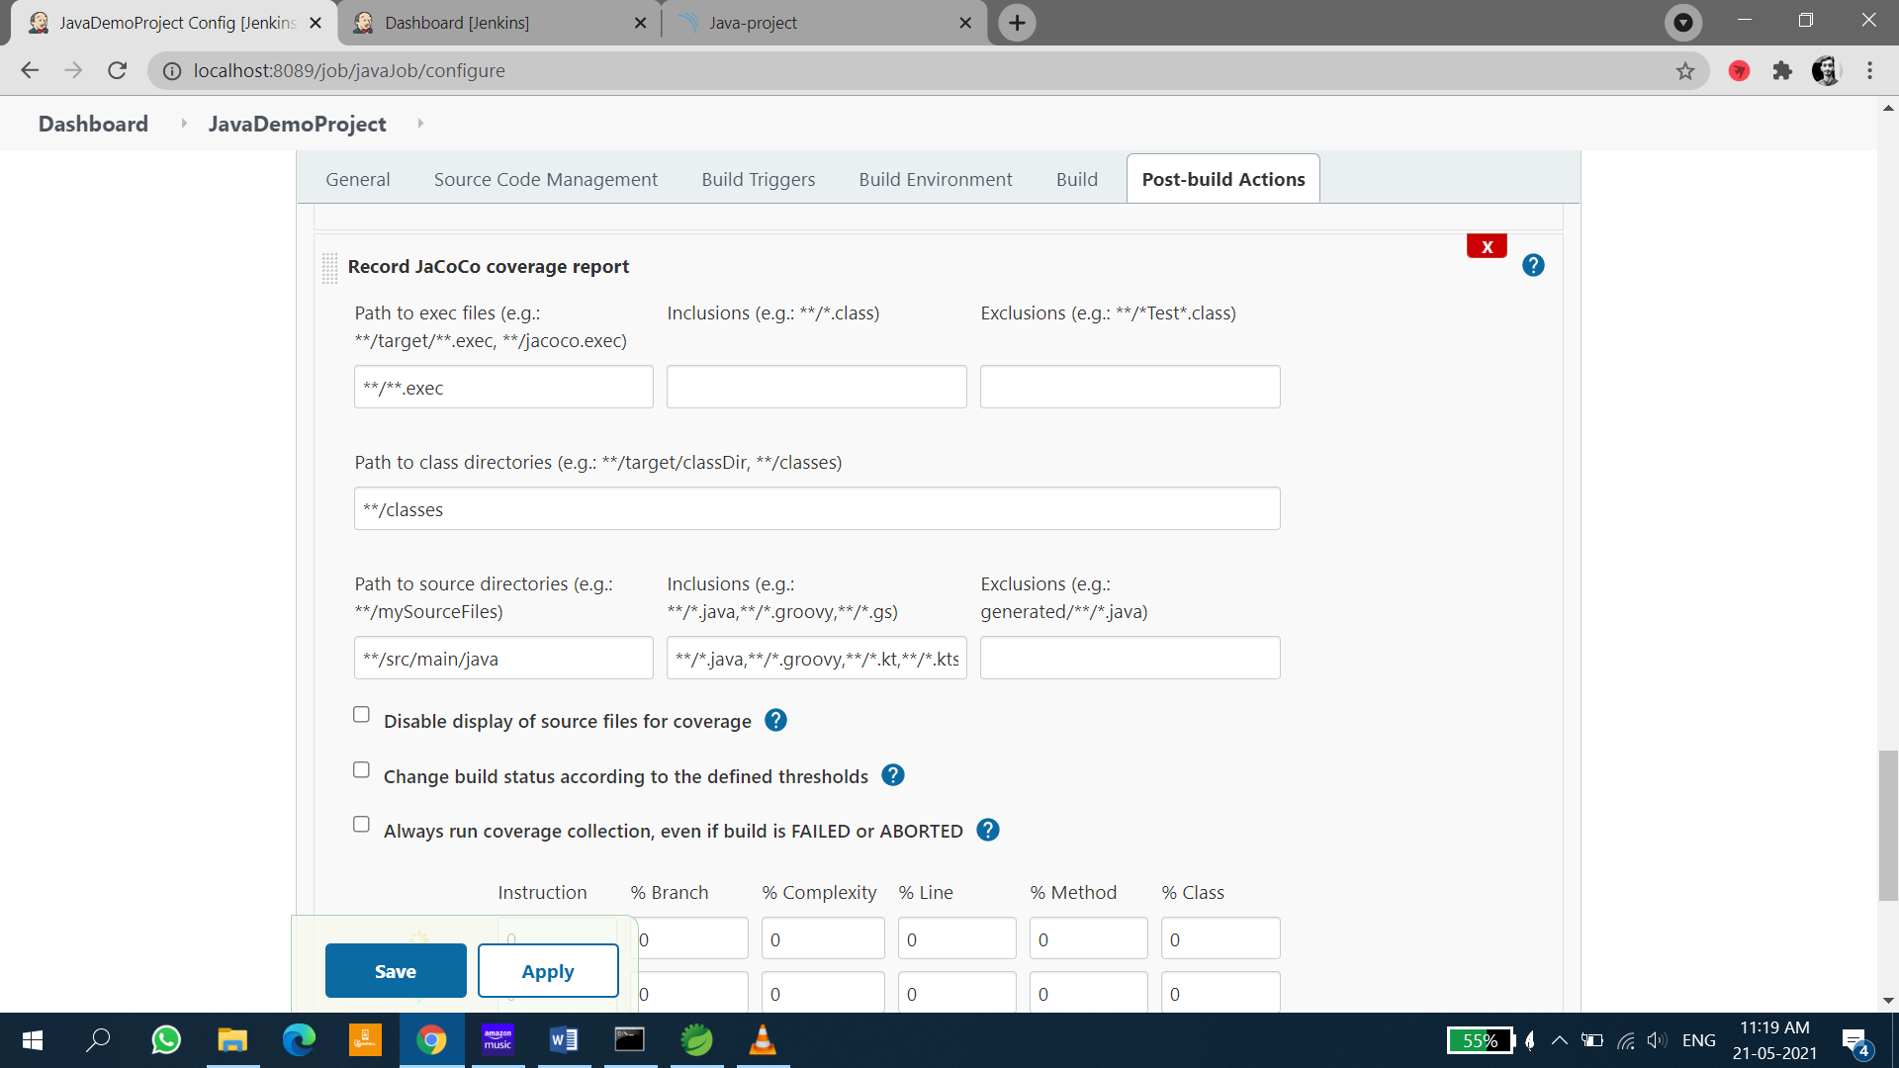

# ARCHIVE THE ARTIFACTS IN JENKINS

Archive the last successful artifact build

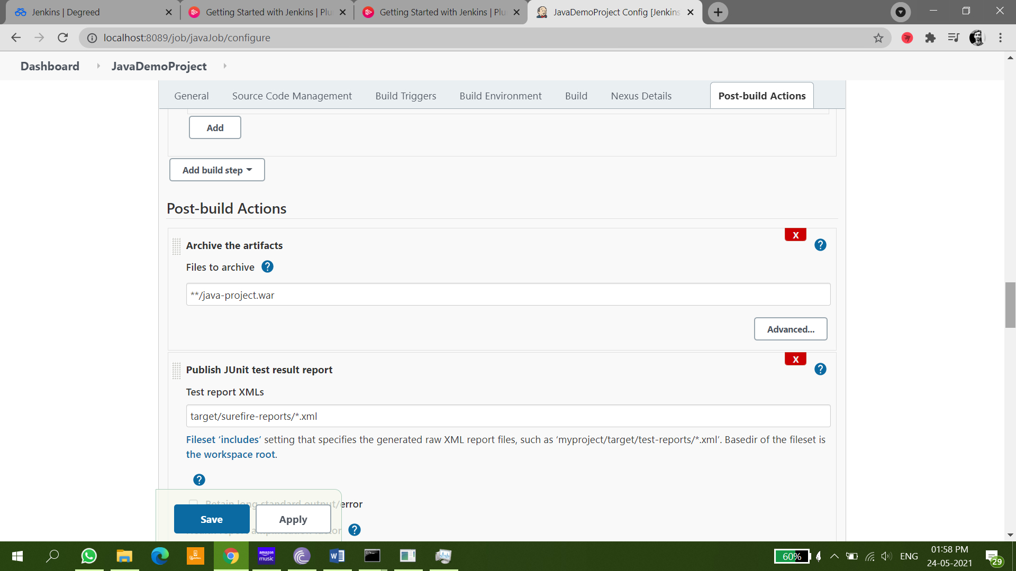

# INTEGRATION OF EMAIL WITH JENKINS

These could be the problem in your task if you are using Gmail Server.

1. [Two Step Verification should be turned off](https://support.google.com/accounts/answer/1064203?hl=en).
2. [Allow Less Secure App (should be turned on)](https://myaccount.google.com/lesssecureapps).
3. Please Check Your User Name and Password.
4. Check the code(which was my Problem), Above three You can change form google help center and by Yourself last one My Experience I can Share with You. You need to Authenticate the Mail server before Communicating the message because it is Challenge Response System By which You are Communicating through the mail. [I am sharing code snippets file you](https://drive.google.com/open?id=0B4x2Ztnd_jhjTFlWVmJmTzdkbVU) can refer not able to format my code by ctrl + K.

Install Email Extension Plugin

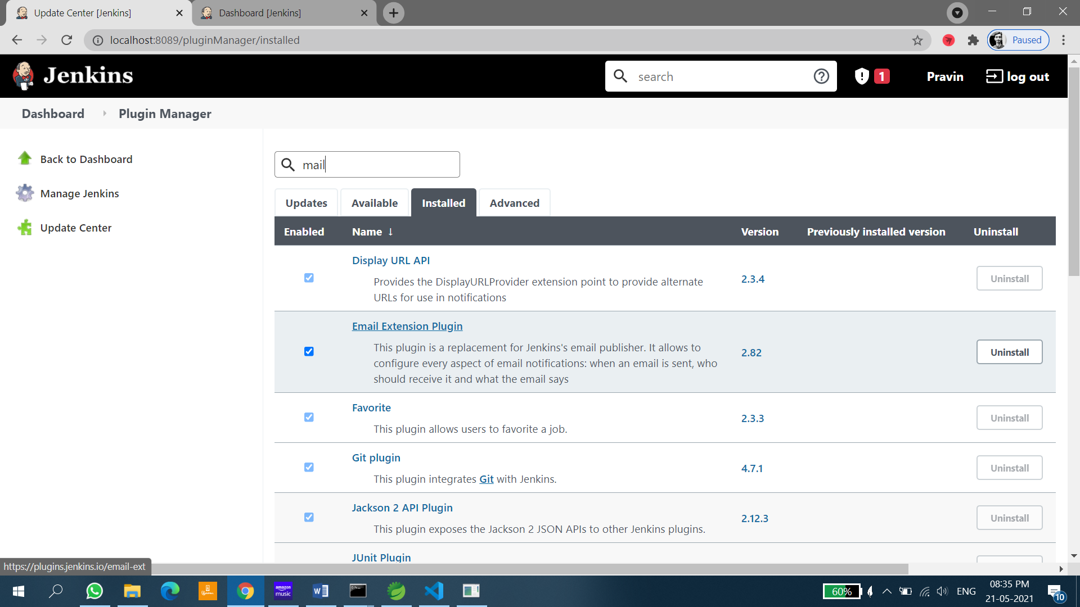

Fill the details as below

UserName: Your email Id from which you want to send email

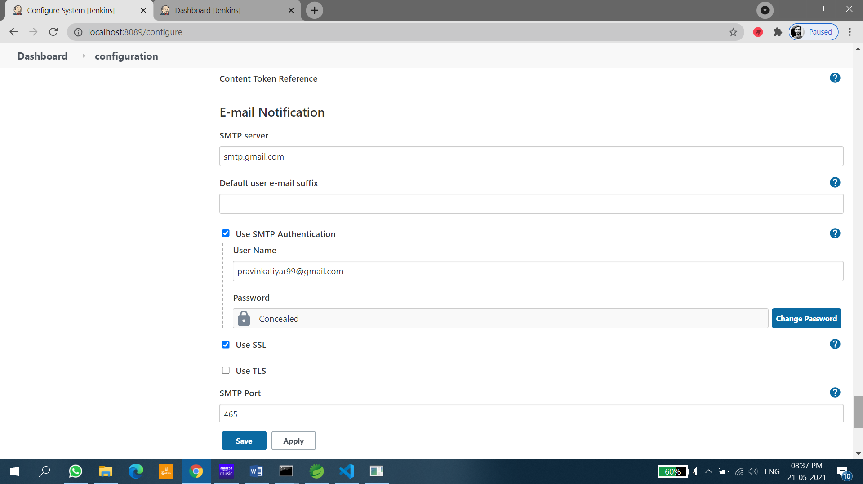

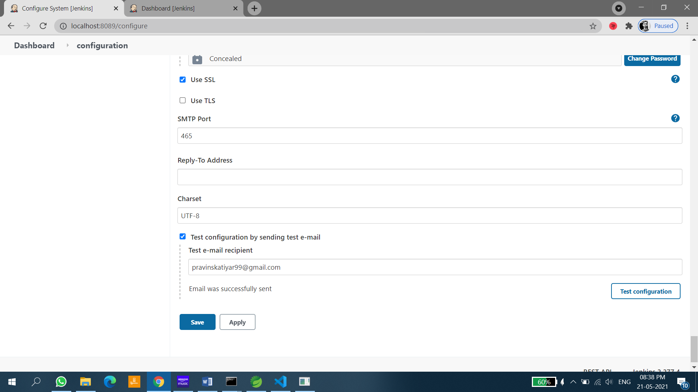

Try sending mail to check if it is working fine or not

After this is done, now configure extended **email Notification**

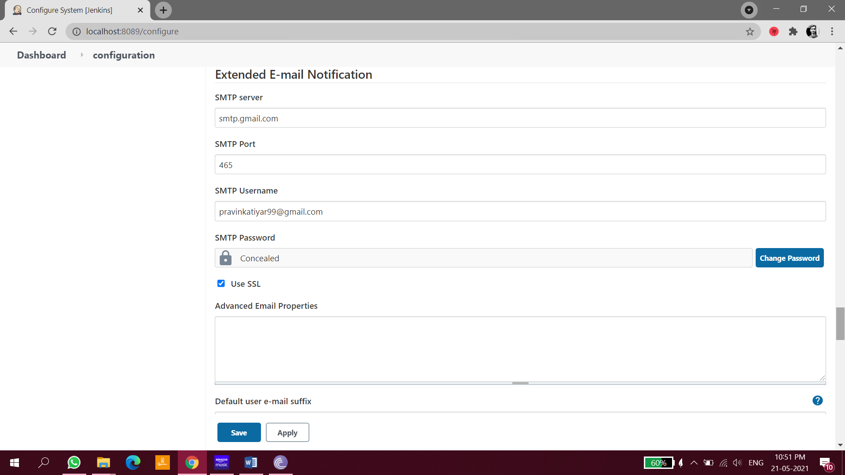

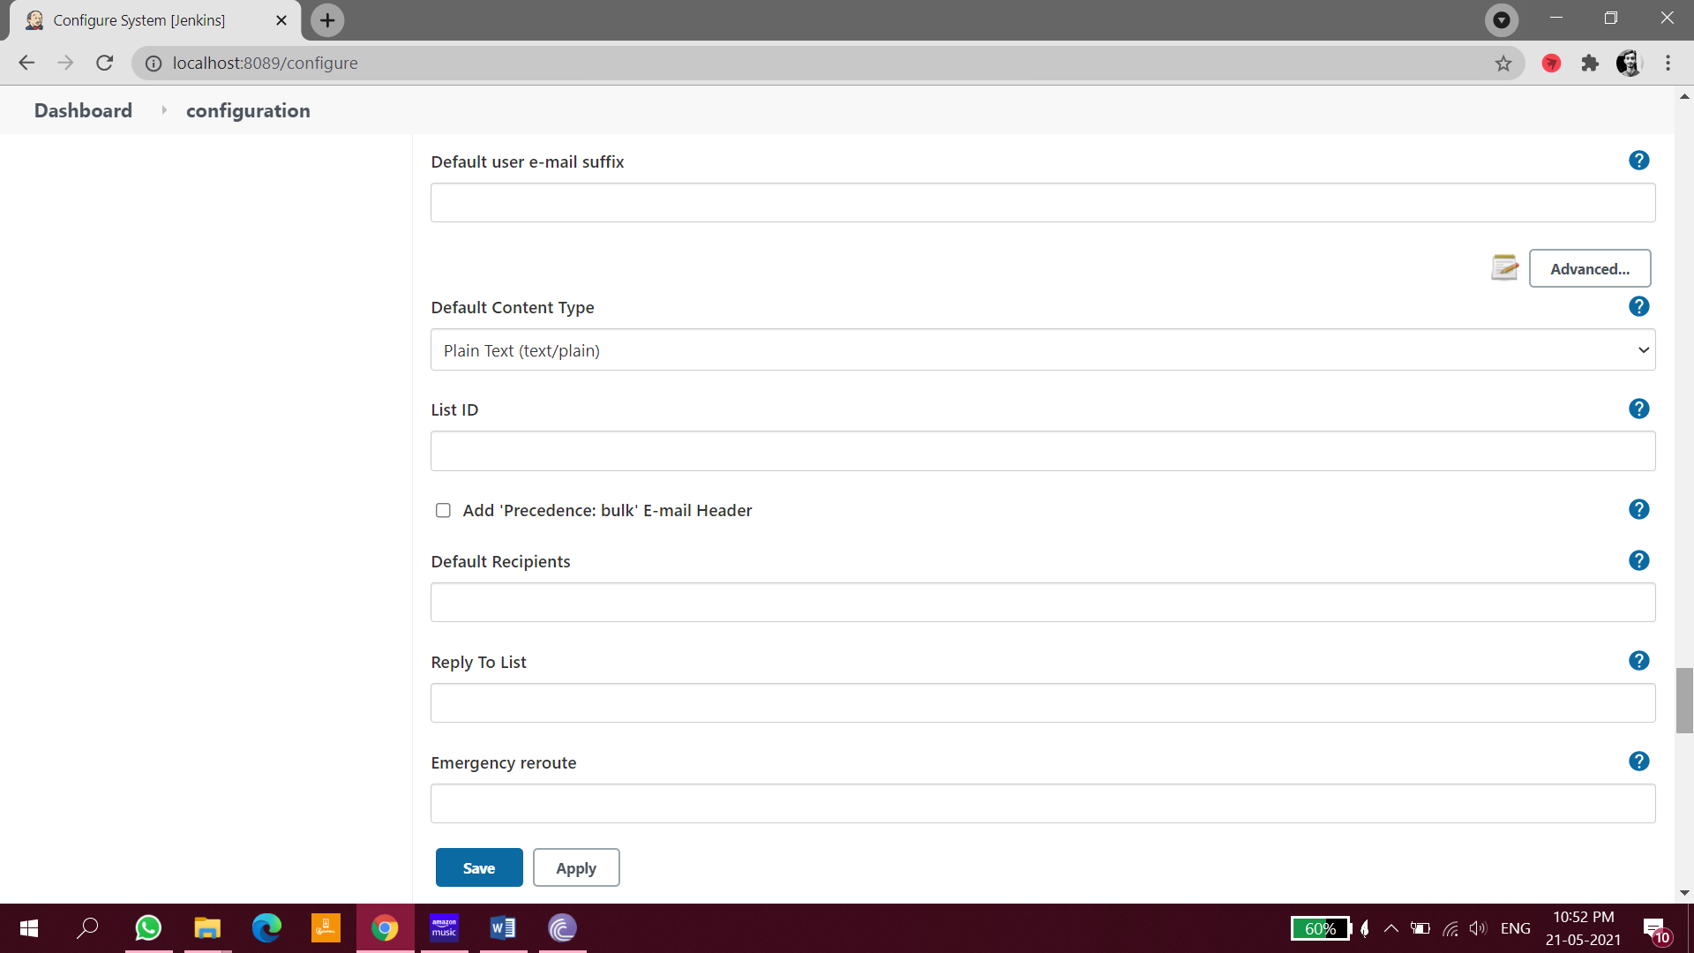

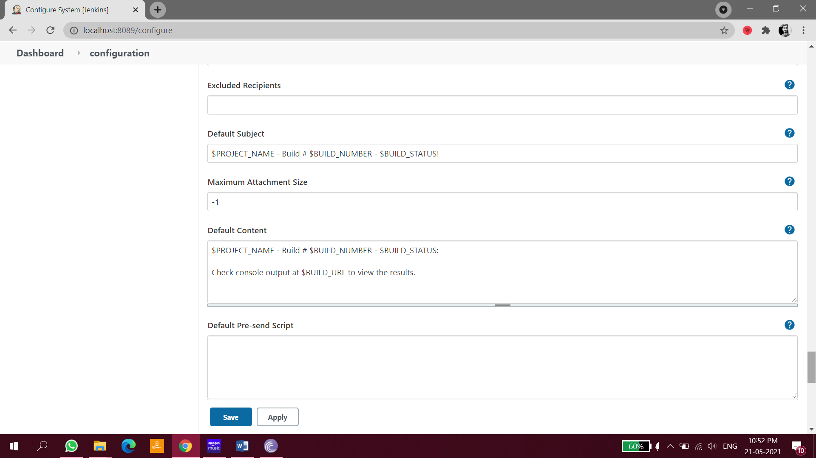

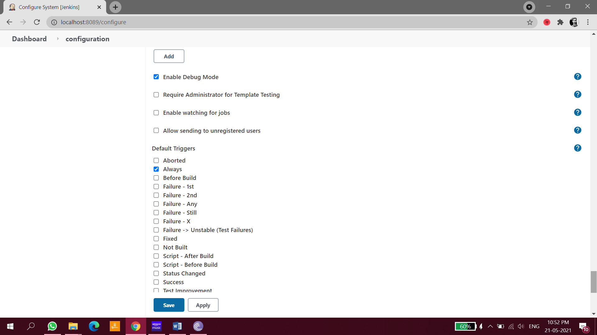

Now configure email in your job

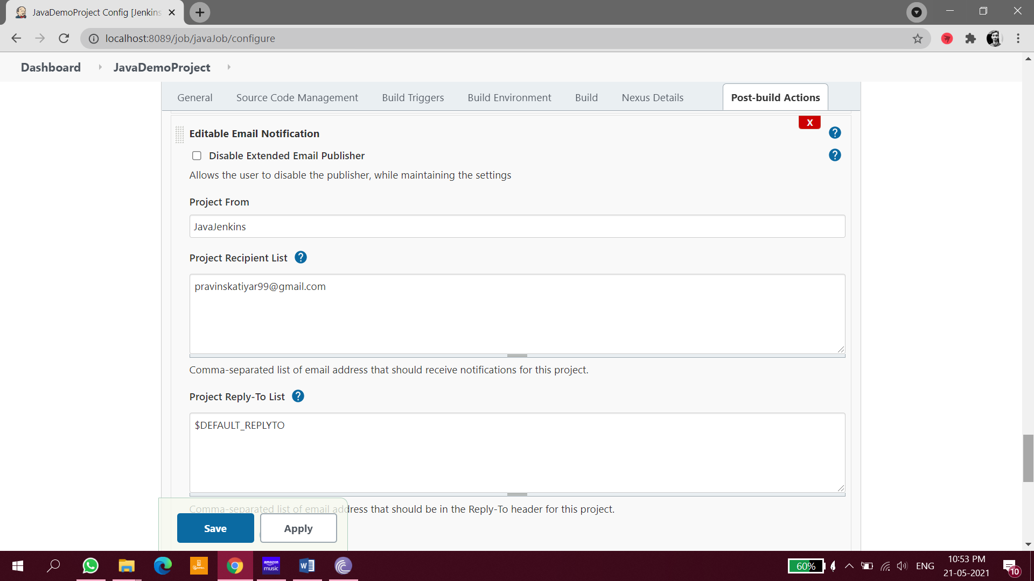

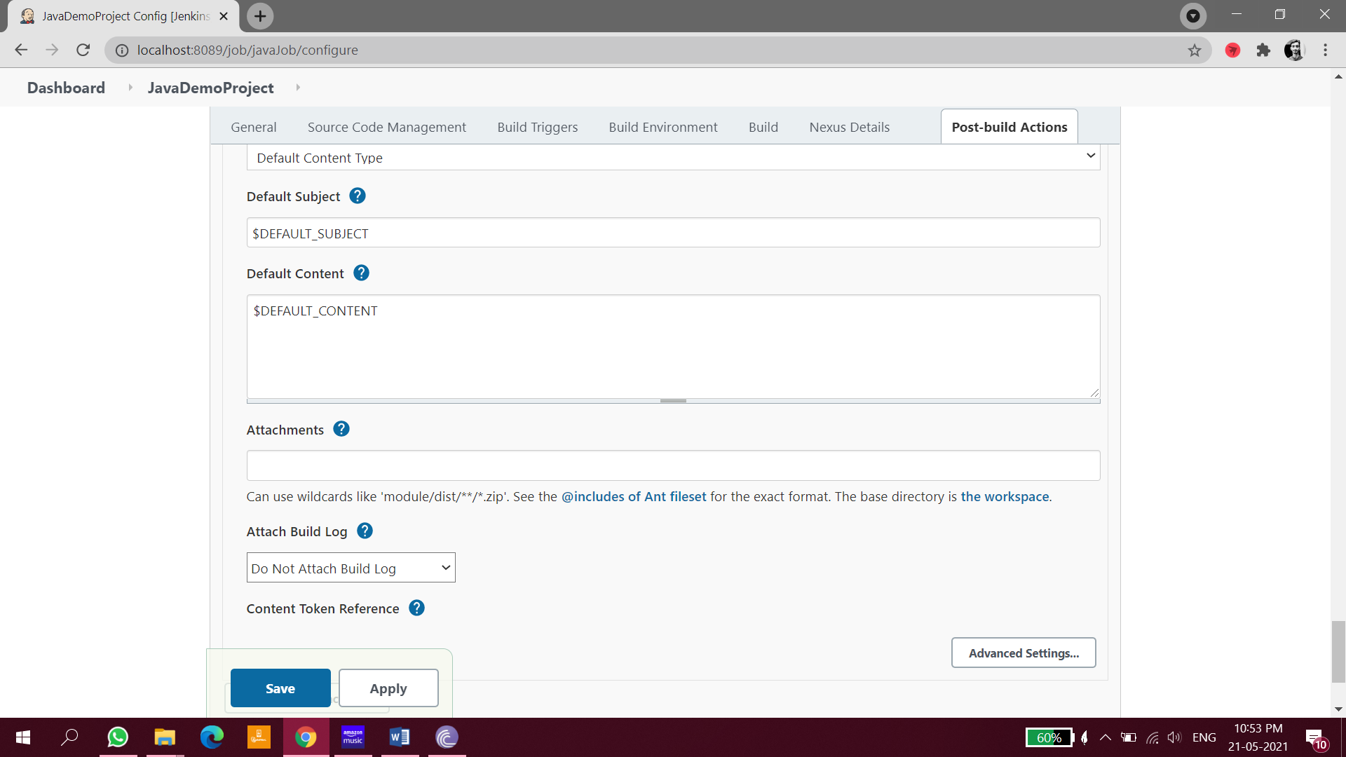

You will receive the similar mail

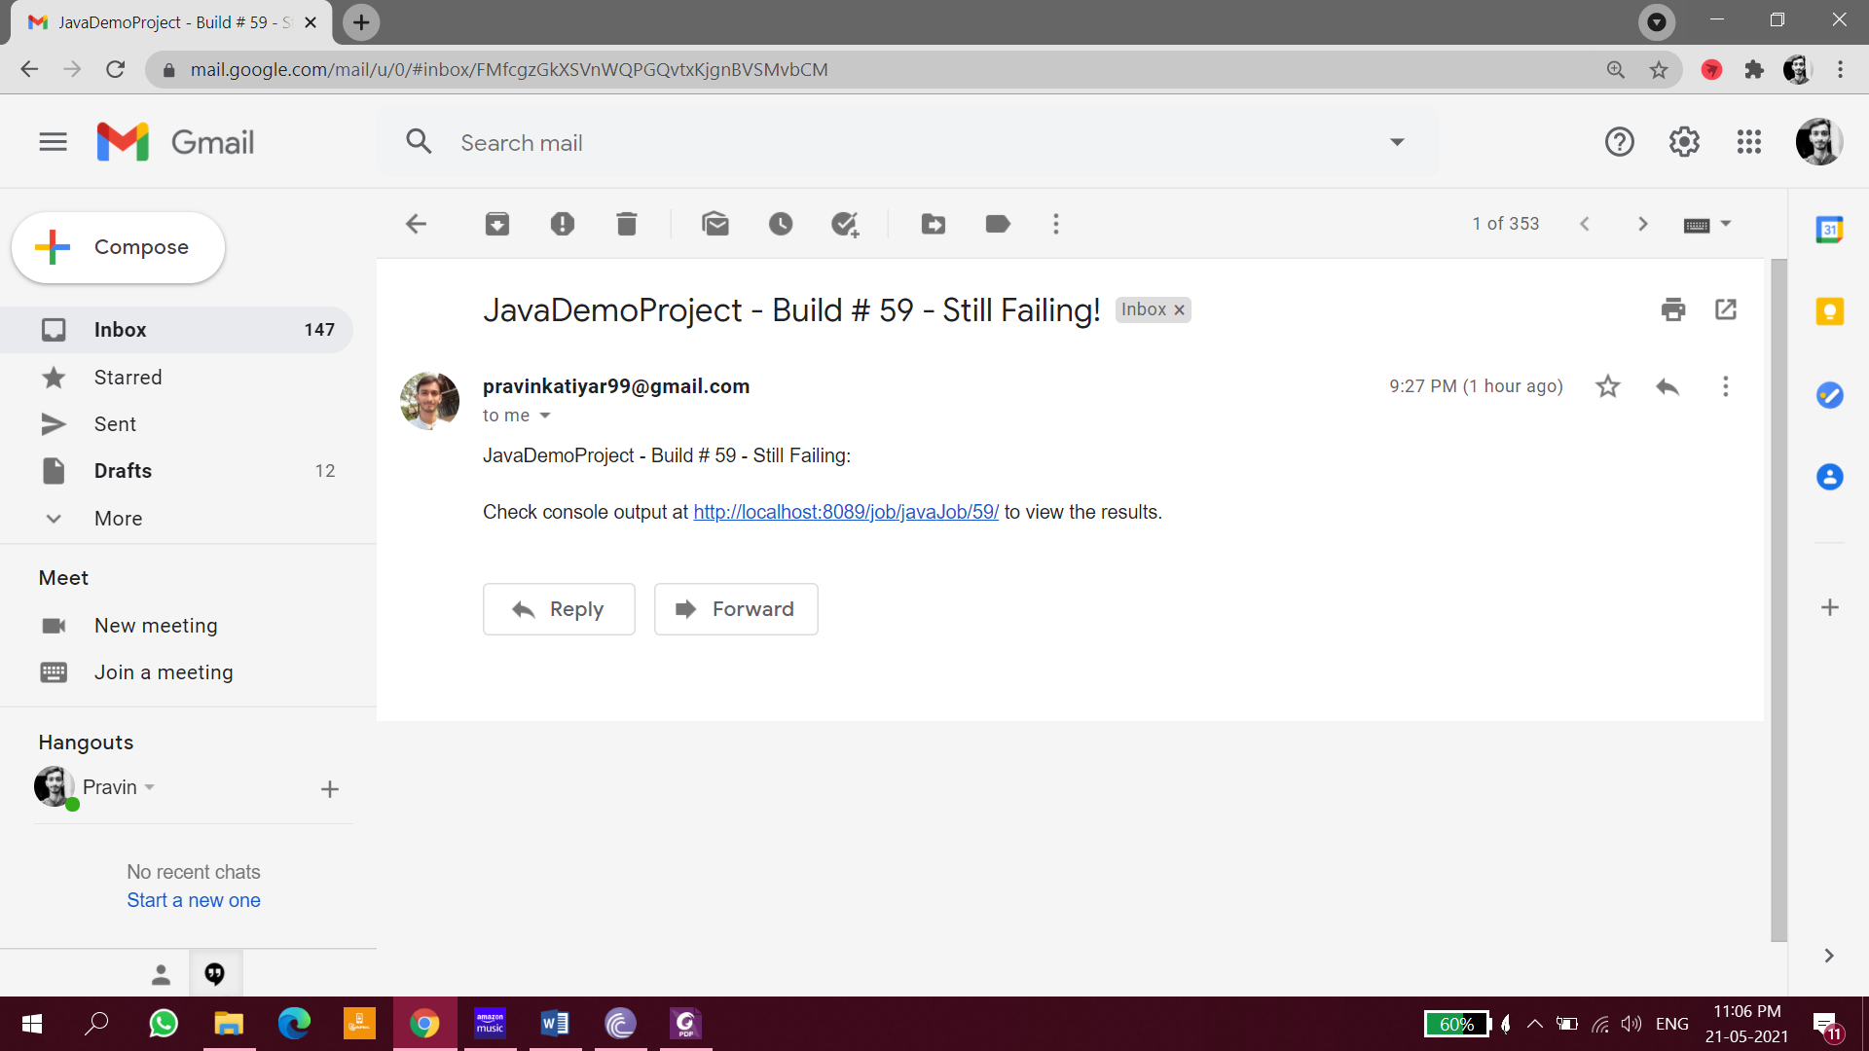

# FIXING PLUGINS NOT INSTALLING IN JENKINS

**Reproduce the problem**

The first time you open Jenkins to install the plug-in, a fork may occur due to network problems, as shown in the figure.  
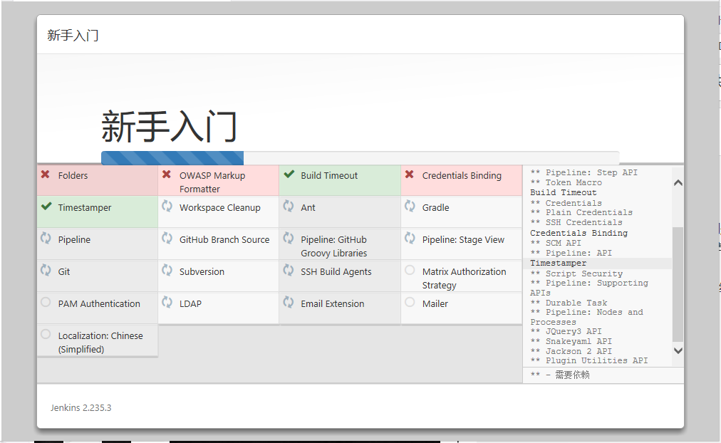  
This is not a problem, first complete the initialization steps for this beginner, and then let the blogger take you to solve the plug-in problem.

**Switch download source address**

* Click Manage Jenkins  
  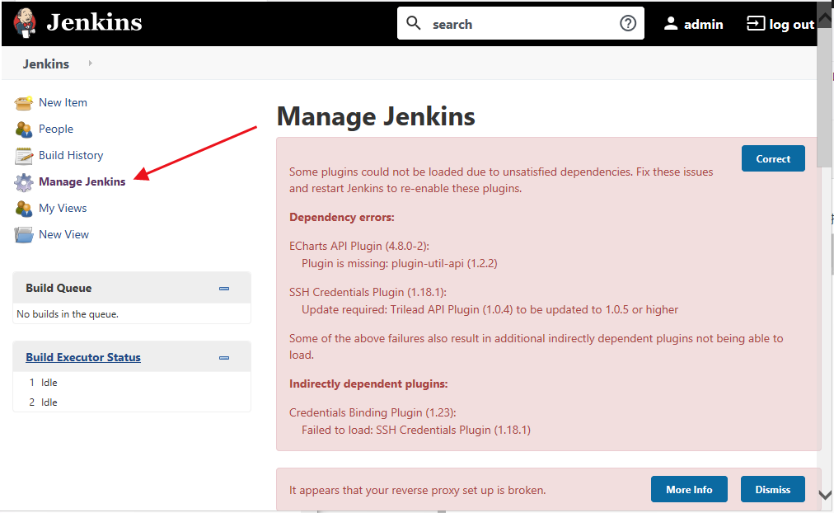
* Click Correct.  
  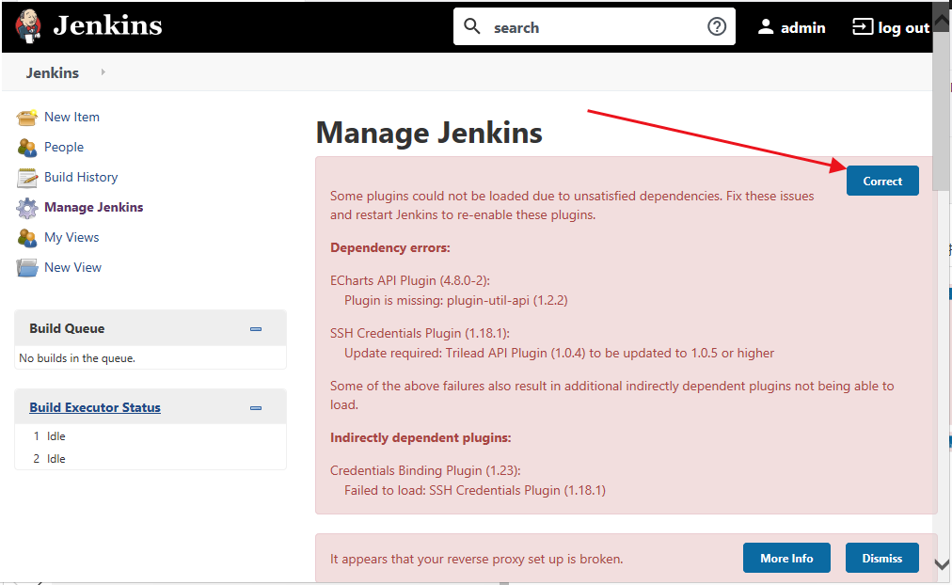
* Click Advanced.  
  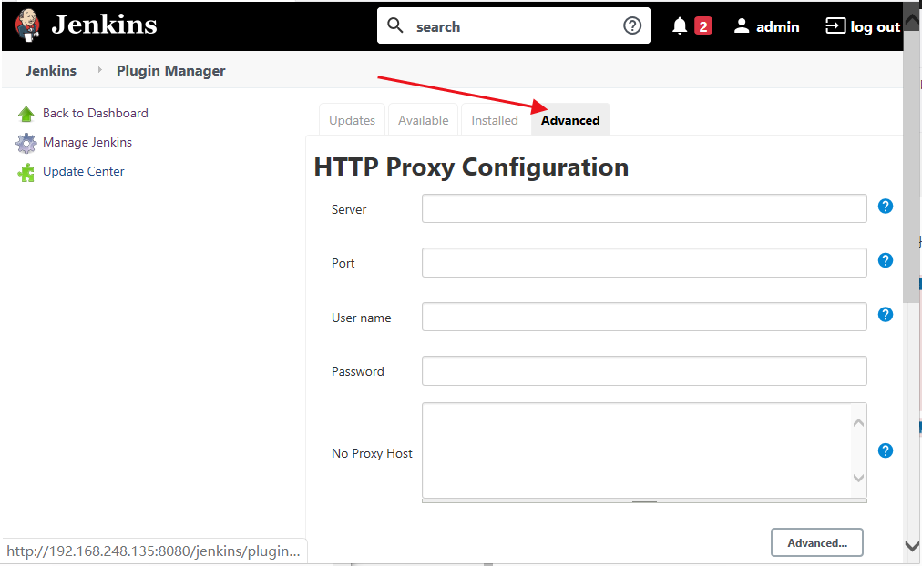
* Find the Update Site at the bottom of the page and replace the link with:https://mirrors.tuna.tsinghua.edu.cn/jenkins/updates/update-center.json  
  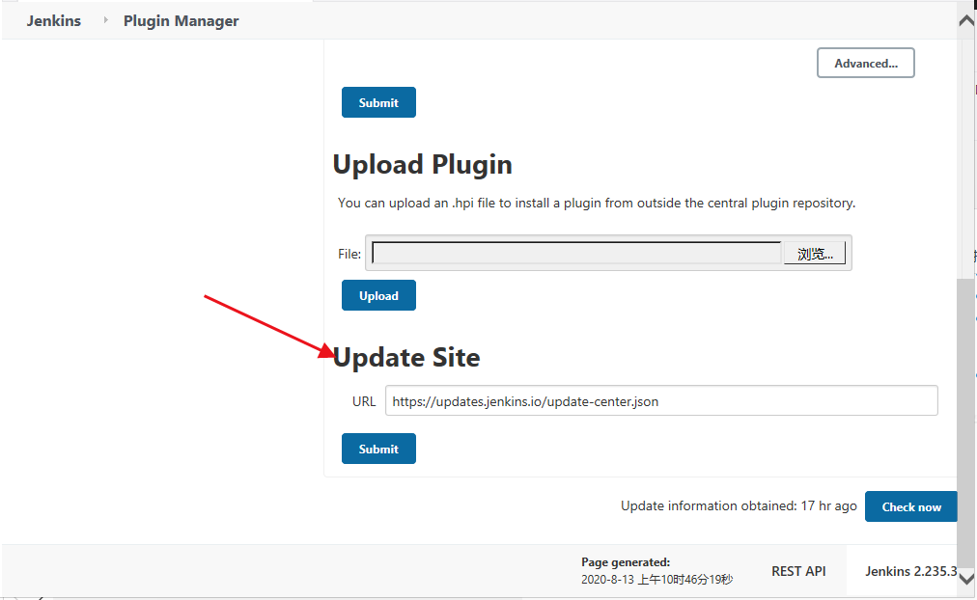
* To view the failed plugins, search for reinstallation in Available.  
  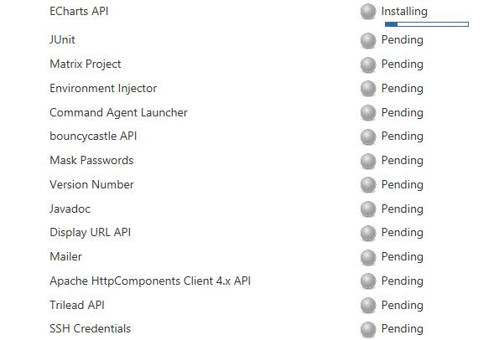

After the installation is complete, restart, and the plug-in error disappears.